
SAP Qualtrics Integration for Lead to Cash Scenarios – Template
Send Order Feedback from SAP Qualtrics to SAP Commerce Cloud as Service Ticket

Table of ContentS
introduction 3
Prerequisites 3
Setting up SAP Commerce Cloud 4
Set up Qualtrics Configurations in SAP Commerce Cloud 4
Modify JSP pages 4
Setting up SAP Commerce Cloud for Service Ticket 4
Setting up SAP Qualtrics 6
Set up a survey project in SAP Qualtrics 6
Set survey questions 6
Set embedded data 6
Set Actions 7
Set up a Website/App feedback project in SAP Qualtrics 9
Design Creatives 9
Design Intercepts 9
Setting Up SAP Cloud Integration 11
Manage Security material 11
Add integration package to workspace 11
SAP Cloud Integration Runtime URL 11

introduction
SAP Qualtrics integration for Lead to Cash scenario helps to connect SAP Qualtrics with C/4 HANA products like SAP Sales Cloud, SAP CPQ, SAP Marketing Cloud, SAP Commerce Cloud etc.
The purpose of this document is to describe the general steps required to set up the configurations within the system landscape, using the corresponding installation or configuration guides.
The integration package runs on the SAP Cloud Platform tenant and collects the survey feedback from SAP Qualtrics. This data is then transformed and sent to SAP Commerce Cloud. This is a template integration flow that helps customers to obtain a general overview of how to connect SAP Qualtrics with SAP Commerce Cloud.
On receiving a survey response, a new action would be triggered in SAP Qualtrics. You can configure a webservice task for this action which sends the formatted survey response to SAP Cloud
integration flow. The integration flow formats the payload and pushes the data to SAP Commerce Cloud.

Prerequisites
You should have the following tenants available:
- SAP Commerce Cloud tenant (e.g. CCv2)
- SAP CPI tenant
- SAP Qualtrics tenant

Setting up SAP Commerce Cloud


The steps mentioned below are based on the template integration packages published in SAP API Hub. These Commerce Cloud configurations are for reference and should be changed according to the customer scenario.

Set up Qualtrics Configurations in SAP Commerce Cloud
SAP Commerce should be integrated with SAP Qualtrics to receive the feedback in the commerce storefront. This integration is available out of the box. You need to enable and configure SAP Qualtrics extensions. Refer SAP Qualtrics Integration Module for the steps to enable this integration.

Modify JSP pages

Modify below JSP pages to add embedded data that SAP Commerce Cloud will pass to SAP Qualtrics. This embedded data provides a context with which the customer feedback can be analyzed in SAP Qualtrics. To understand more about embedded data, read Set embedded data section.

Add js-QualtricsEmailId and js-QualtricsOrderId html id tags in bin/custom/yb2bacceleratorstorefront/web/webroot/WEB-INF/views/responsive/pages/checkout/checkoutConfirmationThankMessage.jsp for B2B and bin/custom/yacceleratorstorefront/web/webroot/WEB-INF/views/responsive/pages/checkout/checkoutConfirmationThankMessage.jsp for B2C.

<div class="checkout-success__body">
<div class="checkout-success__body__headline">
<spring:theme code="checkout.orderConfirmation.thankYouForOrder" />
</div>
<p><spring:theme code="text.account.order.orderNumberLabel"/><b id="js-QualtricsOrderId"> ${fn:escapeXml(orderData.code)}</b></p>
<p><spring:theme code="checkout.orderConfirmation.copySentToShort"/><b id="js-QualtricsEmailId"> ${fn:escapeXml(email)}</b></p>
</div>

Setting up SAP Commerce Cloud for Service Ticket

The steps mentioned below are based on the template integration packages published in SAP API Hub. These CPQ configurations are for reference and should be change according to the customer scenario.

SAP Commerce Cloud has to be updated to include the Integration Object that will accept the Qualtrics feedback as a Service Ticket.
Execute following impex in SAP Commerce Cloud to create the required Integration Object:
INSERT_UPDATE IntegrationObject; code[unique = true]; integrationType(code)
; InboundCsCustomerEvent; INBOUND

INSERT_UPDATE IntegrationObjectItem; integrationObject(code)[unique = true]; code[unique = true]; type(code); root[default = false]
; InboundCsCustomerEvent ; BaseSite ; BaseSite ; ;
; InboundCsCustomerEvent ; CsCustomerEvent ; CsCustomerEvent ; true ;
; InboundCsCustomerEvent ; CsInterventionType ; CsInterventionType ; ;
; InboundCsCustomerEvent ; CsTicketPriority ; CsTicketPriority ; ;
; InboundCsCustomerEvent ; AbstractOrder ; AbstractOrder ; ;
; InboundCsCustomerEvent ; CsTicketCategory ; CsTicketCategory ; ;
; InboundCsCustomerEvent ; CsTicket ; CsTicket ; ;
; InboundCsCustomerEvent ; User ; User ; ;
; InboundCsCustomerEvent ; CommentType ; CommentType ; ;
; InboundCsCustomerEvent ; CsTicketState ; CsTicketState ; ;

INSERT_UPDATE IntegrationObjectItemAttribute; integrationObjectItem(integrationObject(code), code)[unique = true]; attributeName[unique = true]; attributeDescriptor(enclosingType(code), qualifier); returnIntegrationObjectItem(integrationObject(code), code); unique[default = false]; autoCreate[default = false]
; InboundCsCustomerEvent:BaseSite ; uid ; BaseSite:uid ; ; true ;
; InboundCsCustomerEvent:CsCustomerEvent ; commentType ; CsCustomerEvent:commentType ; InboundCsCustomerEvent:CommentType ; ;
; InboundCsCustomerEvent:CsCustomerEvent ; ticket ; CsCustomerEvent:ticket ; InboundCsCustomerEvent:CsTicket ; ; true
; InboundCsCustomerEvent:CsCustomerEvent ; text ; CsCustomerEvent:text ; ; ;
; InboundCsCustomerEvent:CsCustomerEvent ; code ; CsCustomerEvent:code ; ; true ;
; InboundCsCustomerEvent:CsCustomerEvent ; author ; CsCustomerEvent:author ; InboundCsCustomerEvent:User ; ;
; InboundCsCustomerEvent:CsCustomerEvent ; interventionType ; CsCustomerEvent:interventionType ; InboundCsCustomerEvent:CsInterventionType ; ;
; InboundCsCustomerEvent:CsInterventionType ; code ; CsInterventionType:code ; ; true ;
; InboundCsCustomerEvent:CsTicketPriority ; code ; CsTicketPriority:code ; ; true ;
; InboundCsCustomerEvent:AbstractOrder ; code ; AbstractOrder:code ; ; true ;
; InboundCsCustomerEvent:CsTicketCategory ; code ; CsTicketCategory:code ; ; true ;
; InboundCsCustomerEvent:CsTicket ; state ; CsTicket:state ; InboundCsCustomerEvent:CsTicketState ; ;
; InboundCsCustomerEvent:CsTicket ; ticketID ; CsTicket:ticketID ; ; true ;
; InboundCsCustomerEvent:CsTicket ; order ; CsTicket:order ; InboundCsCustomerEvent:AbstractOrder ; ;
; InboundCsCustomerEvent:CsTicket ; customer ; CsTicket:customer ; InboundCsCustomerEvent:User ; ;
; InboundCsCustomerEvent:CsTicket ; category ; CsTicket:category ; InboundCsCustomerEvent:CsTicketCategory ; ;
; InboundCsCustomerEvent:CsTicket ; baseSite ; CsTicket:baseSite ; InboundCsCustomerEvent:BaseSite ; ;
; InboundCsCustomerEvent:CsTicket ; priority ; CsTicket:priority ; InboundCsCustomerEvent:CsTicketPriority ; ;
; InboundCsCustomerEvent:CsTicket ; headline ; CsTicket:headline ; ; ;
; InboundCsCustomerEvent:User ; uid ; User:uid ; ; true ;
; InboundCsCustomerEvent:CommentType ; code ; CommentType:code ; ; true ;
; InboundCsCustomerEvent:CsTicketState ; code ; CsTicketState:code ; ; true ;

Setting up SAP Qualtrics

The steps mentioned below are based on the template integration packages published in SAP API Hub. These Qualtrics configurations, survey questions and embedded data are for reference and should be change according to the customer scenario.

You need to set up a Qualtrics Survey project and Qualtrics Website/App Feedback project for this integration. Design your survey, set up embedded variables to capture survey metadata and set up actions in your survey project. In the Website/ App feedback project, design the creative, set up conditions in your interceptor and activate it.

Set up a survey project in SAP Qualtrics

To set up a new survey project, refer to Survey Basic Overview. The template integration package is based on below survey configurations in SAP Qualtrics.

Set survey questions

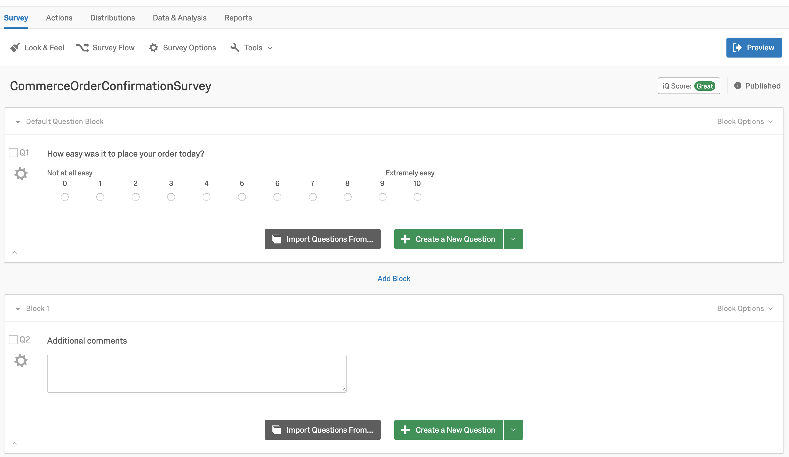

This survey has two questions. First question is of NPS Score Type and captures the customer’s overall experience during the order journey. A second question captures the reasons for the rating.

Set embedded data

You need to set up embedded data for SAP Qualtrics to have some context while processing the survey response. Refer to Embedded Data to understand how to set up embedded data in a survey project. For this template integration, orderId and customer email address are sent from SAP Commerce to SAP Qualtrics.
Once the embedded data is configured, survey response also includes values for these variables.
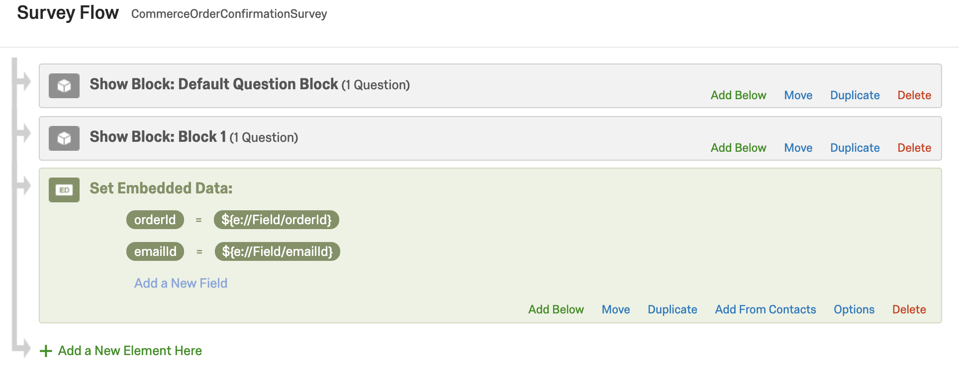

Set Actions
You need to set up actions to send feedback from SAP Qualtrics to SAP CPI. To read more about actions, refer Actions Basic Overview. This template integration contains Actions with Web Service Task.
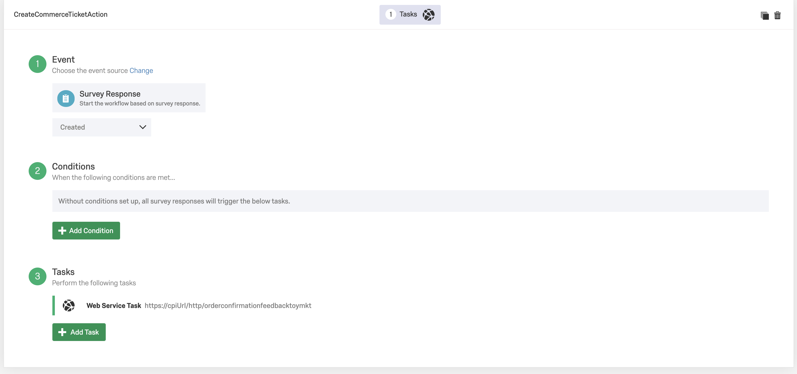

While setting up the Web Service task, remember to create a new authorization. This is done by going to Auth Create New Auth. Select Type as Basic Auth. Fill in the details.
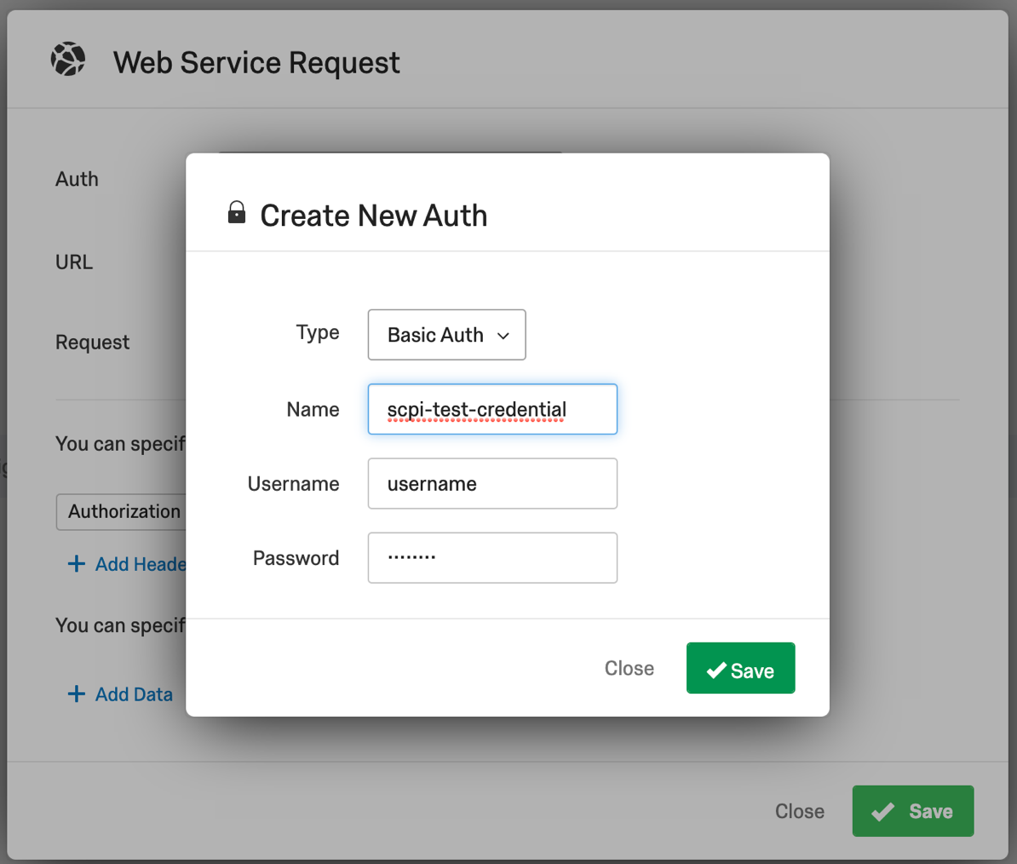

The user configured in the above step should also be available in SAP CPI with sufficient roles. To create a new user in SAP CPI, refer Creating a User for Cloud Integration.
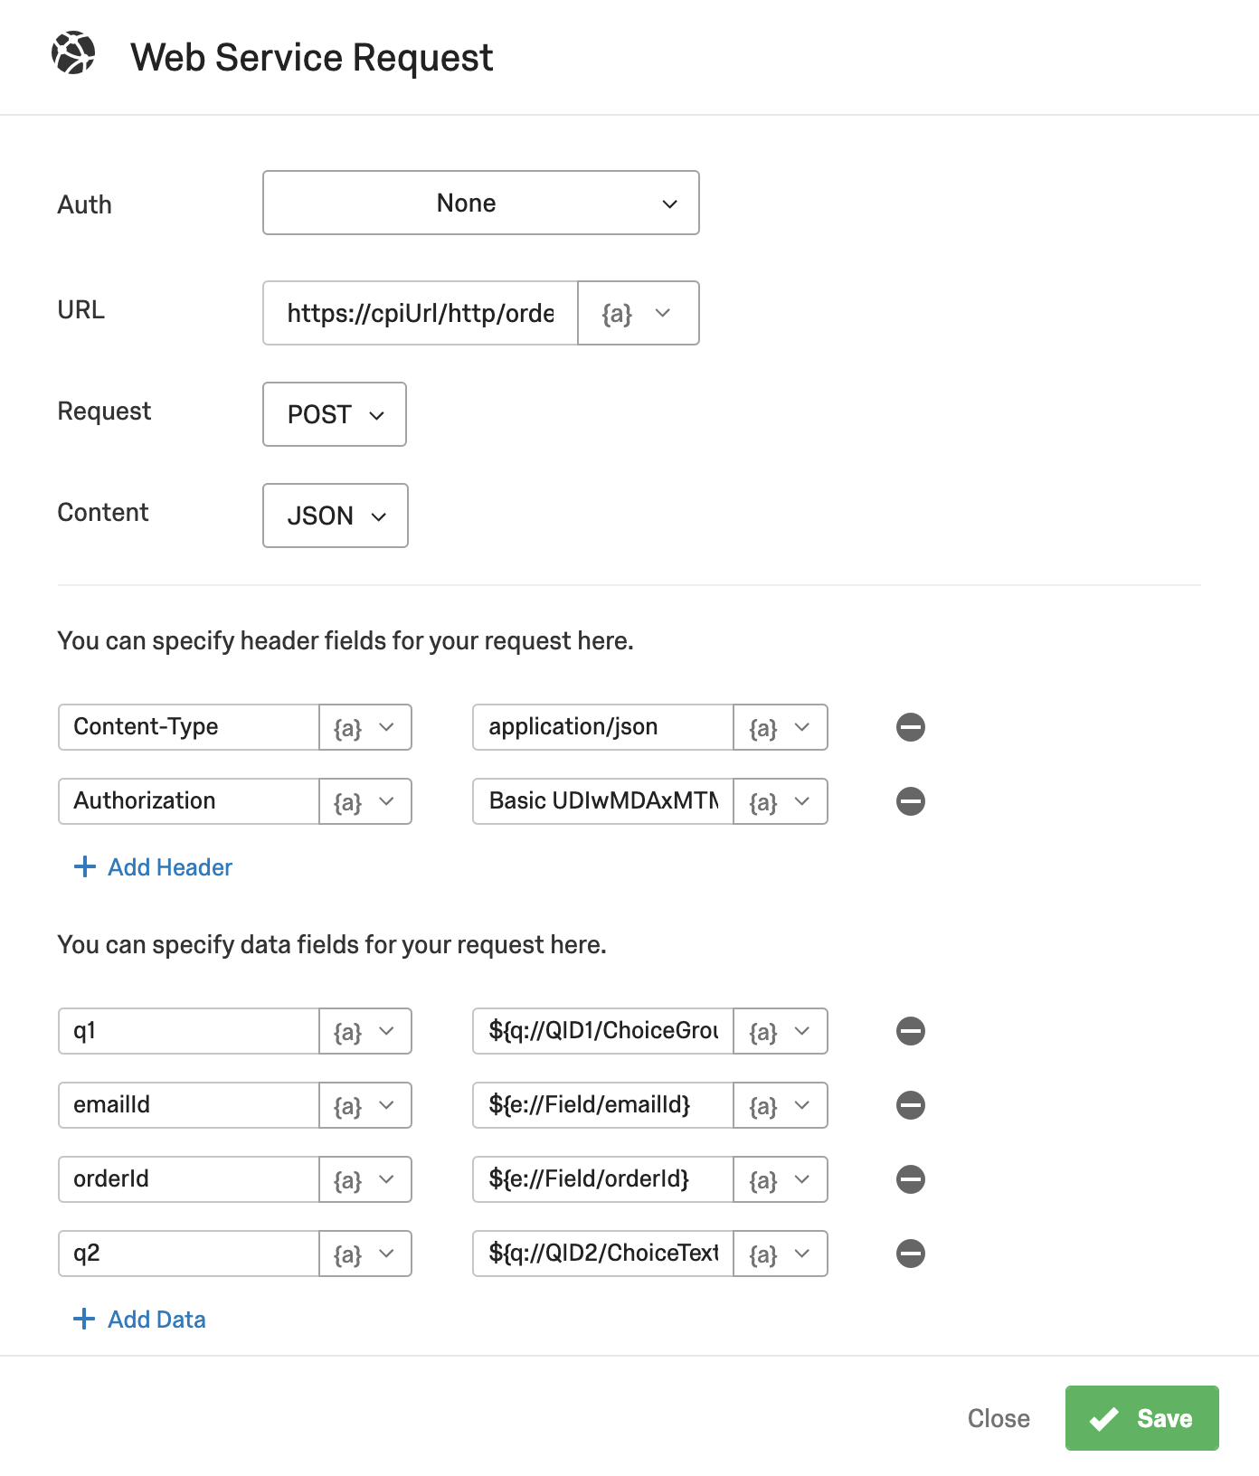
For the payload, click on Add Data button, specify the key and the value. This JSON payload is sent to the configured target endpoint. The orderId, emailId and the feedback received from SAP Commerce Cloud are sent as JSON payload to the template integration flows.

Set up a Website/App feedback project in SAP Qualtrics
To set up a new Website/ App Feedback project, refer Creating a Website / App Feedback Project. Creatives and Intercepts are designed to capture customer’s feedback in SAP Commerce Cloud.

Design Creatives
A Creative is used to display SAP Qualtrics survey in SAP Commerce Cloud. To set up a new creative, refer Navigating the Creatives Tab. The creative type used in the template is Pop Over, you can also use a Slider or a Responsive Dialog.

Design Intercepts

An intercept has action sets that connect a creative to the survey. Action set also has an intercept logic display section. For this template integration package, below configurations have to be maintained.

- Check if the current URL in the website is ‘checkout/orderConfirmation’.
- Select the creative previously designed from Select a Creative to show dropdown.
- Select the Qualtrics survey previously designed, as a target link for your creative.

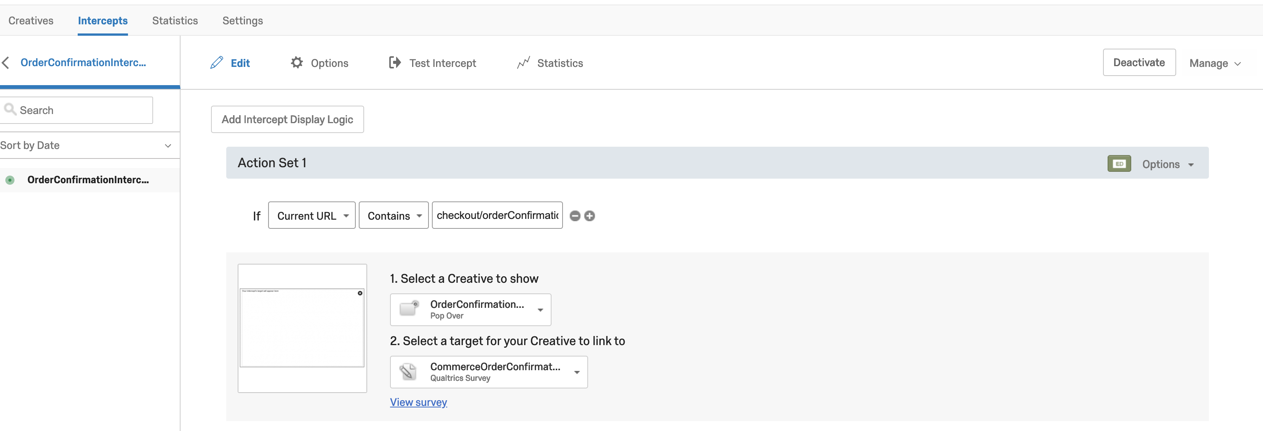

It is also important to define embedded data for this action set. To set the embedded data refer Embedded Data in Website Feedback. For this template integration package, two such variables are defined. These variables are referenced in Set embedded data.
- orderId - document.getElementById('js-QualtricsOrderId').textContent.trim()
- emailId - document.getElementById('js-QualtricsEmailId').textContent.trim()

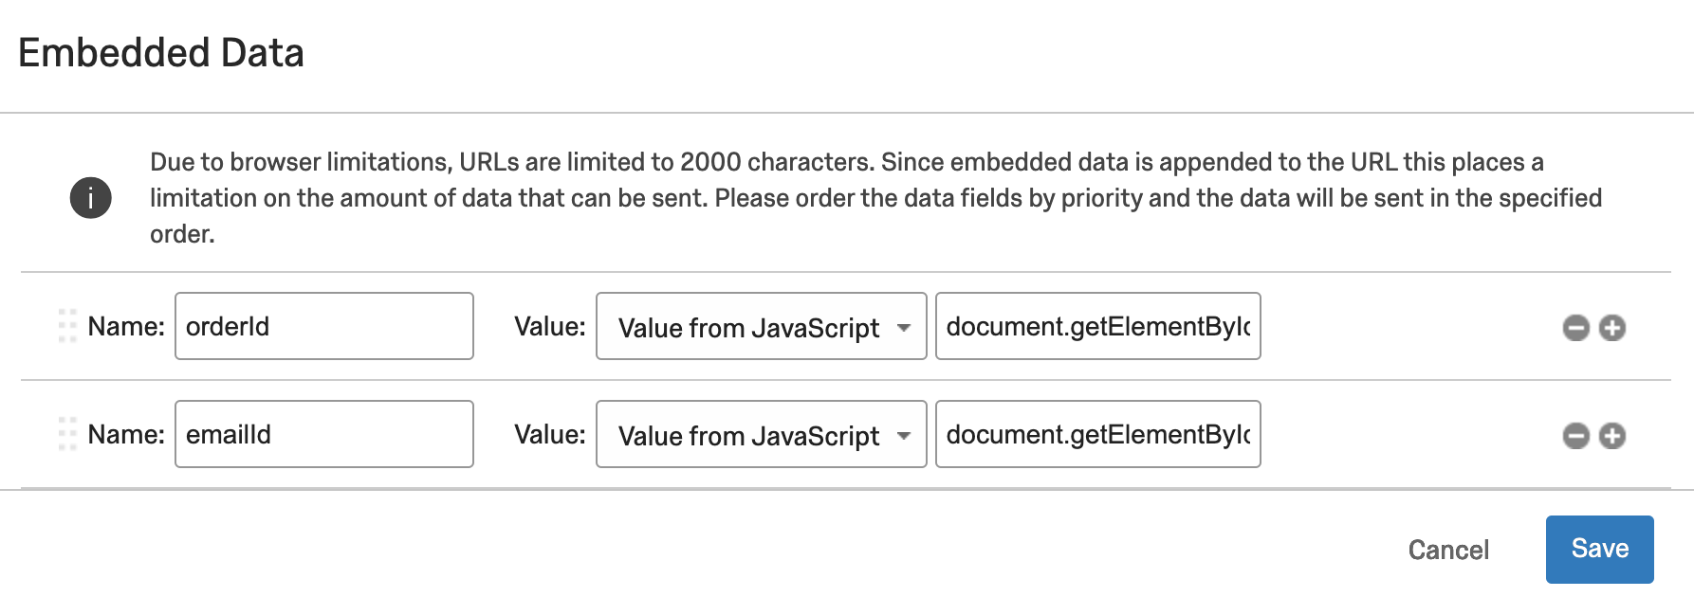

Setting Up SAP Cloud Integration
The integration flows defined in this package have to be copied to customer’s workspace and must be configured and deployed.

Manage Security material
Create a technical user in SAP Commerce Cloud to access API endpoint. This user credentials must be stored in SAP Cloud Integration tenant as User Credentials. For details refer to Deploying / Editing a User Credentials Artifact.

Add integration package to workspace
Template integration package can be copied to customer’s workspace by referring to Add Integration Packages to the Customer Workspace

SAP Cloud Integration Runtime URL

In the SAP Cloud Integration Web UI, perform the following.
- Navigate to Monitor.
- Select the Manage Integration Content - Started tile.
- Search for the Integration Flow names available in this template package.
- The URL will be listed under the Endpoints section.

Receiver | Field Name | Receiver Value
CommerceCloud | Commerce server | Commerce Cloud URL of your ccv2 instance
CommerceCloud | Credential Name | Credential configured for SAP Commerce Cloud from Manage Security material
CommerceCloud | Location ID | Location Id of Cloud Connector if used

Under More section, select type as All Parameters.

Field Name | Receiver Value
Base Site | Base Site in SAP Commerce Cloud in which Service Ticket will be created (eg. electronics)
Comment Type | Refer Commerce - ticketsystem Extension at: https://help.sap.com/viewer/9d346683b0084da2938be8a285c0c27a/1905/en-US/8c7258ff86691014b485bfd58e138ed3.html
Headline | Headline text of the service ticket
Intervention Type | Refer Commerce - ticketsystem Extension at: https://help.sap.com/viewer/9d346683b0084da2938be8a285c0c27a/1905/en-US/8c7258ff86691014b485bfd58e138ed3.html
Ticket Category | Refer Commerce - ticketsystem Extension at: https://help.sap.com/viewer/9d346683b0084da2938be8a285c0c27a/1905/en-US/8c7258ff86691014b485bfd58e138ed3.html
Ticket Priority | Refer Commerce - ticketsystem Extension at: https://help.sap.com/viewer/9d346683b0084da2938be8a285c0c27a/1905/en-US/8c7258ff86691014b485bfd58e138ed3.html

