Building block Configuration Guide  SAP S/4 HANA Integration with SAP Concur – Exchange Rates  January 2022  English | Customer
SAP S/4 HANA Integration with SAP Concur – Exchange Rates

Document History
Revision | Date | Author
0 | January, 2022 | Bertrand Henkel
Content
1 Prerequisites 5
2 Configuration steps on SAP Cloud Integration 6
2.1 Connect to SAP Concur SFTP Server 6
2.2 Create PGP Key 6
2.3 Replicate Exchange Rates from SAP S4 HANA OnPremise and SAP Concur 6
2.4 Configuration Steps - Replicate Exchange Rates from SAP S4 HANA OnPremise and SAP Concur 6
3 SAP BTP – Subaccount RFC Destination 8
4 Cloud Connector 9

Prerequisites
Access to the following systems:
- SAP S/4 HANA System (Technical User required)
- BTP Subaccount for SAP Cloud Integration (Admin Roles)
- SAP Cloud Integration (Configuration Roles)

Configuration steps on SAP Cloud Integration
In this scenario the SAP CI is used as a middleware in order to replicate the exchange rates from SAP S/4 HANA to SAP Concur using a Standard BAPI.

Connect to SAP Concur SFTP Server
Please follow the steps explained in Cloud Integration – How to Setup Secure Connection to sftp Server:
- IP Ranges
- Known Host
- SSH Key

Create PGP Key
In order to encrypt the message, one has to create a PGP Key in SAP CI.

Replicate Exchange Rates from SAP S4 HANA OnPremise and SAP Concur

The main process calls the standard BAPI BAPI_EXCHRATE_GETCURRENTRATES via an RFC Destination and maps the result into a CSV structure, which is uploaded to an SFTP Server in SAP Concur. The file will be PGP encrypted in the Flow.
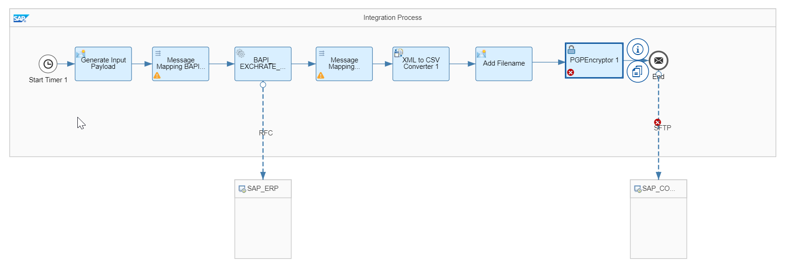

Configuration Steps - Replicate Exchange Rates from SAP S4 HANA OnPremise and SAP Concur
Timer:
Set the Timer on a daily regular basis.

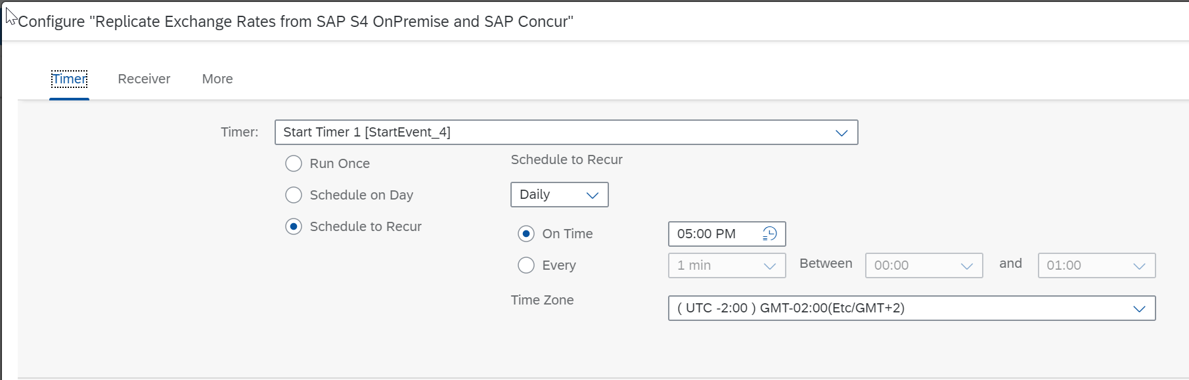

Receiver
SAP_ERP:
- Destination: RFC Destination, which has been defined in the SAP BTP Subaccount pointing to the SAP S/4 HANA.

SAP_CONCUR_SFTP:
- Directory: Inbound Directory of the SFTP Server
- Address: SFTP Server Host
- Proxy Type
- Authentication: Authentication method
- User Name: User Name
- Private Key Alias: Private Key Alias
Processing
- Handling for Existing Files

More
- DATE_TYPE: Date Type – used for the BAPI Inbound Parameter
- PGPEncryptor_UserID: PGP Encryption Key
- RATE_TYPE: Rate Type – used for the BAPI Inbound Parameter
- SFTP_FileName: File Name of the file

SAP BTP – Subaccount RFC Destination
Configuration of the RFC Destination on the BTP subaccount

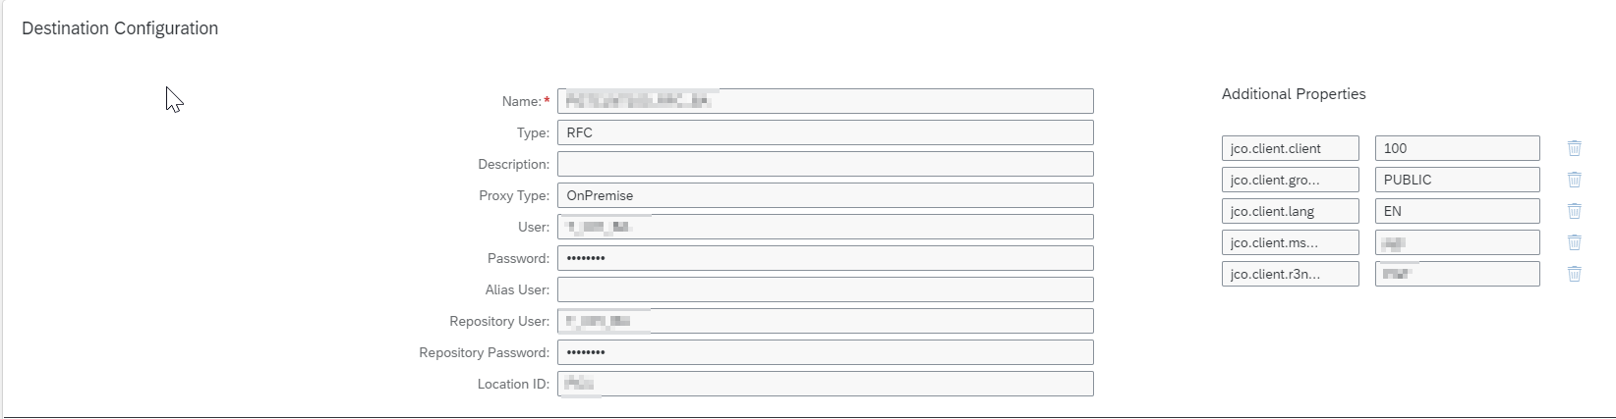

- Type: RFC
- Proxy Type: OnPremise
- User: communication user defined in the SAP S/4 HANA System
- Password: Passwort of this communication user
- LocationID: location ID of the cloud connector
Additional Properties:
- Jco.client.amshost: xxx (as defined in the Cloud Connector)
- jco.client.r3name: xxx (as defined in the Cloud Connector)
- Jco.client.client: SAP S/4 HANA client
- Jco.client.lang: EN (System language)
- jco.client.group: PUBLIC

Cloud Connector
The cloud connector is used as a reverse inbound proxy in order to be able to communicate from Cloud to an OnPremise system.
One has to configure the RFC Destination to the SAP S/4 HANA backend system.

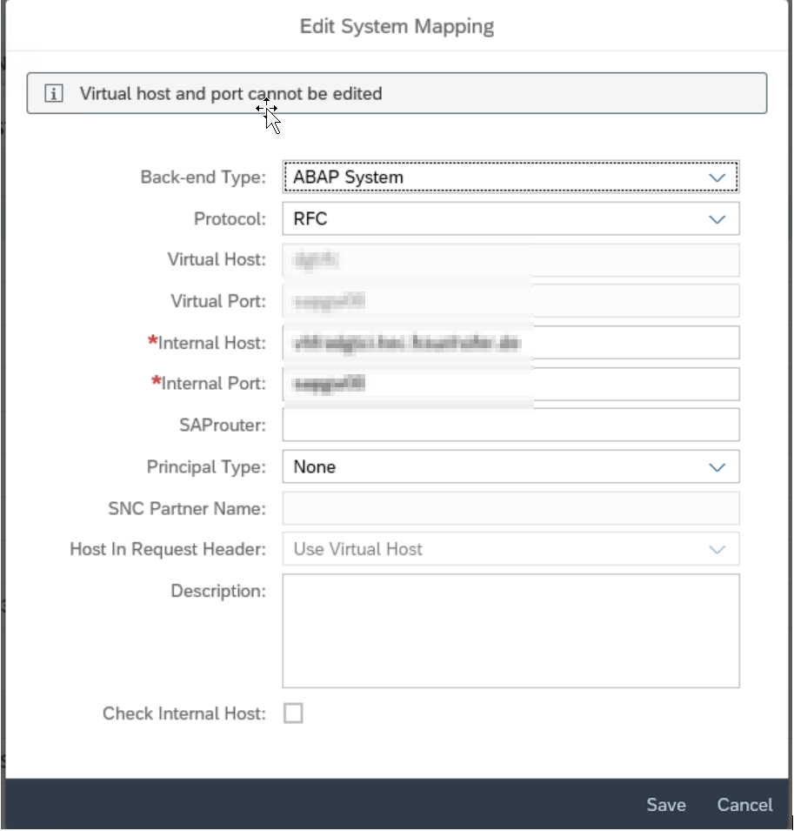

Please also allow the following resource:
- BAPI_EXCHRATE_GETCURRENTRATES

