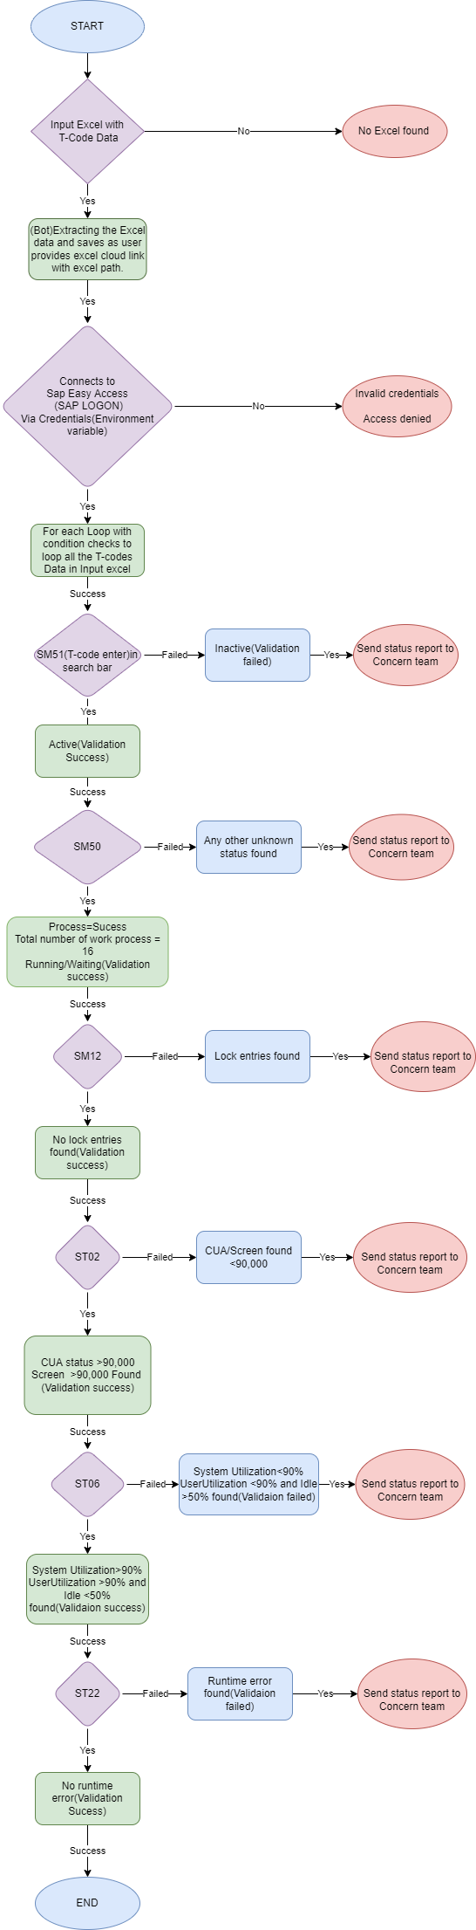
Flow Chart: SAP ECC Monitoring and Health checks

