

[Interactions Data Load From ThirdPartySftp To SAP Marketing Cloud]

Version | Description of change | Date | Author
1.0 | Initial version | 10.03.2020 | Oleg Veliks
Date: 10/03/2020
Version: 1.0
Author: Oleg Veliks

DOCUMENT CONTROL
Owner | Client contact |  | Status | Date issued
Oleg Veliks | N/A | N/A |  | N/A
Version history log
TABLE OF CONTENTS

1 PURPOSE 3
2 OVERVIEW 4
3 PRE-REQUISITES 5
4 INTEGRATION FLOW CONFIGURATION 6
4.1 Configuration Parameters 6
5 STEPS FOR TESTING THE IFLOW 10

PURPOSE
The purpose of this document is to describe the general configuration steps required to set up the integration flow for migrating millions of Interactions from/to third Party systems to SAP C/4 Marketing Cloud Systems. The integration flow provides out of the box capability to consume millions of interactions in files of size 100k records from S3 buckets and splits them into smaller OData (5k) Packets and provides full traceability on whether each 1k or 5k packet is processed successfully or failed in SAP C/4 Marketing Cloud System.

This IFLOW is an enhancement of SAP Standard
Content https://api.sap.com/package/SAPHybrisMarketingCloudfilebaseddataload?se ction=Artifacts that will address the following limitations of the standard content:
- The error handling capability delivered in the standard integration triggers alerts via e-mail which is really not a good use case for complex large volume migration projects unless someone wants to jam their inbox with millions of error email alerts.
- There is no mechanism for full audit logging of what packets failed and what packets are successfully sent to marketing cloud for each file. Imagine a scenario where we need to migrate 20 million interactions that are split into 200 files of 100k records and split into 1000k packet for each OData call to optimize performance and client want to have full traceability to extract files to understand what records failed and what records are processed successfully in SAP C/4 Marketing Cloud System for each file.
- There is no standard SAP Cloud Integration mechanism to automatically move the error files to error folder. Due to that limitation, the files are reprocessed in the next run by the SAP Cloud Integration IFLOW resulting in many message failures in SAP Cloud Integration and also adversely effecting performance.
In this IFLOW, the error logs for each packet of source files are written in HANA Data base. It provides flexibility of customers to review the results of the file packets that failed in graphical HANA reports and helps them to resolve data issues quickly.

OVERVIEW
This IFLOW is used to read millions of interactions from AWS S3 Buckets (100k files) into SAP Marketing Cloud Systems (5k OData Packet).
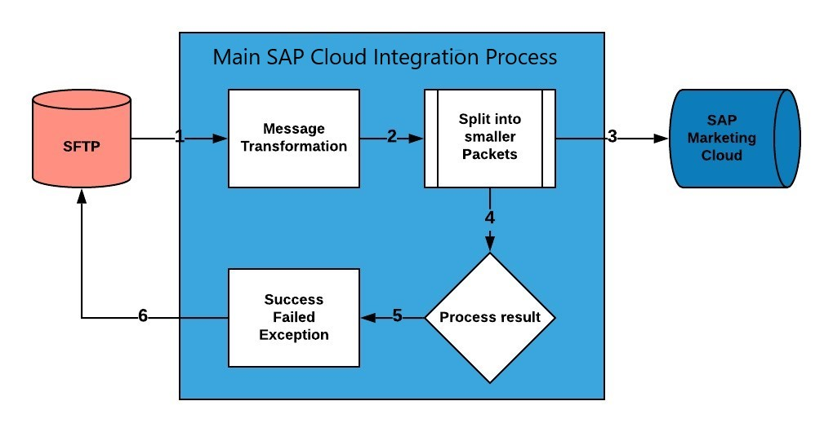
Step 1. The file is uploaded on AWS S3 bucket and AWS SFTP service is set up to read and write files into S3 via SFTP.
Step 2. SAP Cloud Integration Flow splits 100k files into smaller OData API packets.
Step 3. SAP Cloud Integration Flow Sends OData packets one by one to SAP Marketing Cloud.
Step 4. SAP Cloud Integration Flow analyses the SAP Marketing Cloud response of each packet.
Step 5. SAP Cloud Integration Generates the log for each packet of each file indicating which file is successful and which packet is failed. A log folder is created for each file with same name as “source file name” for each file and response of each packet of the file is stored in the AWS S3 with a prefix <PacketNumber_Success/Failure> to easily find out whether a packet is failed or successful for every file that is loaded.
Step 6. The file is automatically moved into error folder if there is an error in processing the full file else it is moved into an archive folder.

PRE-REQUISITES
Before configuring Integration Flow, please make sure the following prerequisites have been met:

1. The SAP HANA Cloud Platform Integration has been delivered.
a. SAP HANA Cloud Platform Integration - https://www.sap.com/products/hana-cloud-integration.html https://cloudplatform.sap.com/index.html
- Amazon Web Services account is enabled. S3 bucket is created and SFTP Transfer server is up and running. S3 bucket is a root directory of SFTP.
- SFTP server is configured and connectivity between SAP Cloud Integration tenant and SFTP is established. SFTP user having permissions to create and update folders and files.

INTEGRATION FLOW CONFIGURATION

Configuration Parameters

Externalized  Parameter Name | Description | Sample Value
Sender (Directory) | Root SFTP directory. A source directory of  SFTP server. | DevelopmentLoads/LoadFiles/Interactions/Other s/AfterSplit/Current
Sender (FileName) | Source File Name on SFTP server. A file from where to load data. | nofile.csv
Sender (Address) | SFTP server host name. | xxx.server.transfer.eu-west-2.amazonaws.com
Sender (User  Name) | SFTP User Name. SFTP user which has access to SFTP directories. | CPI_USER_PROD
Sender (Timeout) | Maximum waiting time to contact the  FTP server  while establishing connection or performing a read operation. | 10000
Sender (Lock  Timeout) | How long to wait before trying to process the file again. | 20
Sender (Change  Directories  Stepwise) | Changes directory levels one at a time | true
Sender (Post-  Processing) | Controls which actions should be done after file processing. | Move File

Sender (Archive  Directory) | Specifies the directory and the file name when moving the file after processing. | ${property.archiveDirectory}/${property.origFileN ame}
Sender (Buffer size) | Write the file content using the mentioned buffer size. | 128
Sender (Max.  Messages per Poll) | Maximum number of messages to gather for each poll. | 50
Receiver - SAPMkt (Address) | Service root URL of the OData service provider. | {{SAP_Mkt_Host}}/opu/odata/SAP/API_MKT_INTER  ACTION_SRV
Receiver - SAPMkt (SAP_Mkt_Host) | Host address of SAP  Marketing  Cloud | https://hostname.s4hana.ondemand.com/sap
Receiver - SAPMkt (Authentication) | Authenticatio  n type of  OData service for SAP  Marketing  Cloud | Basic
Receiver - SAPMkt  (Credential Name) | Credential  name to connect to the system as deployed in the tenant. | KTAPIUSER
Receiver - SAPMkt (Timeout) | Maximum time system waits before termination. | 5
Receiver -  AWS_SFTP  (Address) | Host name or IP address and port of the  SFTP server. | xxx.server.transfer.eu-west-2.amazonaws.com
Receiver -  AWS_SFTP (User  Name) | ID of the user performing file transfer. | CPI_USER_PROD

Receiver -  AWS_SFTP_LOG  (Directory) | File path from where log files should be written. | DevelopmentLoads/LoadFiles/Interactions/Other s/AfterSplit/Current/Error
Receiver -  AWS_SFTP_LOG  (File Name) | Name of the file name to be written. | error_log.csv
Receiver -  AWS_SFTP_LOG  (Address) | Host name or IP address and port of the  SFTP server. | xxx.server.transfer.eu-west-2.amazonaws.com
Receiver -  AWS_SFTP_LOG  (User Name) | ID of the user performing file transfer. | CPI_USER_PROD
More (Splitter  Concurrent  Processes) | Number of processes  running in parallel. Used for Splitter step. | 5
More (Path to  Exception Logs) | Path on FTP server where to write exception logs | DevelopmentLoads/LoadFiles/Interactions/Other s/AfterSplit/Current/Logs/  ${property.origFileName}/${property.CamelSplitI ndex}_Exception_${property.SAP_MessageProce ssingLogID}.xml
More (Path to  Failure Logs) | Path on FTP server where to write error logs | DevelopmentLoads/LoadFiles/Interactions/Other s/AfterSplit/Current/Logs/  ${property.origFileName}/${property.CamelSplitI ndex}_Failure_${property.SAP_MessageProcessin gLogID}.xml
More (Splitter  Grouping) | Specify the group size in which composite message should be split. | 5
More (Path to  Successful Logs) | Path on FTP server where to write logs of successfully processed records | DevelopmentLoads/LoadFiles/Contacts/C4M/Af terSplit/Current/Logs/  ${property.origFileName}/${property.CamelSplitI ndex}_Success_${property.SAP_MessageProcessi ngLogID}.xml
More (Splitter  Timeout) | Maximum waiting time to contact the  FTP server  while establishing | 10800
connection or performing a
write operation.
More (Splitter  Xpath Expression) | Xpath expression to navigate to the split item using absolute path. | /batchParts/batchChangeSet/batchChangeSetPart/Interacti onsDeepInsert/InteractionDeepInsert/Interactions/Interacti on

STEPS FOR TESTING THE IFLOW
Step 1. Access the WEB UI URL on your SAP Cloud Platform Integration tenant.
It should be in the format https://.hci.us1.hana.ondemand.com/itspaces
Step 2. Place the file in the SFTP server using Filezilla or other FTP client in the designed directory
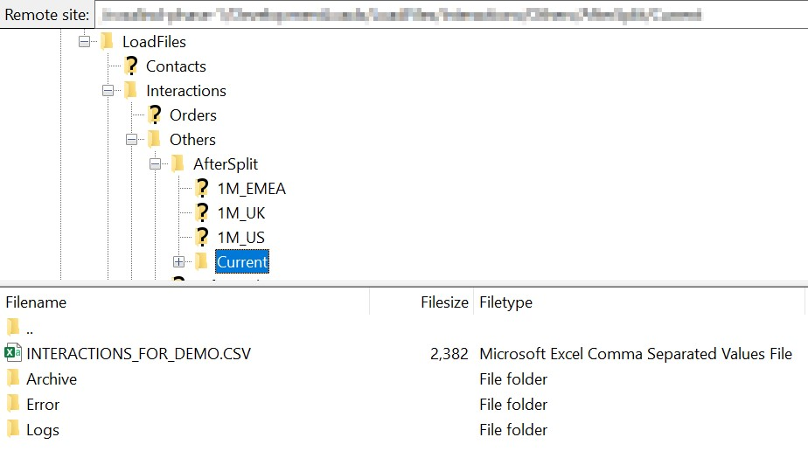
Step 3. Configure iflow and deploy. The iflow should be deployed.
Step 4. Login to SAP Marketing Cloud and go to Import Monitor app. You should be able to see status of processed message.
If there is a message - fix an error and start process from the beginning.
Step 5. Check the interaction is created in the SAP Marketing Cloud Using the Fiori App "Import Monitor"
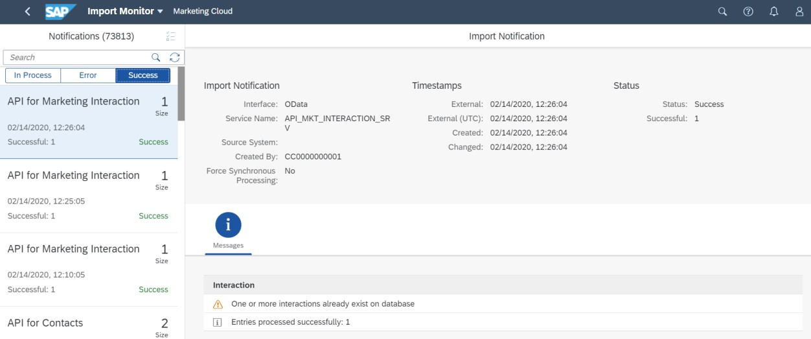
and "Browse Interaction Data".
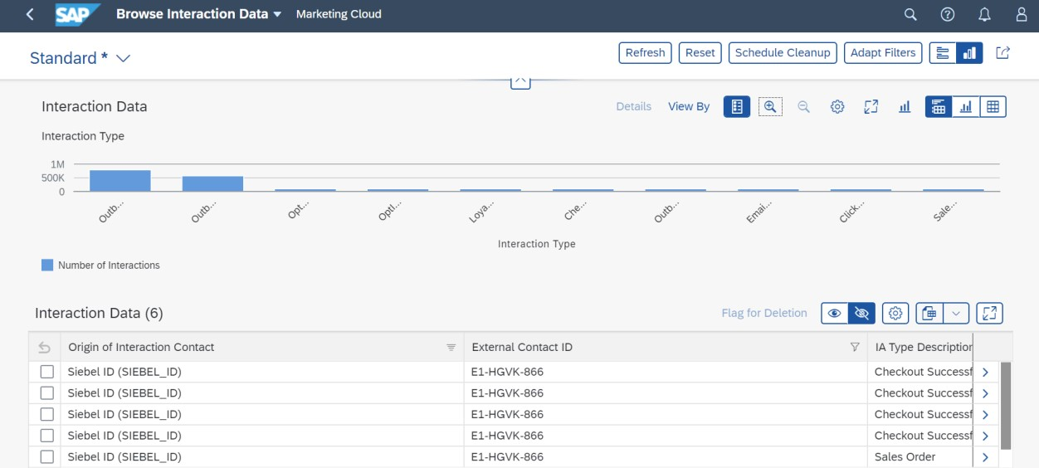
Step 6. Make sure source file has been moved to Archive folder after it has been processed.
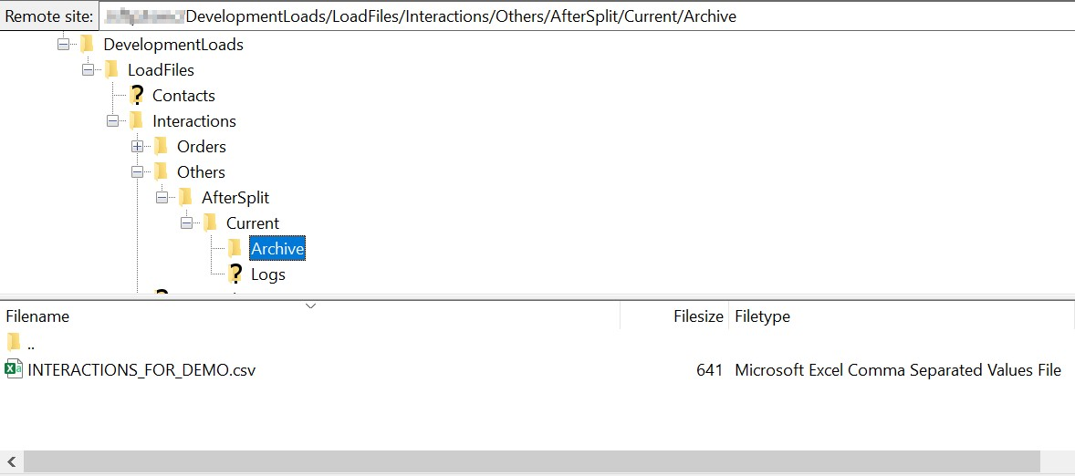

Step 7. Check Logs folder. All response messages in this case were successful. The log folder will create a folder with same name as the source file name and places the OData response for each 1000k packet as shown below. The success on packet 0 indicates that all records from 1 to 1000 in source files are processed successfully and the alpha numeric id after success is the SAP Cloud Integration message id that processed the source file. This audit log is very useful when tracing the errors or reconciling source system files which has millions of records that are split into several 100k files and then further split into 1000 or 2000 packets in SAP Cloud Integration to optimise SAP Cloud OData performance.
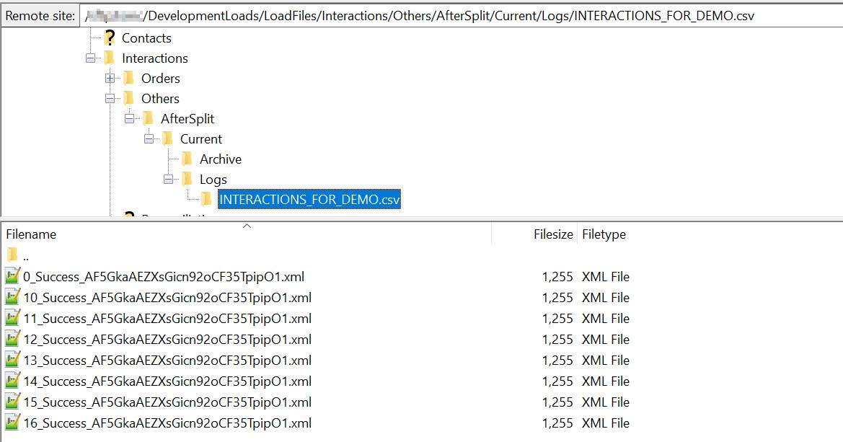
Step 8. Access the Monitor tab (Operations view) on the left side in the navigation for the
"Integration Flow " to see the IFLOW processing status
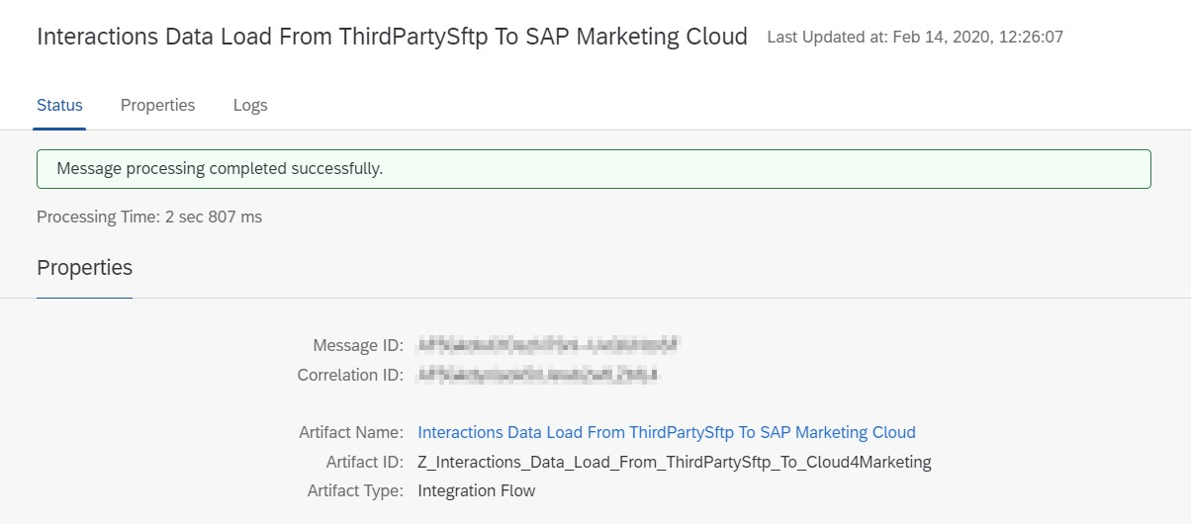
Step 9. To make sure iflow has been processed in the right way - increase log to debug or trace and check detailed log.
