
CONFIDENTIAL

Oitchau Integration

Oitchau Time & Attendance Automatic Payroll Integration with SuccessFactors.

Change History

Version | Date | Author | Comments
0.1 | Oct 12, 2021 | Avi Zrachya | Initial Information

Contents
Change History 2
Overview of the Integration / Extension solution 3
Business Value Proposition 3
Functional Overview 3
Technical Overview 8
EC to OiTchau 8
OiTchau to ECP 16
Absences 16
Configurations 17
Credentials 17
Results 18
Configurations 19
Credentials 19
Job Schedule 20
Employee Central Payroll 20
ECP Basic Permissions 20
RFC Details 20
Prerequistes 22
Support Process 23
Appendix 24

Overview of the Integration / Extension solution

Employees from SAP to OiTchau
Organizational structure data from SAP to OiTchau
Absences & vacations from OiTchau to SAP
Payroll data from OiTchau to SAP

Business Value Proposition

The integration between SAP and Oitchau is aimed to reduce manual work, avoid input errors, and streamline the process for the hr department. Oitchau brings the BEST-IN-CLASS mobile platform suitable both for office, home office and distributed workforce scenario seamlessly integrating the data with successfactors.

Functional Overview

SOLICITATION

Perform the employee hiring process, mapping and using the mandatory fields only (currently mapped).

COMMENTS – CONSULTANT (RESUME)

Take the prints of the complete hiring process of an employee (filling in the required fields) and validate the process by accessing the profile of the hired employee.

PROCESS DEMONSTRATION

The process of hiring a user in the SF EC
Started on the home screen, typing in the top search menu "Add new employee", and clicking on the "Add new Employee" drop-down menu option:

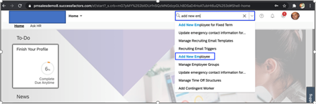

After filling all the mandatory fields and complete the process, the employee is created:

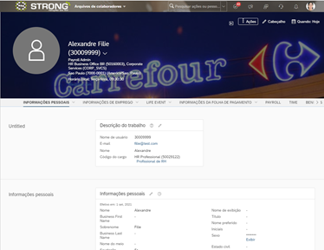

After the hiring process, there is an interface to replicate the employee to ECP:

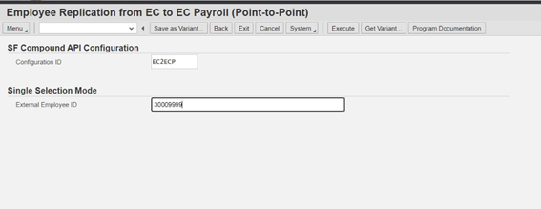
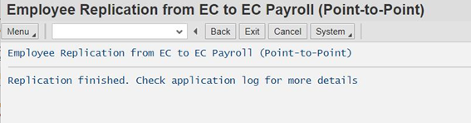
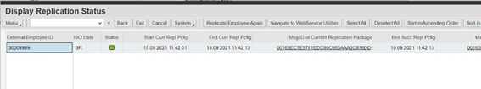
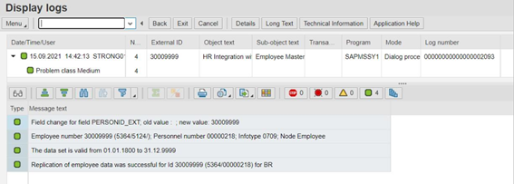
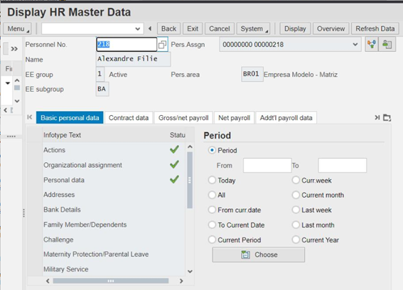
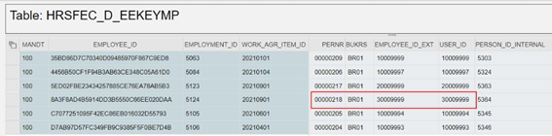

Absence integration with SAP

Each approved absence request is reported to SAP on daily bases.

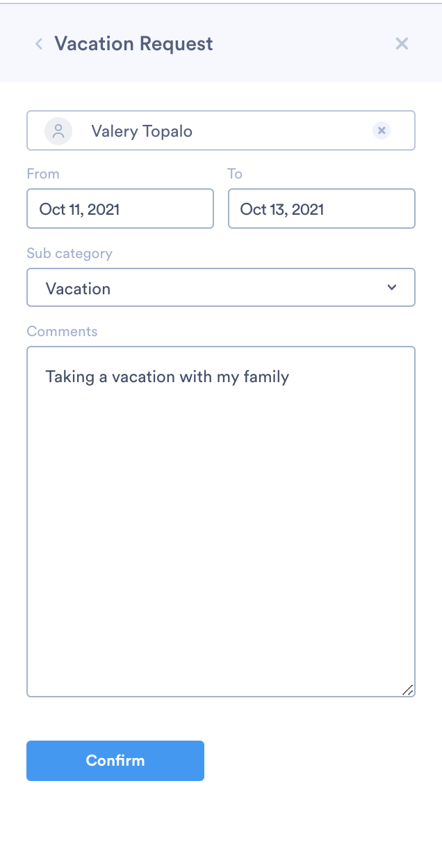
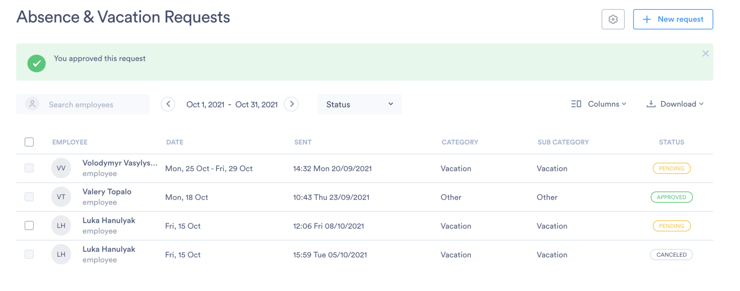

Oitchau payroll integration with SAP

Each period lock is reported to SAP with payroll information including wedge types and absences.

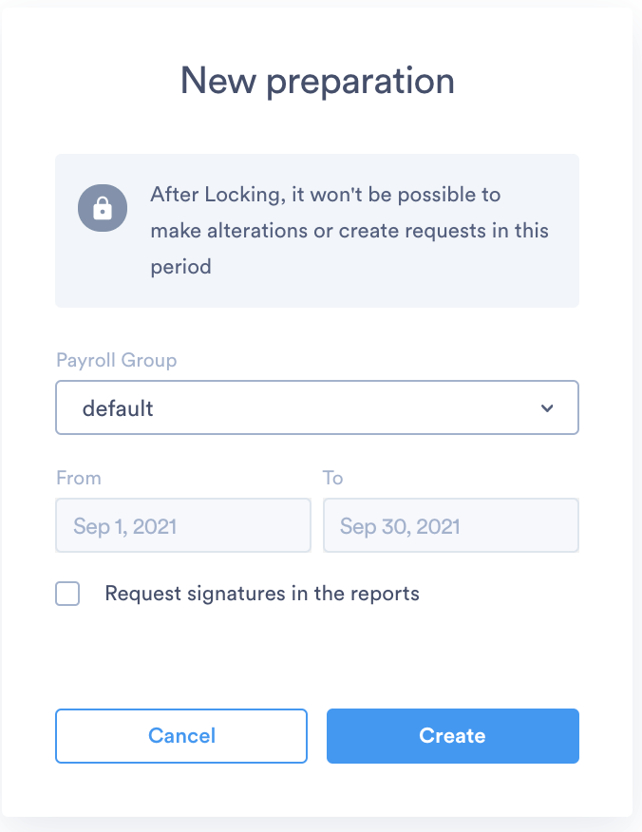
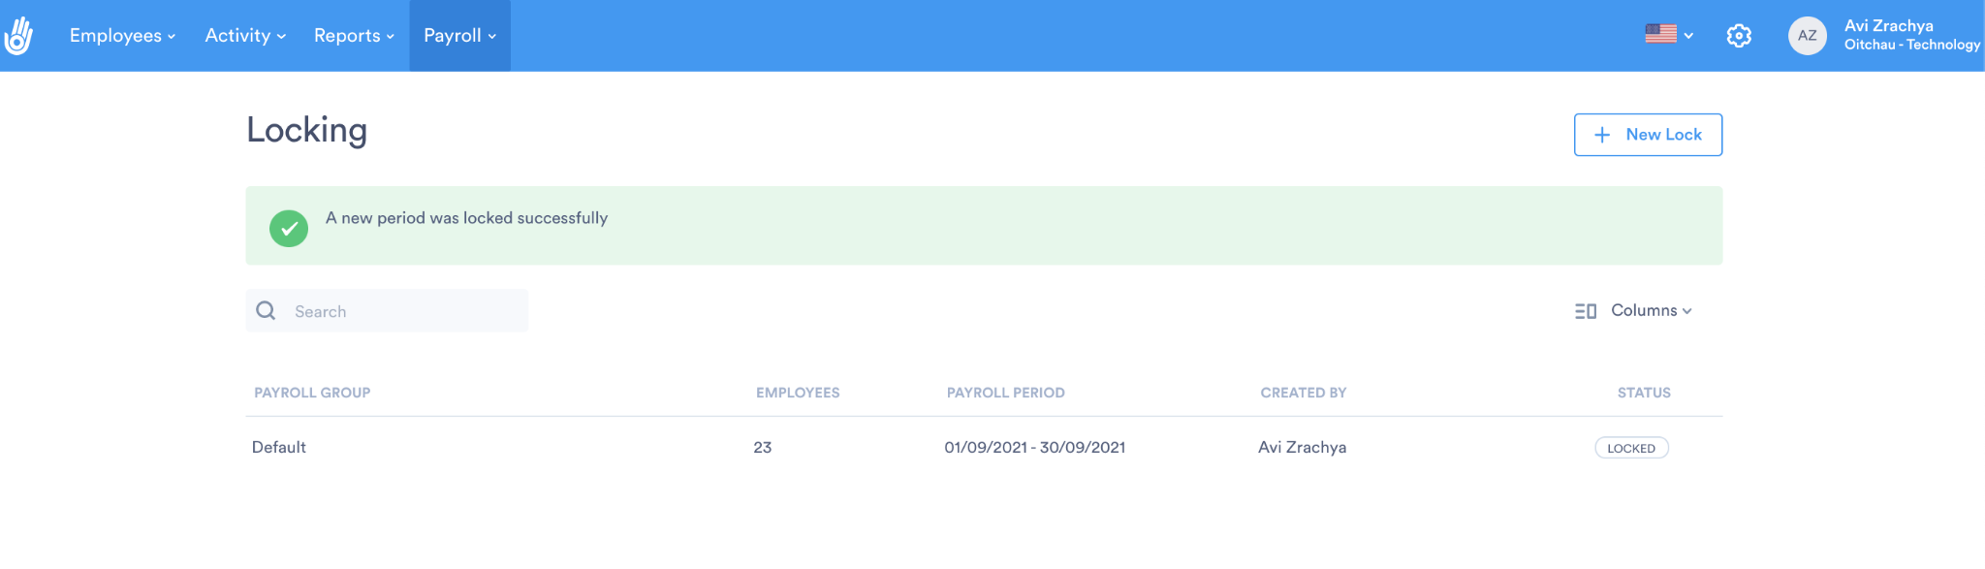

Technical Overview

Three process integrations were created to connect EC x OiTchau / OiTchau x ECP and integrate employee data.

EC to OiTchau

iFlows : CPI_OiTchau_In_EC_Out_Employees and CPI_OiTchau_Request (ProcessDirect)
Package : OiTchau

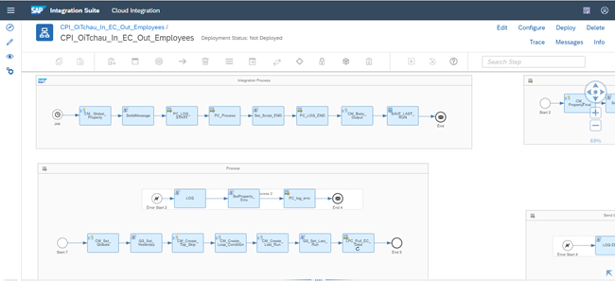
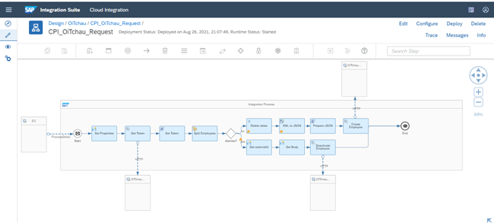
The above flow is scheduled as a job and searches for employees changes in EC via SuccessFactors adapter in EmpJob entity.

SF EC returns employee data in XML format:

CPI maps the required fields expected by OiTchau and send it in JSON format:

List of OiTchau API’s Used

Employee’s API (Create)
Method : POST
Address : https://stg-api.oitchau.com.br/v2/public/integrations_api/employees

Employee’s API (Deactive)
Method : POST
Address : https://stg-api.oitchau.com.br/v2/public/integrations_api/deactivate_employees

Documentation:
https://documenter.getpostman.com/view/5360515/SWE3bJeT?version=latest#703c1ecc-47aa-4dd3-b3c1-7ebb5e5b4f90

Job scheduler:
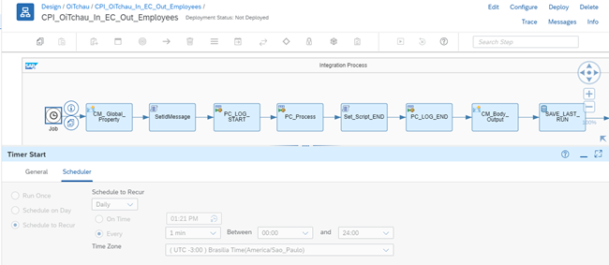
Configurations - CPI_OiTchau_In_EC_Out_Employees

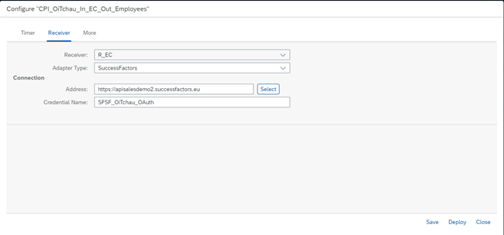
Receiver : R_EC
Adapter Type : SuccessFactors
Address : https://apisalesdemo2.successfactors.eu
Credential Name : SFSF_OiTchau_OAuth

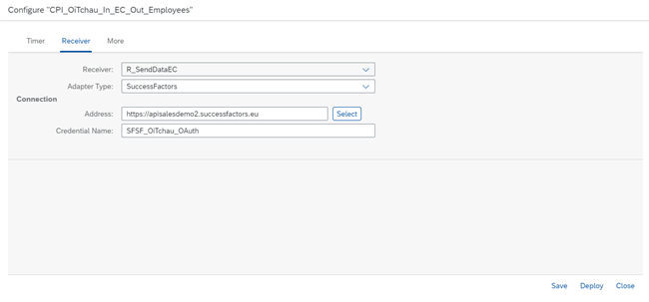
Receiver : R_SendDataEC
Adapter Type : SuccessFactors
Address : https://apisalesdemo2.successfactors.eu
Credential Name : SFSF_OiTchau_OAuth
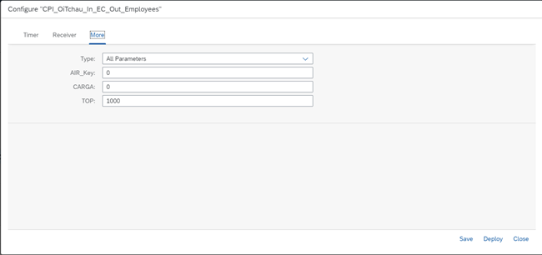Type : All Parameters
AIR_Key : d4jtexcz
CARGA : 0 (send only delta)
TOP : 1000

Configurations - CPI_OiTchau_Request

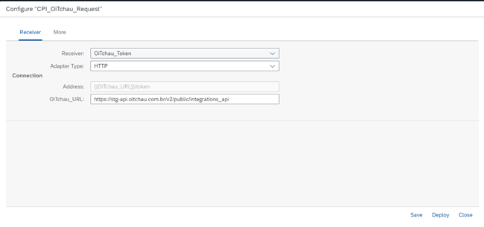
Receiver : OiTchau_Token
Adapter Type : HTTP
OiTchau_URL : https://stg-api.oitchau.com.br/v2/public/integrations_api

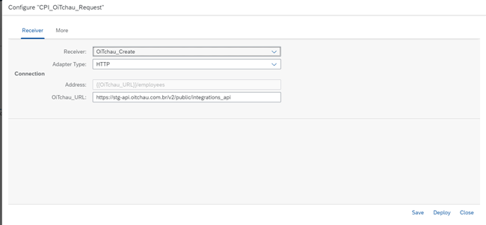
Receiver : OiTchau_Create
Adapter Type : HTTP
OiTchau_URL : https://stg-api.oitchau.com.br/v2/public/integrations_api
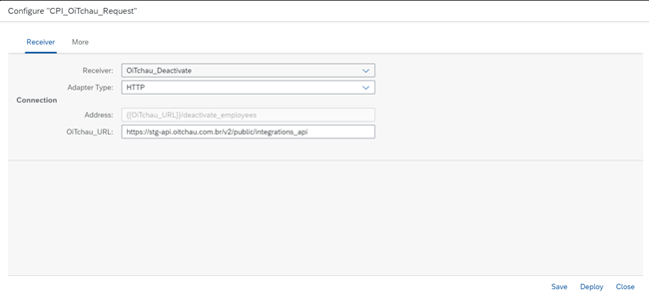
Receiver : OiTchau_Deactivate
Adapter Type : HTTP
OiTchau_URL : https://stg-api.oitchau.com.br/v2/public/integrations_api

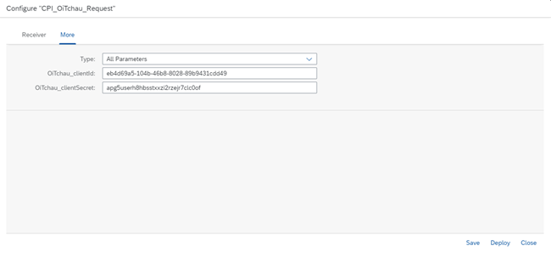
Type : All Parameters
OiTchau_clientId : eb4d69a5-104b-46b8-8028-89b9431cdd49
OiTchau_clientSecret : apg5userh8hbsstxxzi2rzejr7clc0of

Key Pair

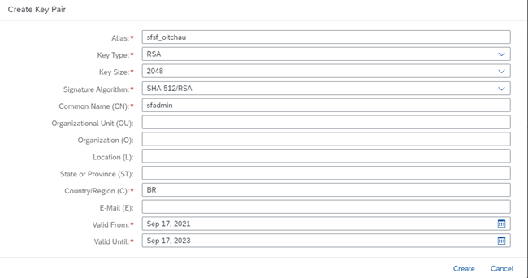
Alias : sfsf_oitchau
Key Type : RSA
Key Size : 2048
Signatura Algorithm : SHA-512/RSA
Common Name (CN) : sfadmin (SFSF user)
Country/Region : BR

Reference:
https://blogs.sap.com/2021/03/26/sap-cloud-integration-oauth2-saml-bearer-x.509-certificate-authentication-support-in-successfactors-connector/

OAuth2 client in SAP SuccessFactors

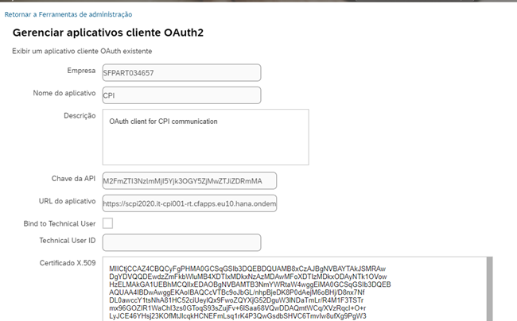

Credentials

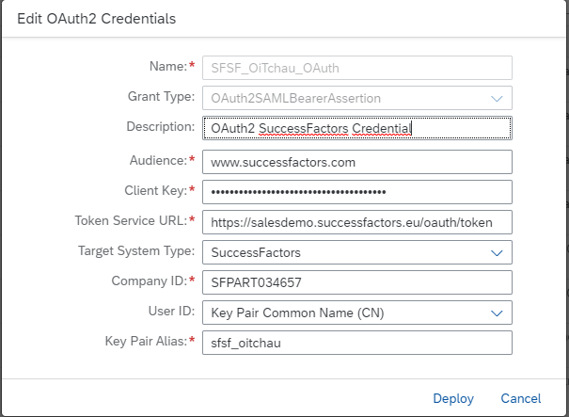
Name : SFSF_OiTchau_OAuth
Grant Type : OAuth2SAMLBearerAssertion
Audience : www.successfactors.com
Client Key : M2FmZTI3NzlmMjI5Yjk3OGY5ZjMwZTJiZDRmMA (generated by SF)
Token Service URL : https://salesdemo.successfactors.eu/oauth/token
Target System Type : SuccessFactors
Company ID : SFPART034657
User ID : Key Pair Common Name (CN)
Key Pair Alias : sfsf_oitchau

OiTchau to ECP

Absences

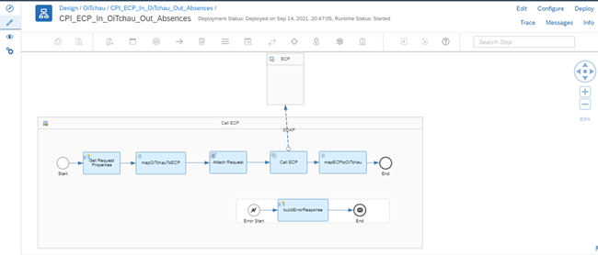
iFlow : CPI_ECP_In_OiTchau_Out_Absences
Package : OiTchau

The CPI flow is a HTTPS endpoint and receives OiTchau request and forward it to ECP via SOAP Adapter, calling the RFC ZHR_FGRP_0001.

OiTchau sends absences data in JSON format:
{
"request": {
"absences": [{
"externalId": "10009999",
"startDate": "2021-07-21",
"endDate": "2021-07-21",
"startTime": "09:00:00",
"endTime": "11:00:00",
"type": "0360"
}
]}
}

CPI maps required fields to ECP and send it in XML format:
<ns1:ZHR_FGRP_0001 xmlns:ns1="urn:sap-com:document:sap:rfc:functions">
<P2001>
<item>
<PERNR>10009999</PERNR>
<INFTY>2001</INFTY>
<SUBTY>0360</SUBTY>
<ENDDA>2021-07-21</ENDDA>
<BEGDA>2021-07-21</BEGDA>
<BEGUZ>09:00:00</BEGUZ>
<ENDUZ>11:00:00</ENDUZ>
<AWART>0360</AWART>
</item>
</P2001>
<TP_OP>I</TP_OP>
</ns1:ZHR_FGRP_0001>

URL CPI : https://scpi2020.it-cpi001-rt.cfapps.eu10.hana.ondemand.com/http/oitchau/absences
Connection Type : Internet
Method : POST
Authentication Type : Basic
Username : sb-4deabd6f-ff08-4e5a-a874-ec4ab2993538!b61481|it-rt-scpi2020!b16077

Configurations

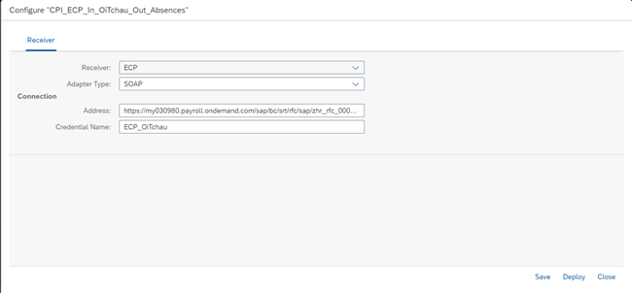
Receiver : ECP
Adapter Type : SOAP
Address : https://my030980.payroll.ondemand.com/sap/bc/srt/rfc/sap/zhr_rfc_0001/100/zhr_rfc_0001/zhr_rfc_0001
Credential Name : ECP_OiTchau

Credentials

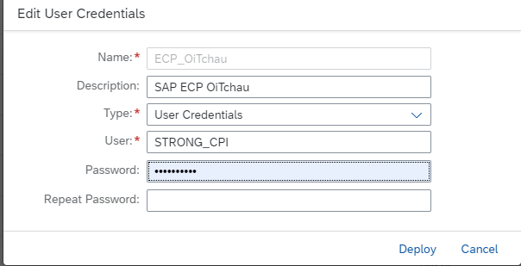
Name : ECP_OiTchau
Type : User Credentials
User : STRONG_CPI

Oitchau System

Enable SAP integration via support ticket.

Results

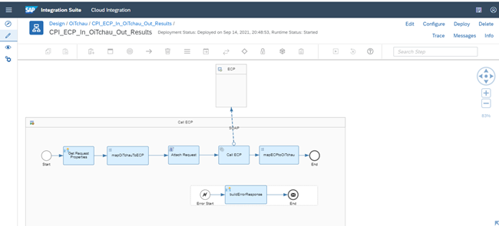
iFlow : CPI_ECP_In_PontoWEB_Out_Resultados
Package : Interfaces PontoWEB

The above flow is a HTTPS endpoint and receives OiTchau request and forward it to ECP via SOAP Adapter, calling the RFC ZHR_FGRP_0001.

OiTchau sends results data in JSON format:
{
"request": {
"results": [{
"externalId": "10009999",
"startDate": "2021-07-21",
"endDate": "2021-07-21",
"wageType": "1100",
"quantityHours": "8.5"
}
]}
}

CI maps required fields to ECP and send it in XML format:

<ns1:ZHR_FGRP_0001 xmlns:ns1="urn:sap-com:document:sap:rfc:functions">
<P2010>
<item>
<PERNR>10009999</PERNR>
<INFTY>2010</INFTY>
<SUBTY>1100</SUBTY>
<ENDDA>2021-07-21</ENDDA>
<BEGDA>2021-07-21</BEGDA>
<LGART>1100</LGART>
<ANZHL>8.5</ANZHL>
</item>
</P2010>
<TP_OP>I</TP_OP>
</ns1:ZHR_FGRP_0001>

URL CPI : https://scpi2020.it-cpi001-rt.cfapps.eu10.hana.ondemand.com/http/oitchau/results
Connection Type : Internet
Method : POST
Authentication Type : Basic
Username : sb-4deabd6f-ff08-4e5a-a874-ec4ab2993538!b61481|it-rt-scpi2020!b16077

Configurations

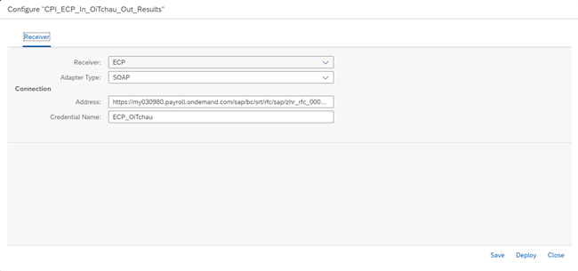
Receiver : ECP
Adapter Type : SOAP
Address : https://my030980.payroll.ondemand.com/sap/bc/srt/rfc/sap/zhr_rfc_0001/100/zhr_rfc_0001/zhr_rfc_0001
Credential Name : ECP_OiTchau

Credentials

Name : ECP_OiTchau
Type : User Credentials
User : STRONG_CPI

Job Schedule

Both integration job scheduling, “EC to OiTchau” and “OiTchau to ECP”, can be customized following the specific process needs of the customer, however, we recommend scheduling this integration to execute at least in a daily basis.

Employee Central Payroll

ECP Basic Permissions

The basic authorization objects are necessary for the correct integration processing, allowing CPI to make changes into ECP through the RFC call. Please check out below our basic recommendation:

RECOMENDED
P_APPL (HR: Applicants)
P_ORGIN (HR: Master Data)
P_ORGXX (HR: Master Data – Extended Check)
P_PERNR (HR: Master Data – Check by Personnel Number)
P_TCODE (HR TRANSACTION CODE)
PLOG (Personnel Planning)

OPTIONAL
P_ABAP (HR: Reporting)
P_ORGINCON (HR: Master Data with Context)
P_ORGXXCON (HR: Master Data - Extended Check with Context)
SU53 (Evaluate Authorization Check)

Using these authorizations object, the integration will be able to make changes on ECP infotypes, since the RFC is programmed to execute this kind of operation.

Considering this documentation (topics above), the infotypes 2001 and 2010 were changed during the integration.

RFC Details

The RFC ZHR_FGRP_0001 (SAP function module) was developed to maintain infotype data, focusing on the infotypes 2001 (absences) and 2010 (results). Check further tech details below:

Attributes

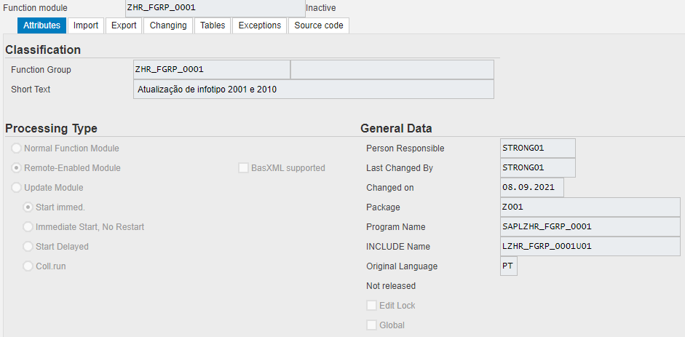

Import Parameters

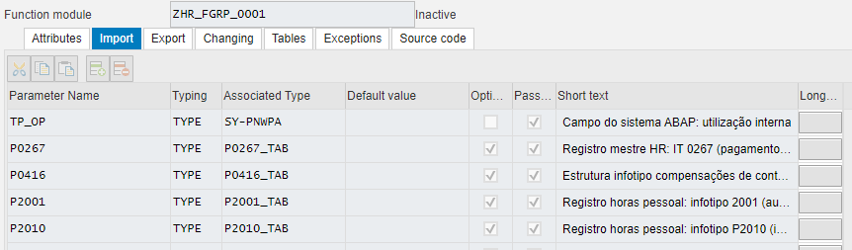

Export Parameters

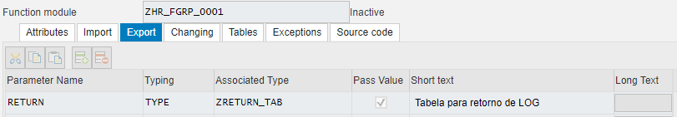

Source Code

Prerequistes
N/A

License Requirements
In order to use the integration, you need to be an active Oitchau client

Technologies
N/A

API Setup‘s
N/A

Configuration / Set up
The solution SAP-SFSF is necessary to have SAP-SCP and also ECP. The configuration of both system are describe in the section Functional Overview and Technical Overview.

FAQs / Troubleshooting tips and tricks
For the SAP support you should consult the SAP Partner Edge.

Support Process

KB for partners
The knowledgebase is available on ​​https://help.oitchau.com.br/

You may open a new ticket by simple emailing suporte@oitchau.com.br

For our customers we provide live chat solution from within ou platform and for VIP support users we also provide a dedicated account manager with whatsapp communication.

Contact Information

Name | Role | Contact
Kauer  Renata  Paulo  Charlie | Head of CS  Onboarding Executive  CS Executive  CS Executive | kauer@oitchau.com.br  renata@oitchau.com.br  paulo@oitchau.com.br  charlie@oitchau.com.br

Professional Services Contact

Name | Role | Contact
<Contact name> | <Designation> | <e-mail ID>  Add rows and columns as required. [Delete this]

Test cases
<Enter the Test case with results>

Case No | Test Case  description | Result | Comments
1.
a.
b.
c. …

2.  a.  b.  c. … |  |  | 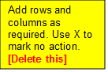

Appendix

List Of API‘s Used
Please check the technical details topic.

Sample API calls
Please check the technical details topic.

Operation | Please check the technical details topic.
URI | Please check the technical details topic.
Payload | Please check the technical details topic.

Extra Details
N/A

