

[Contacts Data Load From ThirdPartySftp To SAP Marketing Cloud]

Date: 10/03/2020
Version: 1.0
Author: Oleg Veliks

DOCUMENT CONTROL
Owner | Client contact |  | Status | Date issued
Oleg Veliks | N/A | N/A |  | N/A
Version history log
Version | Description of change | Date | Author
1.0 | Initial version | 10.03.2020 | Oleg Veliks

TABLE OF CONTENTS
1 PURPOSE 3
2 OVERVIEW 4
3 PRE-REQUISITES 5
4 INTEGRATION FLOW CONFIGURATION 6
4.1 Configuration Parameters 6
5 STEPS FOR TESTING THE IFLOW 11

PURPOSE
The purpose of this document is to describe the general configuration steps required to set up the integration flow for migrating millions of Customers from/to third Party systems to SAP C/4 Marketing Cloud Systems. The integration flow provides out of the box capability to consume millions of customers in files of size 100k records from S3 buckets and splits them into smaller OData (5k) Packets and provides full traceability on whether each 1k or 5k packet is processed successfully or failed in SAP C/4 Marketing Cloud System.

This IFLOW is an enhancement of SAP Standard
Content https://api.sap.com/package/SAPHybrisMarketingCloudfilebaseddataload?se ction=Artifacts that will address the following limitations of the standard content:
- The error handling capability delivered in the standard integration triggers alerts via e-mail which is really not a good use case for complex large volume migration projects unless someone wants to jam their inbox with millions of error e-mail alerts.
- There is no mechanism for full audit logging of what packets failed and what packets are successfully sent to marketing cloud for each file. Imagine a scenario where we need to migrate 20 million customers that are split into 200 files of 100k records and split into 2000k packet for each OData call to optimize performance and client want to have full traceability to extract files to understand what records failed and what records are processed successfully in SAP C/4 Marketing Cloud System for each file.
- There is no standard SAP Cloud Integration mechanism to automatically move the error files to error folder. Due to that limitation, the files are reprocessed in the next run by the SAP Cloud Integration IFLOW resulting in many message failures in SAP Cloud Integration and also adversely effecting performance.

In this IFLOW, the error logs for each packet of source files are written in AWS S3 buckets.

OVERVIEW
This Integration Flow reads millions of customers from AWS S3 Buckets (100k records for each file) and splits them into 5K or 1k OData API packets before sending data to the SAP Marketing Cloud Systems (5k OData Packet).
Please check the below diagram to understand the end-to-end process.
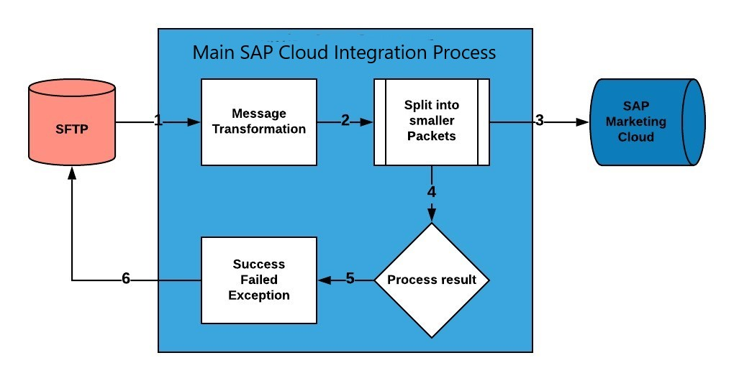
Step 1. The file is uploaded on AWS S3 bucket and AWS SFTP service is set up to read and write files into S3 via SFTP.
Step 2. SAP Cloud Integration Integration Flow splits 100k files into smaller OData API packets.
Step 3. SAP Cloud Integration Integration Flow Sends OData packets one by one to SAP Marketing Cloud.
Step 4. SAP Cloud Integration Integration Flow analyses the SAP Marketing Cloud response of each packet.
Step 5. SAP Cloud Integration generates the log for each packet of each file indicating which packet of the file is successful and which packet is failed. A log folder is created with same name as “source file name” for each file and response of each packet of the file is stored in the AWS S3 with a prefix <PacketNumber_Success/Failure> to easily find out whether a packet is failed or successful for every file that is loaded.
Step 6. The file is automatically moved into error folder if there is an error in processing the full file else it is moved into an archive folder.

PRE-REQUISITES
Before configuring Integration Flow, please make sure the following prerequisites have been met:

1. The SAP HANA Cloud Platform Integration has been delivered.
a. SAP HANA Cloud Platform Integration - https://www.sap.com/products/hana-cloud-integration.html https://cloudplatform.sap.com/index.html
- Amazon Web Services account is enabled. S3 bucket is created and SFTP Transfer server is up and running. S3 bucket is a root directory of SFTP.
- SFTP server is configured and connectivity between SAP Cloud Integration tenant and SFTP is established. SFTP user having permissions to create and update folders and files.

INTEGRATION FLOW CONFIGURATION

Configuration Parameters

Externalized  Parameter Name | Description | Sample Value
Sender (Directory  ) | Root SFTP directory. A source directory of SFTP server. | DevelopmentLoads/LoadFiles/Contacts/C4M/  AfterSplit/Current
Sender  (FileName) | Source File Name on SFTP server. A file from where to load data. | test_contacts.csv
Sender (Address) | SFTP server host name. | xxx.server.transfer.eu-west-2.amazonaws.com
Sender (User Name) | SFTP User Name. SFTP user which has access to SFTP directories. | CPI_USER_PROD
Sender (Timeout) | Maximum waiting time to contact the FTP server while  establishing connection  or performing a read operation. | 10000
Sender  Processing (Lock  Timeout) | How long to wait before trying to process the file again. | 20
Sender (Change  Directories  Stepwise) | Changes  directory | true

 | levels one at a time
Sender (Post-  Processing) | Controls  which actions should be done after file processing. | Move File
Sender (Archive  Directory) | Specifies the directory and the file name when moving the file after processing. | ${property.archiveDirectory}/${property.origFil eName}
Sender (Buffer  size) | Write the file content using the mentioned buffer size. | 128
Sender (Max. Messages per  Poll) | Maximum number of messages to gather for each poll. | 50
Receiver - SAPMkt (Address) | Service root URL of the OData service provider. | {{SAP_Mkt_Host}}/sap/opu/odata/SAP/API_MK T_CONTACT_SRV;v=0002
Receiver - SAPMkt (SAP_Mkt_Host) | Host address of SAP  Marketing  Cloud | https://myxxx.s4hana.ondemand.com
Receiver - SAPMkt (Authentication) | Authenticatio  n type of OData service for SAP  Marketing  Cloud | Basic
Receiver - SAPMkt  (Credential  Name) | Credential  name to connect to | KTAPIUSER

 | the system as deployed in the tenant.
Receiver - SAPMkt (Timeout) | Maximum time system waits before termination. | 10
Receiver -  AWS_SFTP  (Address) | Host name or IP address and port of the SFTP server. | xxx.server.transfer.eu-west-2.amazonaws.com
Receiver -  AWS_SFTP (User  Name) | ID of the user performing file transfer. | CPI_USER_PROD
Receiver -  AWS_SFTP_LOG  (Directory) | File path from where log files should be written. | DevelopmentLoads/LoadFiles/Contacts/C4M/  AfterSplit/Current/Error
Receiver -  AWS_SFTP_LOG  (File Name) | Name of the file name to be written. | error_log.csv
Receiver -  AWS_SFTP_LOG  (Address) | Host name or IP address and port of the SFTP server. | xxx.server.transfer.eu-west-2.amazonaws.com
Receiver -  AWS_SFTP_LOG  (User Name) | ID of the user performing file transfer. | CPI_USER_PROD
More (Splitter  Concurrent  Processes) | This  configuration parameter is used to split the file into  multiple  OData  packets . If the packet size is 5000 then 5000  interactions | 5

will be sent to marketing system in one
API Call
More (Path to  Exception Log) | Path on FTP server where to write  exception logs | DevelopmentLoads/LoadFiles/Contacts/C4M/ AfterSplit/Current/Logs/  ${property.origFileName}/${property.CamelSpl itIndex}_Exception_${property.SAP_Messag eProcessingLogID}.xml
More (Path to  Failure Log) | Path on FTP server where to write error  logs | DevelopmentLoads/LoadFiles/Contacts/C4M/ AfterSplit/Current/Logs/  ${property.origFileName}/${property.CamelSpl itIndex}_Failure_${property.SAP_MessageProce ssingLogID}.xml
More (XML  Converter - XSD  Path) | Path to Target  Element in  XSD | CSV_Contacts/Contact
More (Path to  Successful logs) | Path on FTP server where to write logs of successfully processed records | DevelopmentLoads/LoadFiles/Contacts/C4M/ AfterSplit/Current/Logs/  ${property.origFileName}/${property.CamelSpl itIndex}_Success_${property.SAP_MessageProc essingLogID}.xml
More (Splitter  Timeout) | Maximum waiting time to contact the FTP server while  establishing connection or performing a write operation. | 10800
More (Splitter  Packet Size) | This  configuration parameter is used to split the file into  multiple  OData  packets . If the packet size is 5000 then 5000 | 5000

interactions
will be sent to marketing system in one
API Call
More (XPath  Expression) | Xpath expression to navigate to the split item using absolute path. | /CSV_Contacts/Contact

STEPS FOR TESTING THE IFLOW
Step 1. Access the WEB UI URL on your SAP Cloud Platform Integration tenant.
It should be in the format https://.hci.us1.hana.ondemand.com/itspaces
Step 2. Place the file in the SFTP server using Filezilla or other FTP client in the designed directory
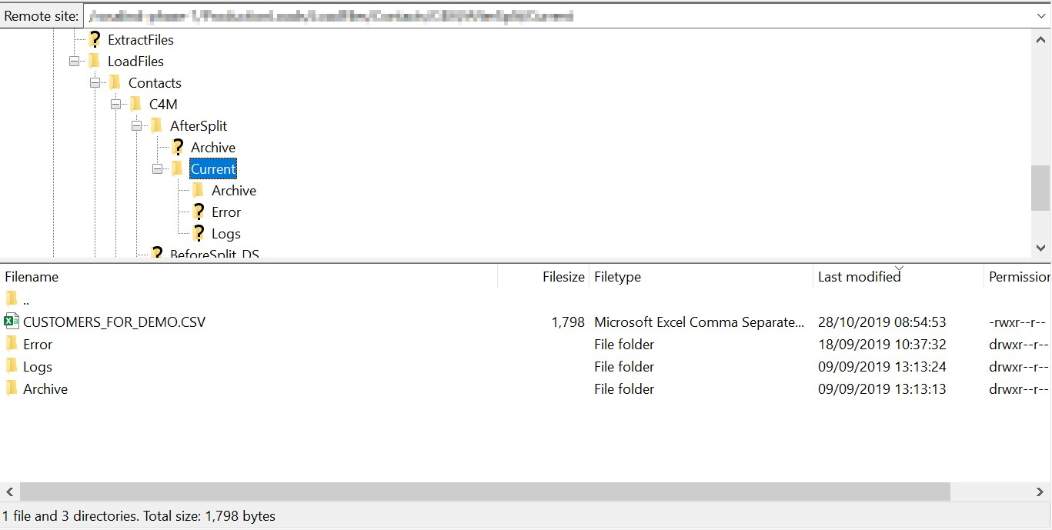
Step 3. Configure iflow with above parameters in step 4 and deploy. The iflow should be deployed.
Step 4. Login to SAP Marketing Cloud and go to Import Monitor app. You should be able to see status of processed message.
If there is a message - fix an error and start process from the beginning.
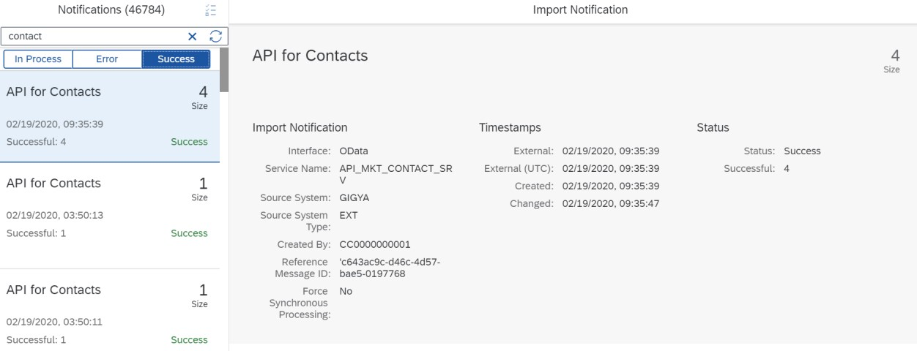
Step 5. Check the customer is created in the SAP Marketing Cloud Using the Fiori App "Inspect Contact"
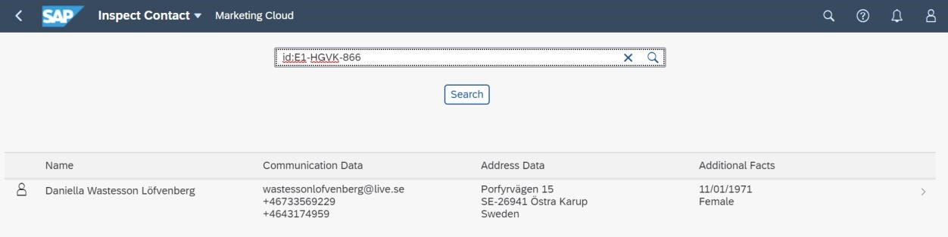
Step 6. Make sure source file has been moved to Archive folder after it has been processed.
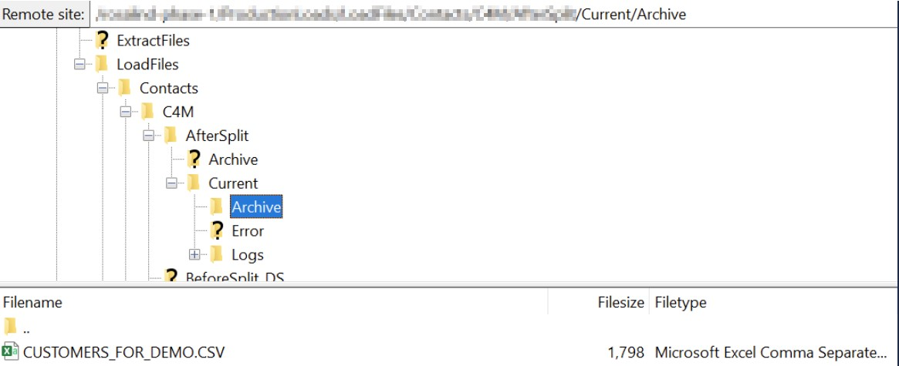
Step 7. Check the AWS SFTP log to see how many packets are successfully processed and how many packets failed.
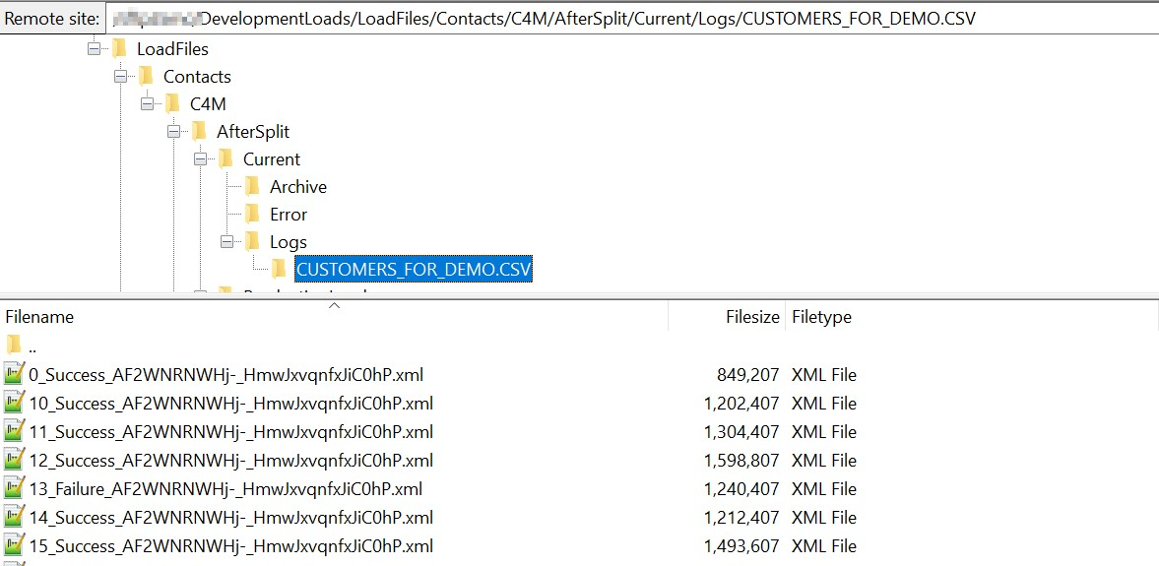
Step 8. Access the Monitor tab (Operations view) on the left side in the navigation for the
"Integration Flow " to see the IFLOW processing status
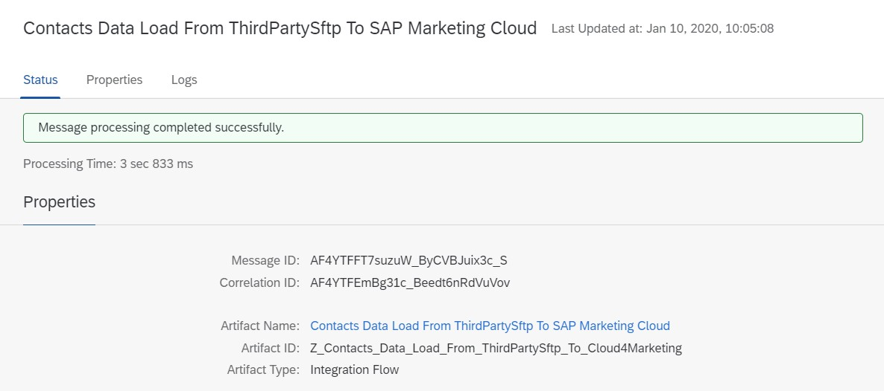
Step 9. To make sure iflow has been processed in the right way - increase log to debug or trace and check detailed log.
