Motivation:
Apart from the configuration parameters that are part of channel configuration or process steps, you want to externalize additional parameters to use during the message processing.
Solution:
Note – this procedure is only possible in the Eclipse UI as of today. I will update this document when the corresponding feature is available on the Web tooling as well.
Add a Content Modifier to the message pipeline. Add a new header and property as follows:
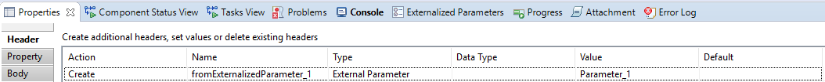

In the above example, the header fromExternalizedParameter_1 takes its value from an external parameter Parameter_1. In the second screenshot, the property fromExternalizedParameter_2 takes its value from external parameter Parameter_2.
The external parameters do not exist before this step, but when the system sees that the header and property take their values from these external parameters, it automatically creates 2 entries in the list of externalized parameters.
Go to the Externalized Parameters view and click on Sync with Editor:
You will see Parameter_1 and Parameter_2 are added as externalized parameters to the integration flow.
They will also be added to the configure page of the integration flow.
Now you can use the value of header fromExternalizedParameter_1 and property fromExternalizedParameter_2 in your integration flow. They value entered by the user to the externalized parameters Parameter_1 and Parameter_2 will be assigned to the corresponding header and property.
Working Integration Flows can be found at:
WebUI Discover View Cloud Integration - Exemplars Artifacts Externalizing Additional Parameter

