Problem:
Your iflow shows the following error message when you try to open it in Eclipse:
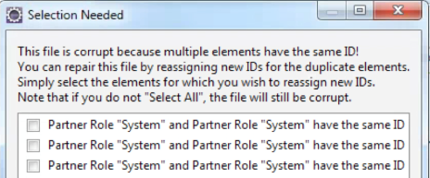

Solution:
Open the iflow file in a text editor and find duplicate entries for the node <bpmn2:parnerRole.
Resolve all duplicate entries by renaming the id and save the file.

