Motivation:
Connecting to a PI Enterprise Service Repository from Eclipse to retrieve artifacts like Message Mapping, Operations Mapping and Interfaces

Solution:
In Eclipse, goto to Windows Preferences SAP HANA Cloud Integration Repository Connection
Maintain the ESR details here:
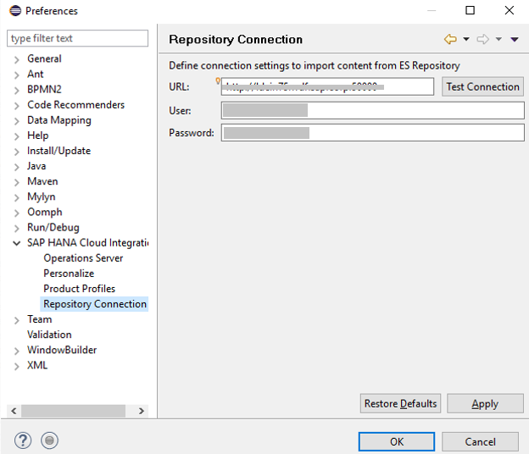
Now in the Project Explorer, right click on the project where you’d like to import content from ESR and click on Import PI Content
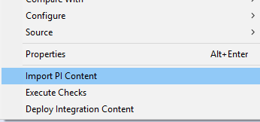
Choose the object you would like to import:
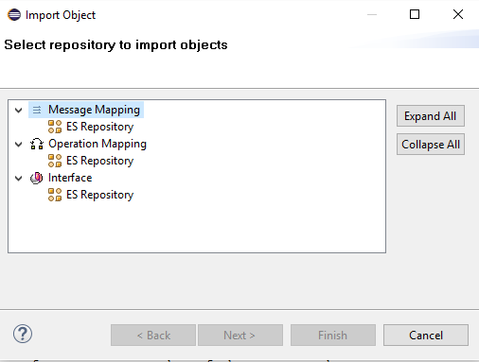

Choose the artifact that you would like to import.
The system shall list all the artifacts in the connected ESR.
Choose the Artifact that you want to import and click Finish.
The artifact will be downloaded to the project along with all the supporting objects.

