API to access monitoring and runtime entities:
Message processing log and other runtime entities can be read using REST based OData APIs. These APIs can be used to render the corresponding information in other applications and interfaces.

The format of the OData API is:
https://<tmn>/api/v1/<Entity>[<ID>]/[Property]?[<filter/select options>]

<tmn> - tenant management node URL
<Entity> - the resource whose information needs to be retrieved. For the list of supported entities, refer to https://uacp2.hana.ondemand.com/viewer/DRAFT/4e2b95bfe5f84915b5e54a6dd9213b46/Cloud/en-US/9e990d5d0a1e438dbb3675d43a8f91c3.html
<ID> - unique identifier of the resource/entity being queried.
Each entity is specified by a number of properties to which filter/select options can also be applied

For examples on how the above API can be used, refer to https://uacp2.hana.ondemand.com/viewer/DRAFT/4e2b95bfe5f84915b5e54a6dd9213b46/Cloud/en-US/cb643921a2ab4a4d8c5f7fc092120811.html
Login used: to access this API, you shall use the same user/password that you use to access the tenant.
Note: The above API only returns the message processing log header and quick link to additional information. Detailed message processing log is not rendered.
Example:
- https://XXXX-tmn.hci.eu1.hana.ondemand.com/api/v1/MessageProcessingLogs gives all the message processing logs on the said tenant:
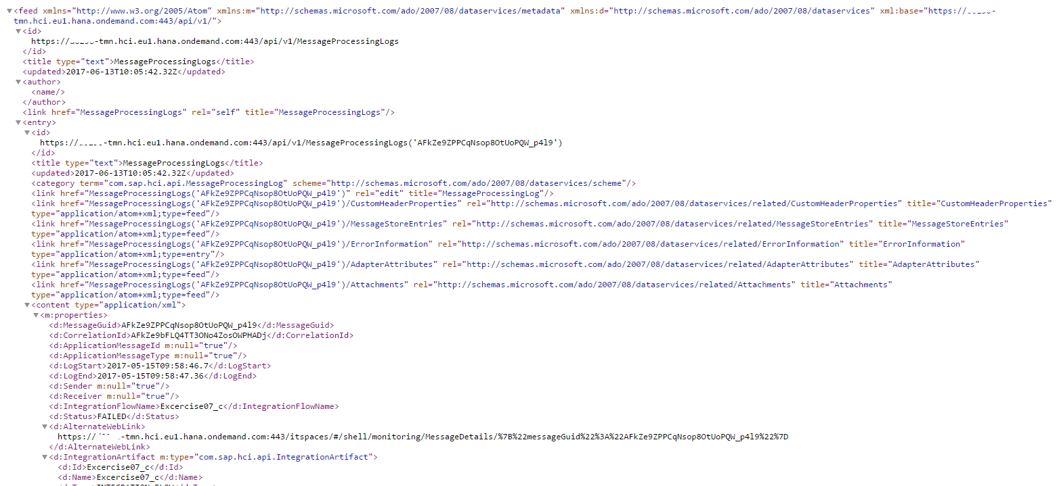

- https://XXXXX-tmn.hci.eu1.hana.ondemand.com/api/v1/MessageProcessingLogs('AFkZe9ZPPCqNsop8OtUoPQW_p4l9') gives all the details about the message processing whose messageGuid is specified:
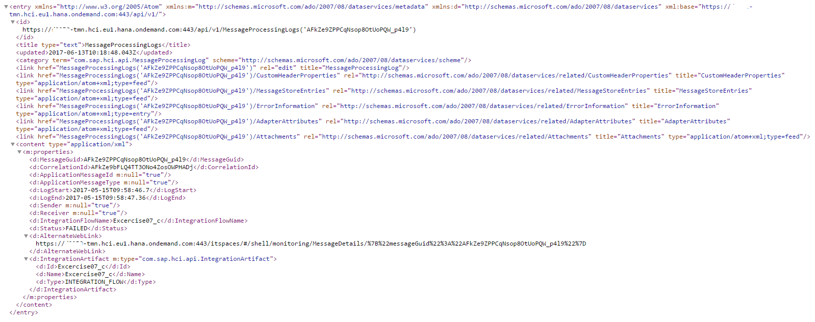

- https://XXXXX-tmn.hci.eu1.hana.ondemand.com/api/v1/IntegrationRuntimeArtifacts gives the list of all the artifacts deployed on the tenant:

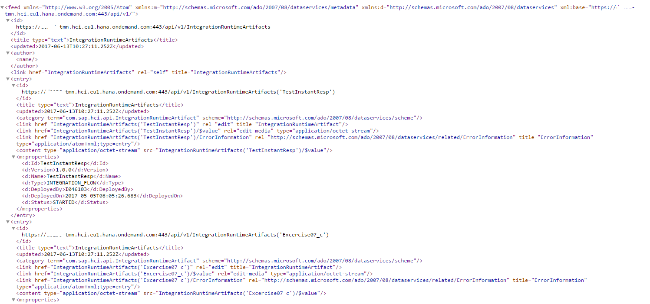

Visit http://www.odata.org to know more about how to construct the query options.

