Motivation:
Following a standard in content layout design fosters ease of maintenance.
Guidelines:
- Always keep the flow direction from left to right. The sender always comes on the left and the receiver on right.
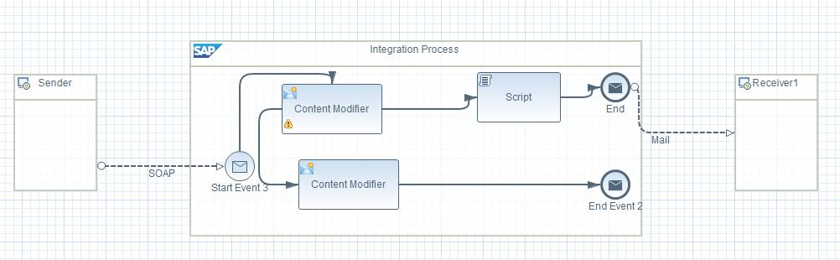
- Try to avoid overlapping sequence flows
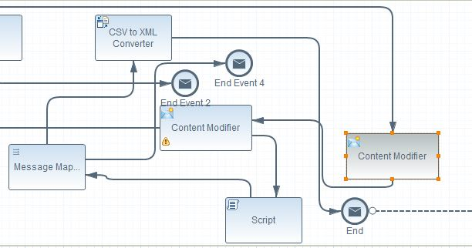
- Avoid kinks (or confusing twist/turns) in the sequence and message flow connectors – try to keep them as straight as possible.
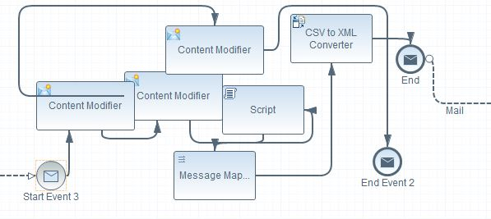
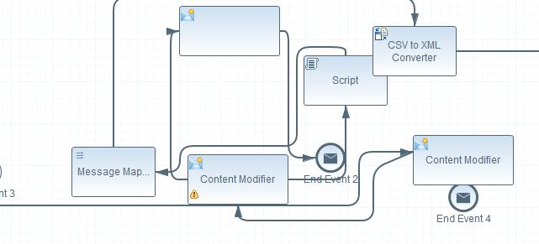
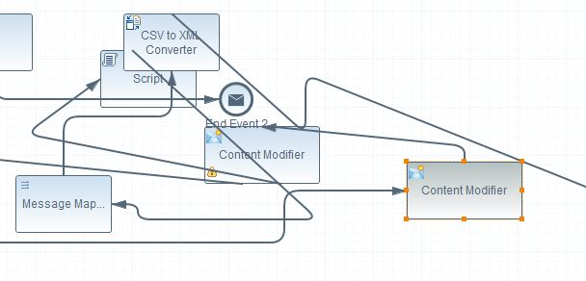
- Avoid overlapping process steps – in case you need many process steps, try expanding the canvas and arrange the process steps neatly.
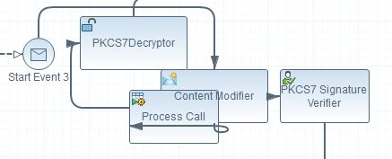
- Modularize wherever possible – in case of complex logics, try to break it down into small, easy to understand modules. Move the logic of each module into a sub-process. Name the sub-process appropriately to describe the module’s operation.
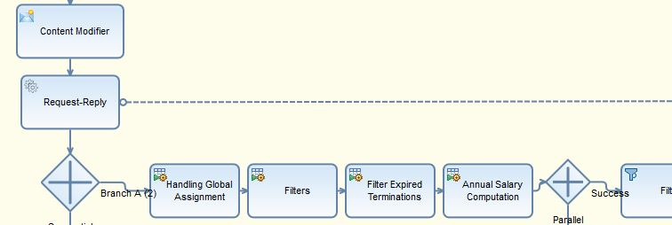

- Do not mix multiple transformations in a single script or sub-process – one sub-process should only contain the logic for one function.
- Undeploy unwanted and unused flow from your tenant.
- Do not assign the whole XML message to a header or a property unless necessary. Clear it once done.

