Credential:
Credential is a means of using user-password in a Cloud Platform Integration process.
You need to use user-password when connecting to a system via basic authentication.
Need for credentials: if user-password is configured as a part of the scenario configuration, even though the password shows as masked characters on the screen, it is stored as plain text in the system. Due to the overhead involved and the corresponding performance implication of storing the entire scenario configuration as encrypted, only sensitive information is stored by the system as encrypted. In order to mark the user-password as sensitive information, we create a special artifact called credentials and deploy it explicitly on the tenant.
Creating a credential artifact:
In order to create a credential, goto the Operations view in your webUI and click on Security Material:
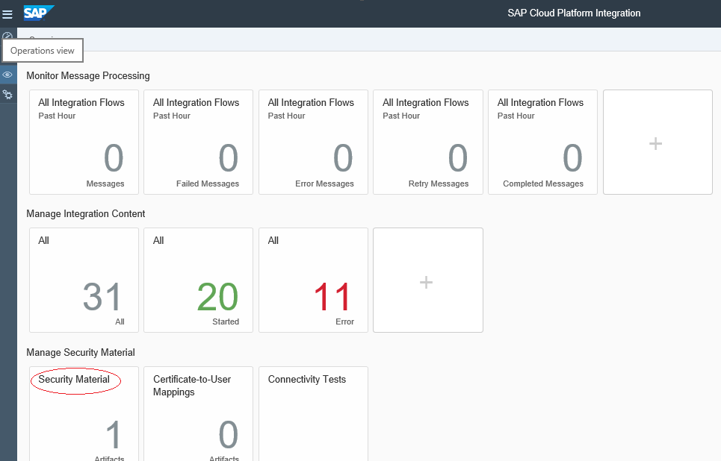
Clicking on Security Material launches the following screen:
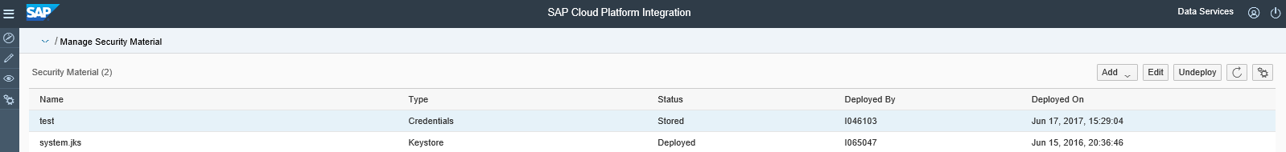

Click on the Add dropdown and select User Credentials:
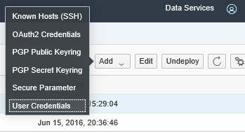
On clicking on User Credentials, the Add User Credential pop-up like the one below comes up:
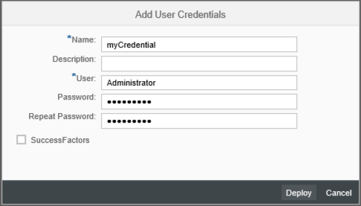
Give a unique name to this credential. User and password field should be filled with the username and password to connect to the backend system. An optional Description can be entered to adds more details to the credential. Click on Deploy to store the credential on the tenant in an encrypted form.

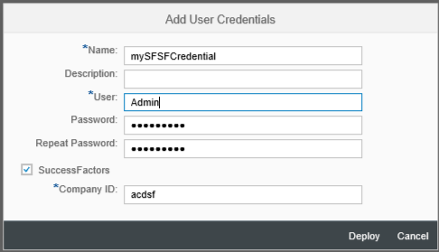
Creating a SuccessFactor credential:
The same procedure can be used to create a SuccessFactor credential. A SuccessFactor credential needs a company ID additionally - click on the SuccessFactor checkbox to enable the Company ID textbox.
Click on Deploy to store the credential on the tenant in an encrypted form.

Using a credential:
In channel configuration, enter the name of the credential (not the user name) in the Credential Name field:
