Set-Up Instructions  English | Customer
SAP AI Business Service Data Attribute Recommendation

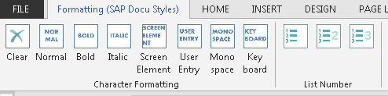

Enable the Formatting ribbon with the SAP Styles by adding the template file SAP_styles.dotm (download here) to your Microsoft Templates folder.
C:\Users\<user ID>\AppData\Roaming\Microsoft\Templates

To add the template, go to Developer > Document Template > Attach
Make sure that macros are enabled.

To view the template instructions, turn on Paragraph Marks.
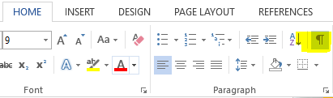
Make sure to use the appropriate style in order to facilitate the efficient, error-free migration to the DITA CMS.

- For user Interface texts use SAP_ScreenElement
- For user input, use SAP_UserEntry.
- For subheadings (Use, Procedure), apply the SAP_KeyblockTitle style
- For tables, use the SAP_StandardTable table format.
- Do not merge cells in tables.
- Do not nest a table within another table.

Typographic Conventions
Type Style | Description
Example | Words or characters quoted from the screen. These include field names, screen titles, pushbuttons labels, menu names, menu paths, and menu options.  Textual cross-references to other documents.
Example | Emphasized words or expressions.
EXAMPLE | Technical names of system objects. These include report names, program names, transaction codes, table names, and key concepts of a programming language when they are surrounded by body text, for example, SELECT and INCLUDE.
Example | Output on the screen. This includes file and directory names and their paths, messages, names of variables and parameters, source text, and names of installation, upgrade and database tools.
Example | Exact user entry. These are words or characters that you enter in the system exactly as they appear in the documentation.
<Example> | Variable user entry. Angle brackets indicate that you replace these words and characters with appropriate entries to make entries in the system.
EXAMPLE | Keys on the keyboard, for example, F2 or ENTER.
Document History
Revision | Date | Change
1.0 | 2020-11-17 | Initial Draft
Table of Contents
1 Purpose 5
2 Prerequisites 6
3 Configuration 7
3.1 User Credentials Setup 7
3.2 Integration Flow Config 9
3.3 Integration Flow Config Mailbox 10
3.4 Integration Flow Config Document Information Extraction Service 11
4 Appendix 12
4.1 Ticket Component 12

Purpose
The purpose of this document is to describe the steps that customer can configure Cloud Platform Integration (CPI) for SAP AI Business Service Data Attribute Recommendation for SFTP integration.

Prerequisites
The customer has purchased the license of Document Attribute recommendation and Cloud Integration Platform. The customer also needs an SFTP-Server for processing the files.

Configuration

User Credentials Setup
Use
This step needs you to access Manage Security Material in order to create the user credentials for Document Attribute Recommendation Service integration and the crendtials for the FTP-Server
Procedure
- Go to Manage Security Material section of Cloud Platform Integration.
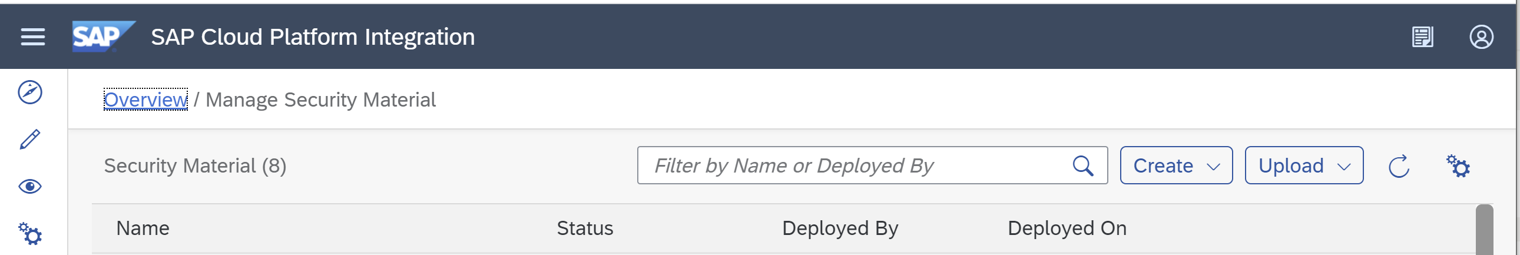

- Click Create and select User Credentials
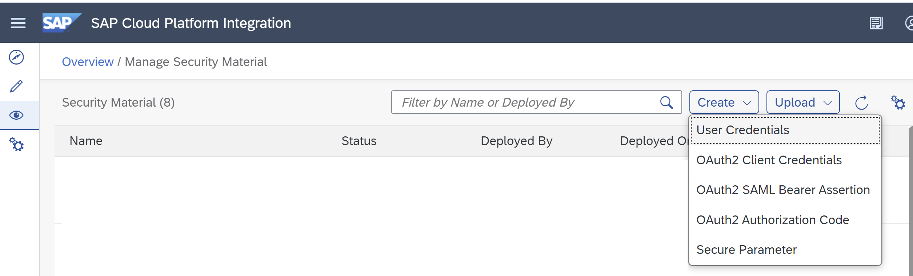.

- Add User Credentials for the Document Attribute Recommendation Service with the following settings and click Deploy
  - Input Name as DAR User.
  - Input Description as DAR Service Key.
  - Select Type as User Credentials.
  - Input User with <clientid> from Document Attribute Recommendation service key JSON file.
  - Input Password with <clientsecret> from Document Attribute Recommendation service key JSON file.

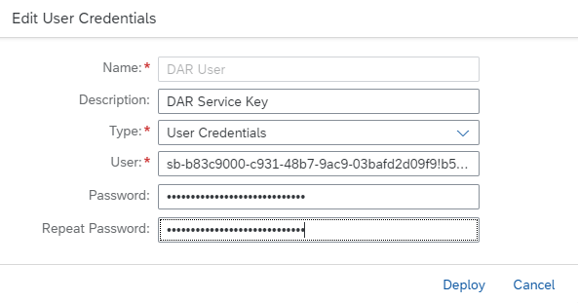

- Add User Credentials for the SFTP-Server with the following settings and click Deploy
  - Input Name as DAR SFTP User.
  - Input Description as SFTP User credentials for DAR.
  - Select Type as User Credentials.
  - Input User with <username> for the SFTP-Server.
  - Input Password with <password> for the SFTP user.
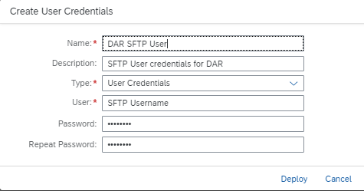

Integration Flow Config
Use
Once the credentials are created, the SAP AI Business Service Data Attribute Recommendation Integration Flows can be further configured.
Procedure
- In Discover section of Cloud Platform Integration and go to Search and write SAP AI Business Service Document Information Extraction and copy the package with name SAP AI Business Service Data Attribute Recommendation

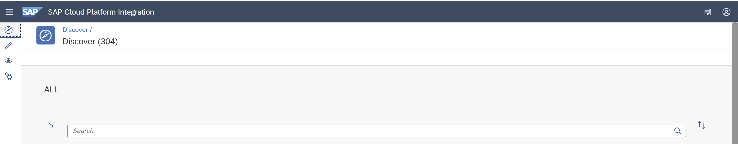

- Once the package is copied, go the Design section and select SAP AI Business Service Data Attribute Recommendation.

- In package SAP AI Business Service Data Attribute Recommendation, you should be able to see 3 integration flow artifacts.

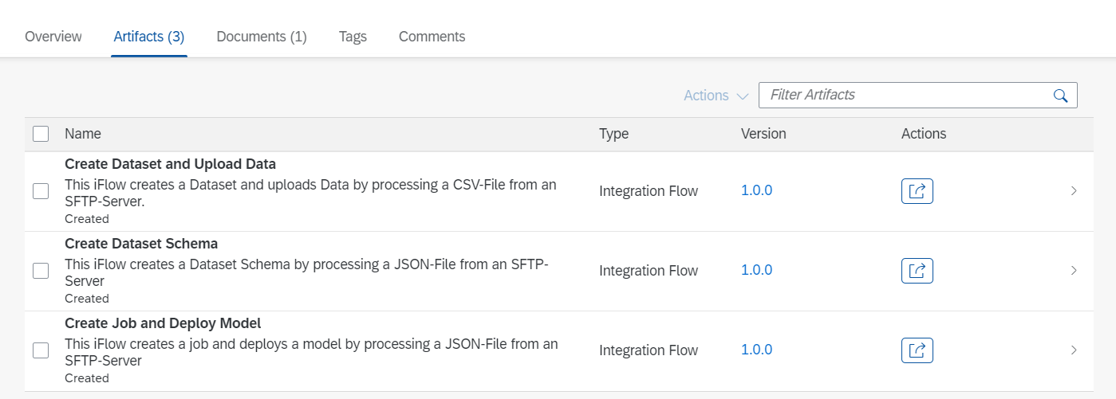
- Select Configure on each Integration Flow and follow the next steps for the configuration parameters
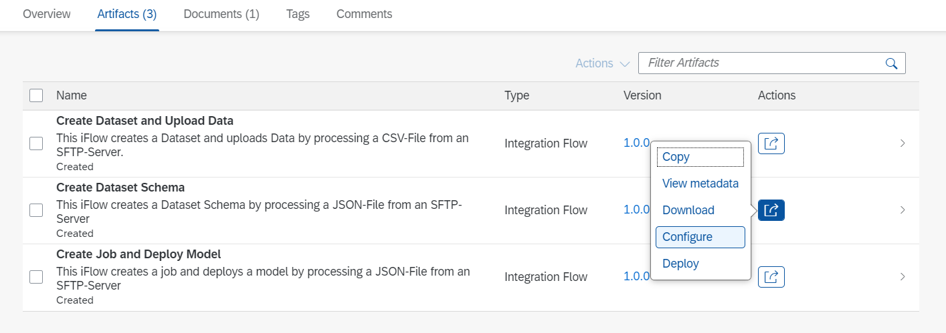

Configure Create Dataset Schema
The Create Dataset Schema Integration Flow creates a Dataset schema based on a JSON input file. You have to configure the following parameters:

- Configure the SFTP_Sender by providing the required information. The Directory property specifies in which directory the JSON Files are located. In the address field the address of the SFTP-Server must be set. As a proxy type you can either use On-Premise and provide the Location ID if necessary or use Internet. For Authentication you can reuse the DAR SFTP User created in step 4 of chapter 3.1. Also, Post-Processing can be configured to specify the operation after a file has been processed by the Integration Flow.

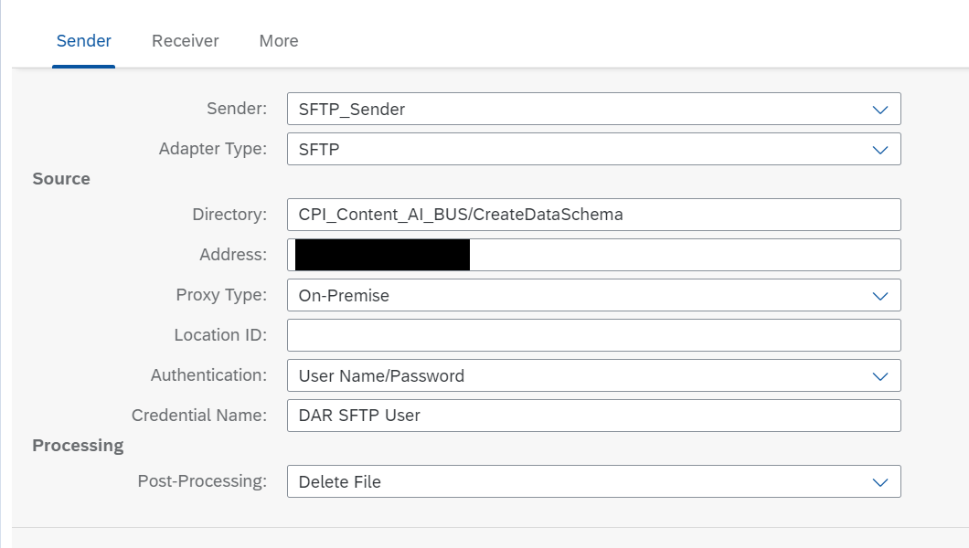
- Configure the SFTP_Receiver. Here you can enter the same data as in the previous step. Only the directory must be different to the one specified in the SFTP_Sender.
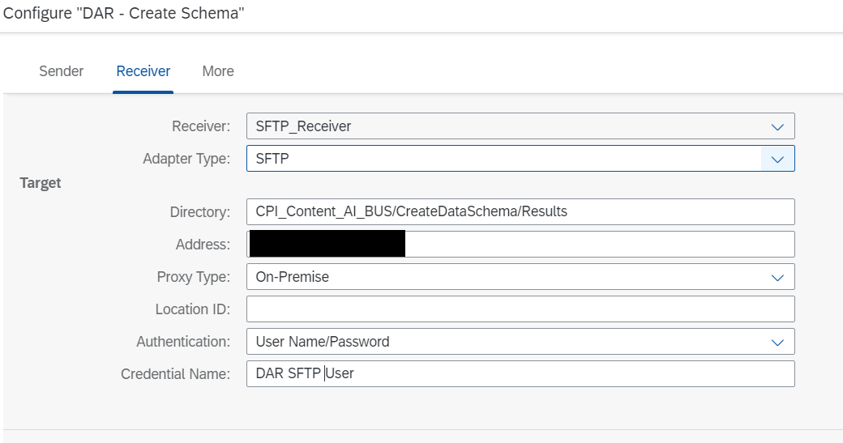

- In the Receiver section configure the OAuth_Server
    - Input Address as url from uaa section from Document Attribute Recommendation service key JSON file
    - Input Credential Name with DAR USER, the credentials name created in chapter 3.1, step 3.
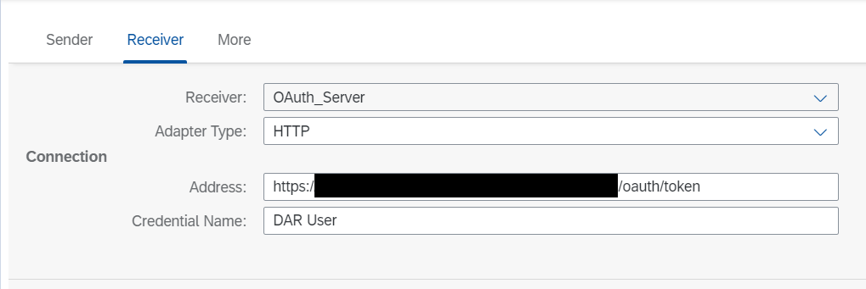

- In the More section configure the Parameter DAR Base URL as url from Document Attribute Recommendation service key JSON file 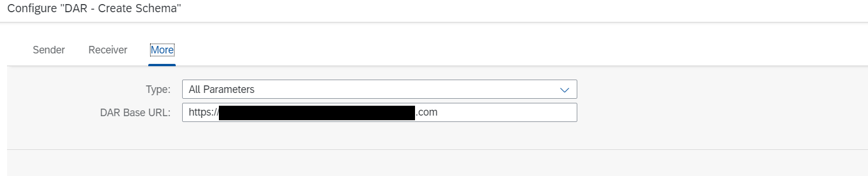

Configure Create Dataset and Upload Data
The Create Dataset and Upload Data Integration Flow creates a Data Set and uploads Data based on a CSV input file. You have to configure the following parameters:

- Configure the SFTP_Sender by providing the required information. The Directory property specifies in which directory the JSON Files are located. In the address field the address of the SFTP-Server must be set. As a proxy type you can either use On-Premise and provide the Location ID if necessary or use Internet. For Authentication you can reuse the DAR SFTP User created in step 4 of chapter 3.1. Also, Post-Processing can be configured to specify the operation after a file has been processed by the Integration Flow.

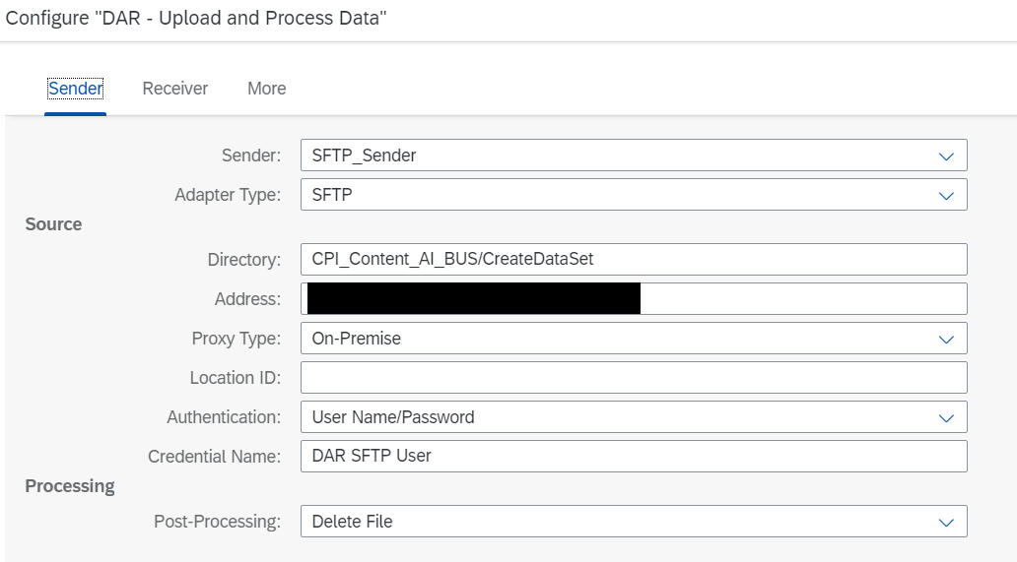

- Configure the SFTP_Receiver. Here you can enter the same data as in the previous step. Only the directory must be different to the one specified in the SFTP_Sender.
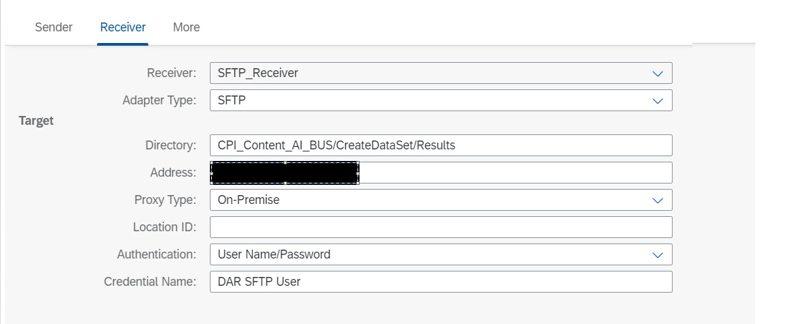

- Configure the SFTP_Receiver_Error. Here you can enter the same data as in the previous step. Only the directory must be different to the one specified in the SFTP_Sender.

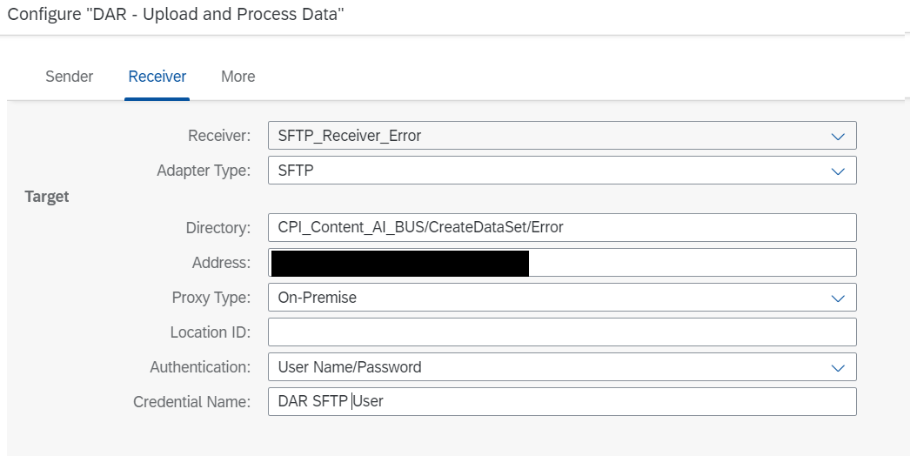
- In the Receiver section configure the OAuth_Server
    - Input Address as url from uaa section from Document Attribute Recommendation service key JSON file
    - Input Credential Name with DAR USER, the credentials name created in chapter 3.1, step 3.
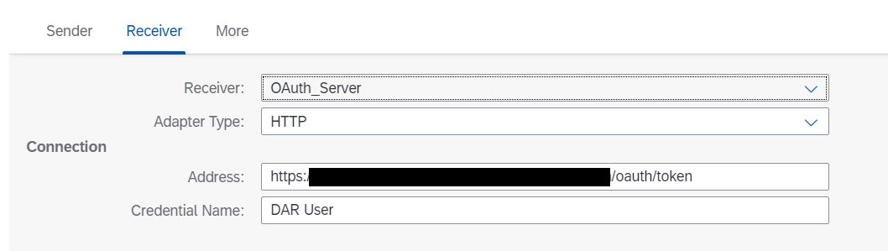

- In the More section configure the Parameter DAR Base URL as url from Document Attribute Recommendation service key JSON file 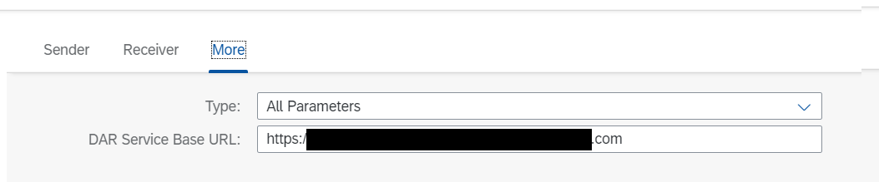

Configure Create Job and Deploy Model
The Create Job and Deploy Model Integration Flow creates a Job and deploys the model based on a JSON input file. You have to configure the following parameters:

- Configure the SFTP_Sender by providing the required information. The Directory property specifies in which directory the JSON Files are located. In the address field the address of the SFTP-Server must be set. As a proxy type you can either use On-Premise and provide the Location ID if necessary or use Internet. For Authentication you can reuse the DAR SFTP User created in step 4 of chapter 3.1. Also, Post-Processing can be configured to specify the operation after a file has been processed by the Integration Flow.

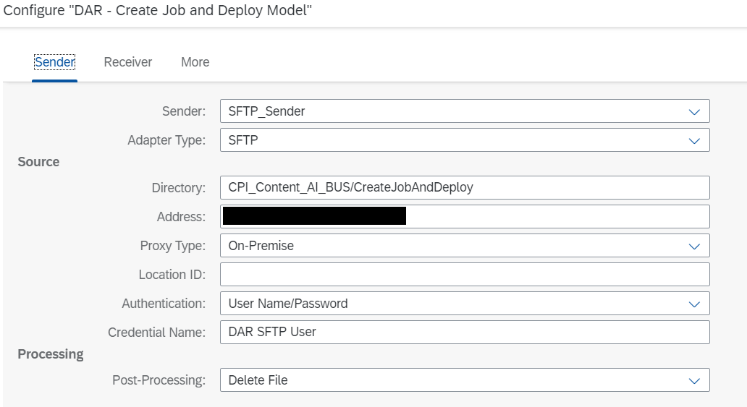

- Configure the SFTP_Receiver. Here you can enter the same data as in the previous step. Only the directory must be different to the one specified in the SFTP_Sender. 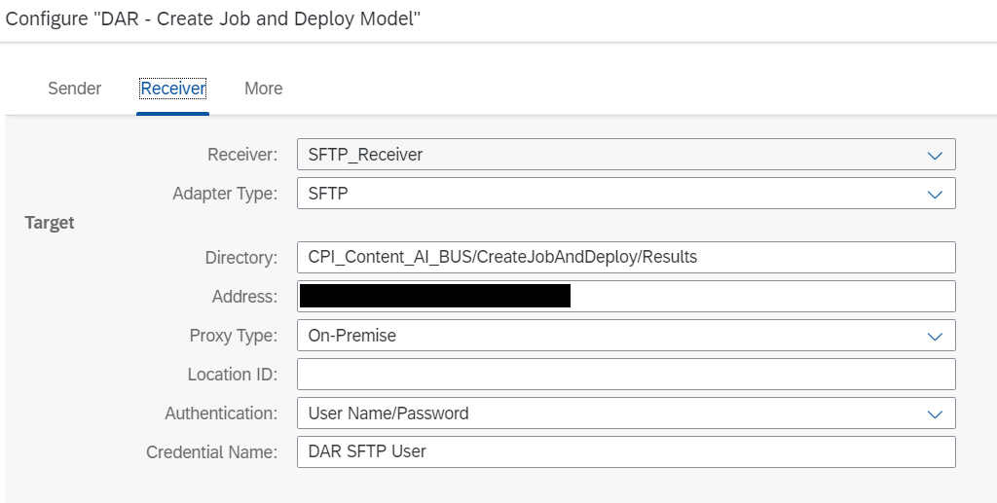

- Configure the SFTP_Receiver_Error. Here you can enter the same data as in the previous step. Only the directory must be different to the one specified in the SFTP_Sender.

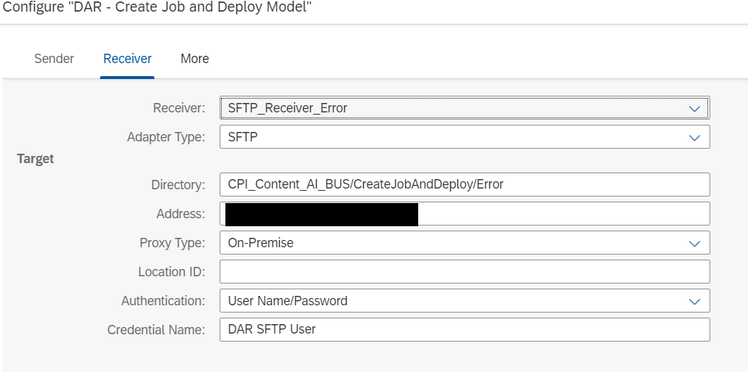
- In the Receiver section configure the OAuth_Server
    - Input Address as url from uaa section from Document Attribute Recommendation service key JSON file
    - Input Credential Name with DAR USER, the credentials name created in chapter 3.1, step 3.
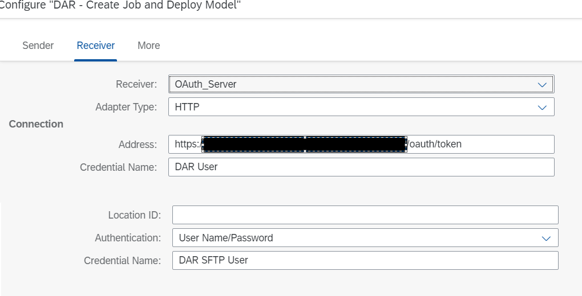

- In the More section configure the Parameter DAR Base URL as url from Document Attribute Recommendation service key JSON file.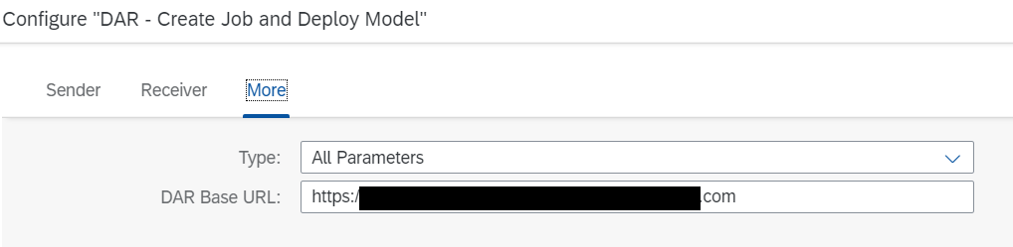

Processing of Files
This Chapter describes how the processing of files is working for each Integration Flow.

File Handling Create Dataset Schema
To create a new Dataset Schema a JSON-File has to be uploaded to the directory of the SFTP_Sender specified in chapter 3.2.1, step 1. The Integration Flow picks up the files and processes them. The JSON-File must be in the following structure (according to the /datasetSchemas API):

{
"features": [
{
"label": "string",
"type": "TEXT"
}
],
"labels": [
{
"label": "string",
"type": "TEXT"
}
],
"name": "string"
}

File Handling Create Dataset and Upload Data
To create a Dataset and upload Data, a CSV-File has to be uploaded to the directory of the SFTP_Sender specified in chapter 3.2.2, step 1. The Integration Flow picks up the files and processes them. The Dataset is in CSV file format containing a header that should match the feature and label names provided in the dataset schema. Dataset CSV file uses only commas (,) as separators. The Dataset CSV file only contains UTF-8 encoding. Any other encoding type is not supported by Data Attribute Recommendation. The Filename of the CSV must start with the name of the dataset, then a dot as a separator followed by the id of the dataset schema (example: “my-dataset-name.datasetSchemaId.csv”)

File Handling Create Job and Deploy Model
To create a Job and deploy a Model a JSON-File has to be uploaded to the directory of the SFTP_Sender specified in chapter 3.2.3, step 1. The Integration Flow picks up the files and processes them. The JSON-File must be in the following structure:
{
"datasetId": "String",
"modelTemplateId": "String",
"modelName": "String"
}

Appendix

Ticket Component
In case of issues during the configuration, open an SAP support ticket for the following component.
Implementation Step | Component | Comment
3.1 ,3.2, | LOD-HCI-PI-OPS | SAP Cloud Platform Integration Operations
3.3 | CA-ML-DAR | Document Attribute Recommendation

www.sap.com/contactsap
© 2019 SAP SE or an SAP affiliate company. All rights reserved.
No part of this publication may be reproduced or transmitted in any form or for any purpose without the express permission of SAP SE or an SAP affiliate company.
SAP and other SAP products and services mentioned herein as well as their respective logos are trademarks or registered trademarks of SAP SE (or an SAP affiliate company) in Germany and other countries. Please see http://global.sap.com/corporate-en/legal/copyright/index.epx#trademark for additional trademark information and notices.
Some software products marketed by SAP SE and its distributors contain proprietary software components of other software vendors.
National product specifications may vary.
These materials are provided by SAP SE or an SAP affiliate company for informational purposes only, without representation or warranty of any kind, and SAP SE or its affiliated companies shall not be liable for errors or omissions with respect to the materials. The only warranties for SAP SE or SAP affiliate company products and
services are those that are set forth in the express warranty statements accompanying such products and services, if any. Nothing herein should be construed as constituting an additional warranty.
In particular, SAP SE or its affiliated companies have no obligation to pursue any course of business outlined in this document or any related presentation, or to develop or release any functionality mentioned therein. This document, or any related presentation, and SAP SE’s or its affiliated companies’ strategy and possible future developments, products, and/or platform directions and functionality are all subject to change and may be changed by SAP SE or its affiliated companies at any time for any reason without notice. The information in this document is not a commitment, promise, or legal obligation to deliver any material, code, or functionality. All forward-looking statements are subject to various risks and uncertainties that could cause actual results to differ materially from expectations. Readers are cautioned not to place undue reliance on these forward-looking statements, which speak only as of their dates, and they should not be relied upon in making purchasing decisions.

