

[Technical Split of Files From ThirdPartySftp To ThirdPartySftp]

Version | Description of change | Date | Author
1.0 | Initial version | 10.03.2020 | Oleg Veliks
Date: 10/03/2020
Version: 1.0
Author: Oleg Veliks

DOCUMENT CONTROL
Owner | Client contact |  | Status | Date issued
Oleg Veliks | N/A | N/A |  | N/A
Version history log
TABLE OF CONTENTS

1 PURPOSE 3
2 OVERVIEW 4
3 PRE-REQUISITES 5
4 INTEGRATION FLOW CONFIGURATION 6
4.1 Configuration Parameters 6
5 STEPS FOR TESTING THE IFLOW 9

PURPOSE
The purpose of this document is to describe the general configuration steps required to split Interactions and Contacts files of 1 million records into 100k or 200k records before loading to SAP Marketing Cloud to optimize load performance.

OVERVIEW
This Integration flow splits the Customer & Interactions source file (1 million records) into 100k files without changing source file name.
[Ex: 1 Million Customer_Test.csv file will be split into 10 files with naming convention Customer_Test_1 ..Customer_Test_N]
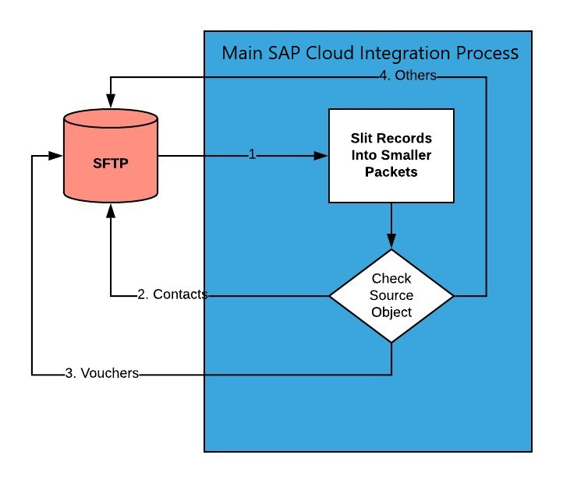
Step 1. Read source CSV file from SFTP and split into smaller packets.
Step 2, 3, 4. : Identify the file type from the file name i.e. Contacts or Voucher Interaction or Marketing Interactions and place the split files (100k or 200k each) into different folders according to the source file type.

PRE-REQUISITES
Before configuring Integration Flow, please make sure the following prerequisites have been met:

- SAP Cloud Platform Integration service is enabled and running.
- Amazon Web Services account is enabled. S3 bucket is created and SFTP Transfer server is up and running. S3 bucket is a root directory of SFTP.
- SFTP server is configured and connectivity between SAP Cloud Integration tenant and SFTP is established.
- SFTP user having permissions to create and update folders and files.

INTEGRATION FLOW CONFIGURATION

Configuration Parameters

Externalized  Parameter Name | Description | Sample Value
Sender (Directory) | Root SFTP directory. A source directory of  SFTP server. | DevelopmentLoads/LoadFiles/Contacts/C4M/Be foreSplit_DS
Sender (FileName) | Source File Name on SFTP server. A file from where to load data. | Test.csv
Sender (Address) | SFTP server host name. | xxx.server.transfer.eu-west-2.amazonaws.com
Sender (User  Name) | SFTP User Name. SFTP user which has access to SFTP directories. | CPI_USER_PROD
Sender (Timeout) | Maximum waiting time to contact the  FTP server  while establishing connection or performing a read operation. | 10000
Sender (Maximum  Reconnect  Attempts) | Maximum reconnect  attempts  allowed to reconnect. | 10
Sender  (Reconnect Delay  in ms) | Time period to wait before attempting to reconnect to the remote FTP server. | 1000
Sender Processing (Lock Timeout) | How long to wait before | 30

 | trying to process the file again.
Sender (Change  Directories  Stepwise) | Changes  directory levels one at a time | true
Sender (Post-  Processing) | Controls which actions should be done after file processing. | Move File
Sender (Buffer size) | Write the file content using the mentioned buffer size. | 128
Sender (Max.  Messages per Poll) | Maximum number of messages to gather for each poll. | 20
Receiver -  R_CRM_Customers  (Address) | Host name or IP address and port of the  SFTP server. | xxx.server.transfer.eu-west-2.amazonaws.com
Receiver -  R_CRM_Customers  (User Name) | ID of the user performing file transfer. | CPI_USER_PROD
Receiver- R_CRM_  Customers  (Timeout) | Maximum waiting time to contact the  FTP server  while establishing connection or performing a read operation. | 10000
Receiver- R_CRM_I nteractions (Timeout) | Host name or IP address and port of the  SFTP server. | xxx.server.transfer.eu-west-2.amazonaws.com
Receiver -  R_CRM_Customers  (User Name) | ID of the user performing file transfer. | CPI_USER_PROD

Receiver- R_CRM_  Customers  (Timeout) | Maximum waiting time to contact the  FTP server  while establishing connection or performing a read operation. | 100000
More (Splitter  Grouping) | Specify the group size into which the  composite message should be split. | 100000

STEPS FOR TESTING THE IFLOW
Step 1. Upload file under location specified in "Sender (Directory)". Based on filename IFLOW will decide which object to split.
For example if filename is "Customers*" process will split customers. If filename "INTERACTIONS_VOUCHERS*" process will split interactions with type Vouchers.
Step 2. Deploy IFLOW and wait until it is finished.
Step 3. Browse SFTP directory based on input file name.
For example:
- Split Customers files should be created under DevelopmentLoads/LoadFiles/Contacts/
- Split Interactions with Voucher files - should be created under DevelopmentLoads/LoadFiles/Interactions/
End to End Test:
Iflow Components:

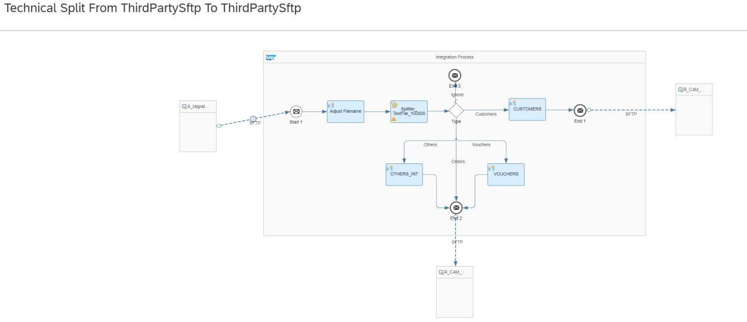
Uploaded Customer file into Sender Sftp folder
"DevelopmentLoads/LoadFiles/Contacts/C4M/BeforeSplit_DS"

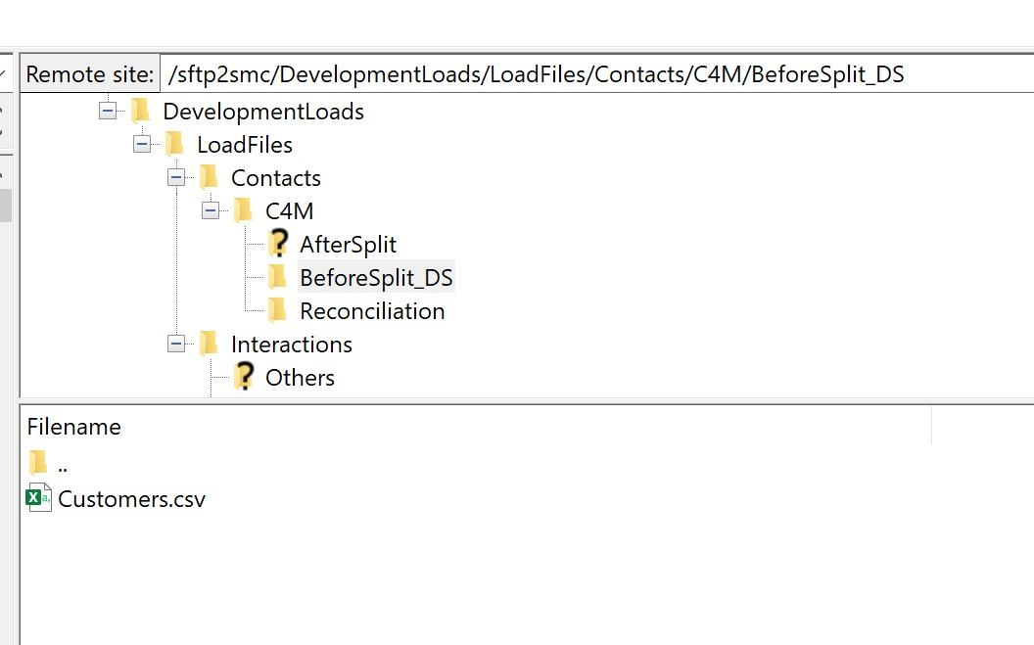
Archived file.
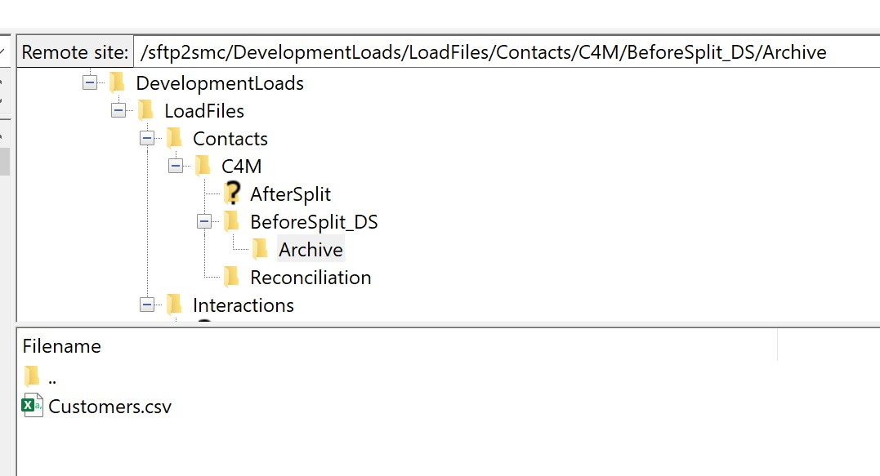
Status of message is successful.
Page 10 of
11
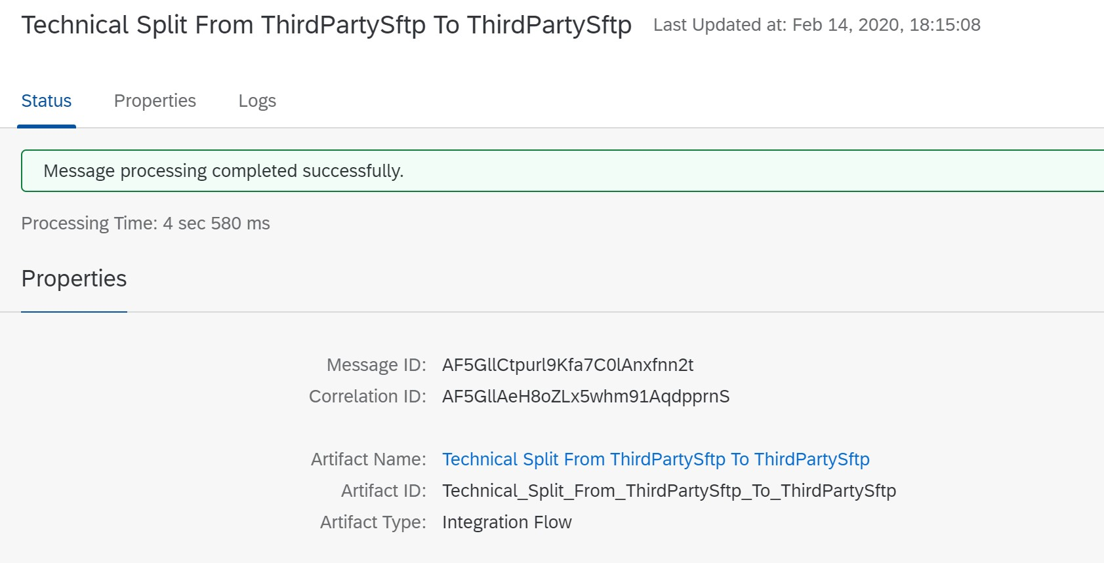
Sender File is routed to target folder based on input file.
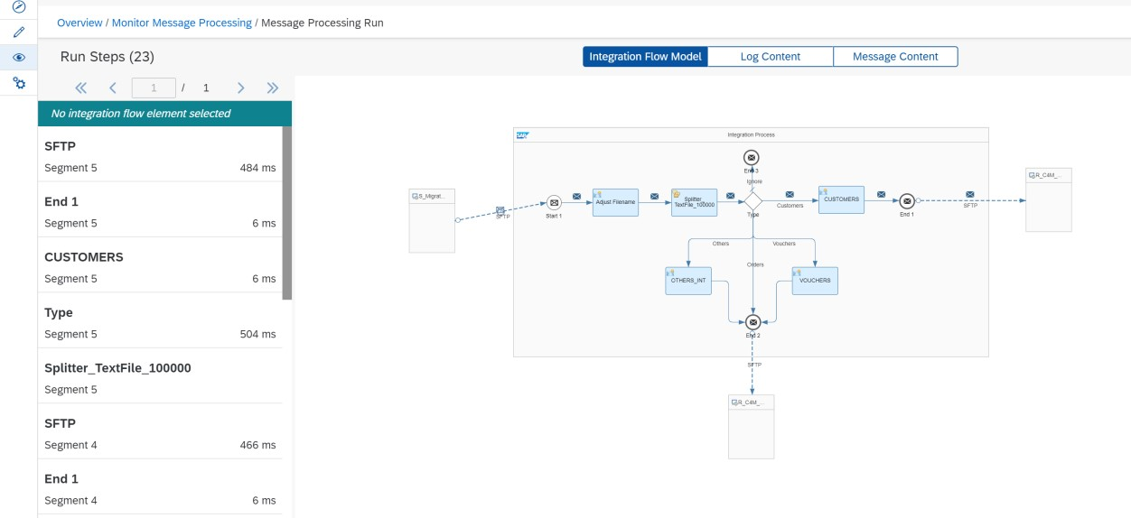
Split files are into target folder:
