Accessing valueMaps from a script:

Valuefrom valueMaps can be accessed programmatically from a script with the help of the getMappedValue api of the ValueMappingApi class.

Classes needed:
com.sap.it.api.ITApiFactory
com.sap.it.api.mapping.ValueMappingApi

Method signature:
public String getMappedValue(String sourceAgency, String sourceIdentifier, String sourceValue, String targetAgency, String targetIdentifier);

Sample Code:
Get a handle to the ValueMappingApi service:
def service = ITApiFactory.getApi(ValueMappingApi.class, null);

Retrieve the target value using:
def mappedValue = service.getMappedValue(<SrcAgencey>,<SrcSchema>,<SrcValue>,<TargetAgency>, <TargetSchema>);

Example:

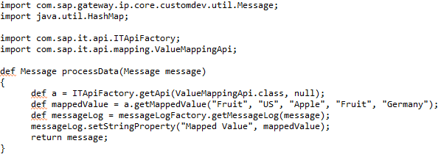

The above code will print the retrieved value to the message processing log.

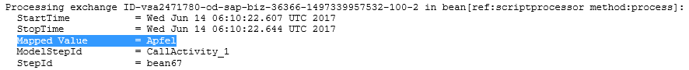

Working integration flow can be found at:
Content hub Design Cloud Integration – Exemplars Artifacts Accessing Value Maps in Scripts
The valueMap used for the above example is attached:

