Batch processing with SuccessFactors
This article focuses on how pagination is realized in Cloud Integration for the SuccessFactor adapter.
Please note that batch processing in general is also supported in Cloud Integration for select other connectors. I am writing another article that explains pagination in general.

Pagination is a feature implemented in SAP Cloud Platform Integration to be able to process large requests in pages.
When pagination is configured, the sender SFSF system sends only one page to Cloud Integration at a time. When Cloud Integration finishes processing the page, it requests for the next page. You can choose to collate all the pages later before sending out the final response or send the response page by page to the receiver.
As of today, pagination is only supported for SFSF SOAP and OData V2 communication.
In order to enable pagination in your scenario, you need to make the following settings in your integration flow:
1) Move all the logic of processing the message into a sub-process.
2) Invoke the sub-process from the main process using a looped process call:

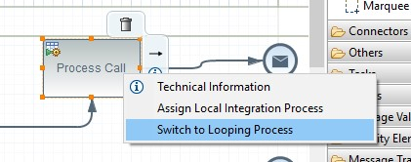

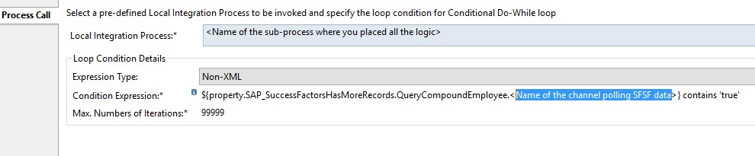
The condition expression refers to the name of the SFSF channel that polls request from the SFSF system.
${property.SAP_SuccessFactorsHasMoreRecords.QueryCompoundEmployee.<Name of the channel polling SFSF data>} contains ‘true’
Set the value for ‘Max. Number of Iterations’ appropriately to ensure that it is not:
- Too high – if you know that typical number of expected pages
- Too low – that it leads to truncation of incoming pages – it should be able to capture all the data and not get truncated due to a cap on the number of maximum iterations
The condition expression, together with the Max number of iteration are meant to save the system from going into an endless loop.
3) The SFSF channel should be configured inside the sub-process using the request-reply pattern.
4) Configure the following settings in the SFSF channel:
- Define a name for the channel that you can use for defining the condition expression in step 2
- Define a page size keeping in mind:
    - It should be able to capture all the data and not get truncated due to a cap on the number of maximum iterations
    - It should not too big that we encounter OOMs.
- Check the checkbox “Process in batches”
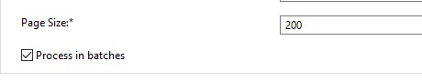
If you do not see these options, delete the channel and create a fresh one.
5) Finally, any housekeeping or post-processing tasks should be put in the main process after the call to the looping process.

Scenario template can be found at:
Content hub Discover Cloud Integration - Exemplars Artifacts Pagination with SFSF

