What is a transaction?
A transaction is one atomic unit of commit. Everything defined as a transaction is either committed or rolled-back together.
Transaction management empowers an integration developer to define the boundaries of a transaction that not just control database operations but also queue operations. It allows:
- Managing a transaction at a process and sub-process level
- Having multiple individual transactions in an integration flow
- Disabling transaction to commit every operation individually

Cloud Platform Integration supports transaction handling for JDBC and JMS operations.
A Database transaction is started whenever you perform any of the following DB operation –
- Data Store operation: Select, Write, Get, Delete
- Write or Read Variable (local or global)
- Use of an aggregator
A JMS transaction is initiated as soon as you try to write to or read from a JMS queue.
A transaction is closed only at the end of the process (or sub-process) where it is defined.

Transaction handling can be configured at an Integration process level or a local integration process (sub-process) level – Click on the integration flow or sub-process and go to the properties sheet Processing tab:
Integration Flow:
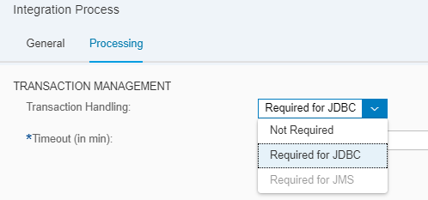

Sub-process
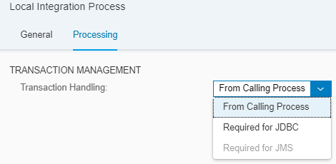
Transaction Handling:
  - Not required indicates that there is no need to initiate a process-wide atomicity lock. Every JDBC/JMS operation is independent and shall be committed individually. This can lead to data inconsistencies in case of a message processing failure, which needs to be handled explicitly by the developer – in the exception sub-process (for instance).

  - Required for JDBC indicates that all database operations in the flow should be part of one transaction. The transaction and a database lock is issued with the first database operation and will stay open until the end of the flow execution or till the Timeout (in mins), whatever happens first. The database lock stays until the transaction is open. Transactions must be planned based on the scenario in a way that the transaction does not stay open for a long time. Since a lock is issued on the database for each transaction, long running transactions – and hence a long held database lock can lead to blocking the entire database.
  - Required for JMS indicates that all queue operations (read and write) to Enterprise Messaging happens in one atomic unit. A JMS transactions also issues a lock, but only on the corresponding queue where the integration flow is either writing to or reading from. All other queue can be operated upon.

  - From Calling Process is set at a sub-process level and indicates that the operations in the sub-process need to be clubbed as a part of the bigger transaction of the integration flow that called the sub-process.

Timeout (in mins) is used to save the system from keeping the transaction open for an unlimited duration. The transaction is kept open until the end of the flow or for the duration set in this field – which ever happens first.

- You can only manage either JDBC or JMS transaction in a flow, not both.
- The maximum allowed Transaction Timeout is 12 hours. Specify timeouts longer than 1 hour only in case it is necessary. Default timeout is 30 mins.
- Whenever possible, move related tasks into a sub-process so that the transaction can be limited to the sub-process and the main process can be kept non-transactional. This will ensure that the transactions are not kept open for long or for the entire message execution duration.
- Always activate transaction handling when the integration process contains one or more Aggregator steps.
- Asynchronous parallel processing of messages cannot be transactional. Asynchronous parallel processing of messages is configured by the Parallel Processing option of the (general or iterating) Splitter step or the Parallel Multicast step. You can choose one of the following options to overcome this limitation: Either deactivate transactional processing or use a Sequential Multicast instead of a Parallel Multicast.
- Database locks can be explicitly removed manually. Create a ticket on LOD-HCI-PI-OPS for the same.

Blogs:
https://blogs.sap.com/2017/05/31/cloud-integration-how-to-configure-transaction-handling-in-integration-flow/

Documentation
https://help.sap.com/viewer/368c481cd6954bdfa5d0435479fd4eaf/Cloud/en-US/e4630de9a8314848b73555e0b0c35d7e.html

Sample Flow:
Discover Cloud Integration.Lessons Learnt Transaction Management with JDBC(Artifacts tab)
Discover Cloud Integration.Lessons Learnt Transaction Management for JMS(Artifacts tab)

Click on the integration process, go to the Processing tab in the properties sheet.
Set the Transaction Handling drop box to Required for JDBC.

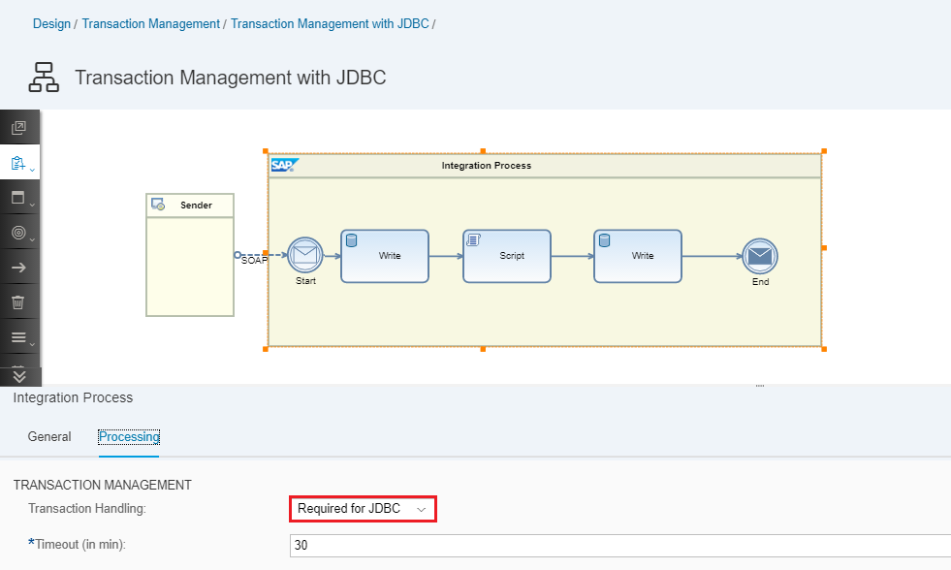

Go to the script and ensure that the statement that throws exception is commented.

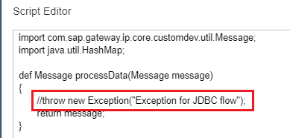

Save and deploy your integration flow by using the corresponding operations from the top right corner of your screen.
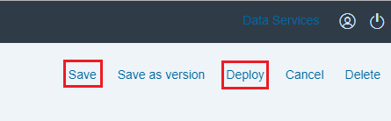
Go to the Operations view Manage Integration Content. Click on the first tile to manage all deployed content
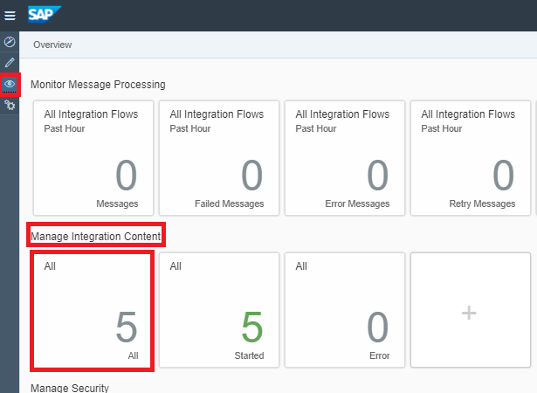
Ensure that your bundle Transaction Management with JDBC is in status Started.
You can find the endpoint URL in the right-side pane under ENDPOINTS.

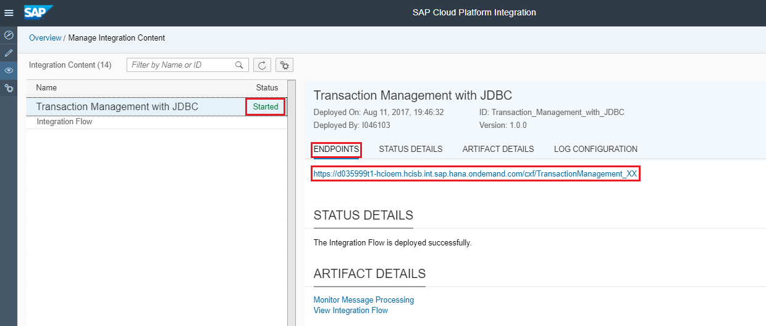

Open another tab in the web browser and launch Postman
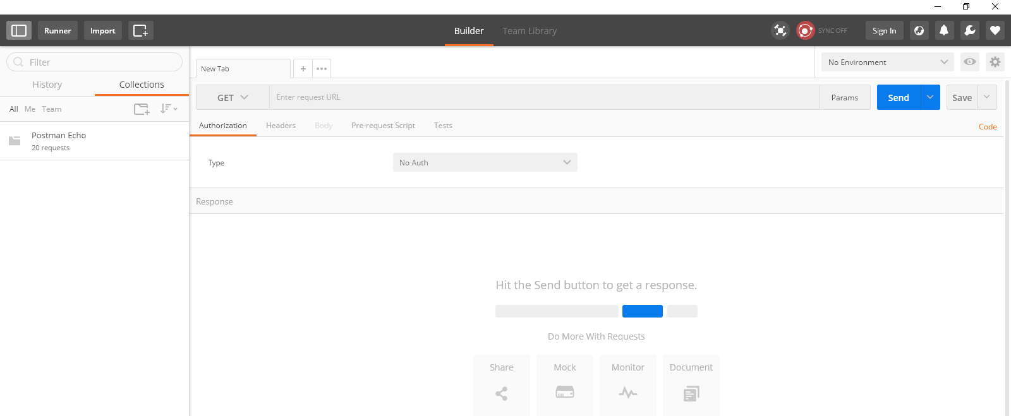

Enter the following details:
Method: POST
URL: Endpoint URL exposed by the integration flow
Go to the Authorization tab
Type: Basic Auth - Username: <your user on the tenant>/Password: <your password on the tenant>
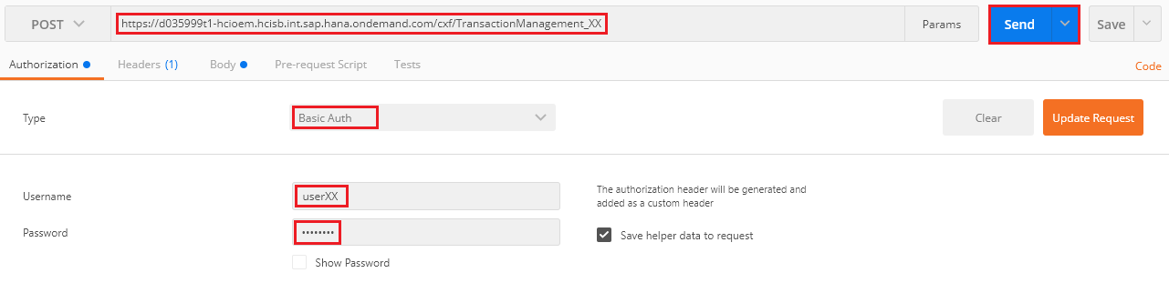

Go to the Body tab Choose the radio button next to raw Enter the request and hit Send.
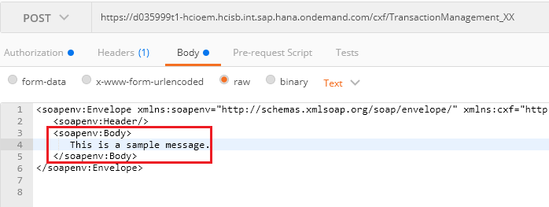
Go to the Operations View Manage Stores Data Stores.

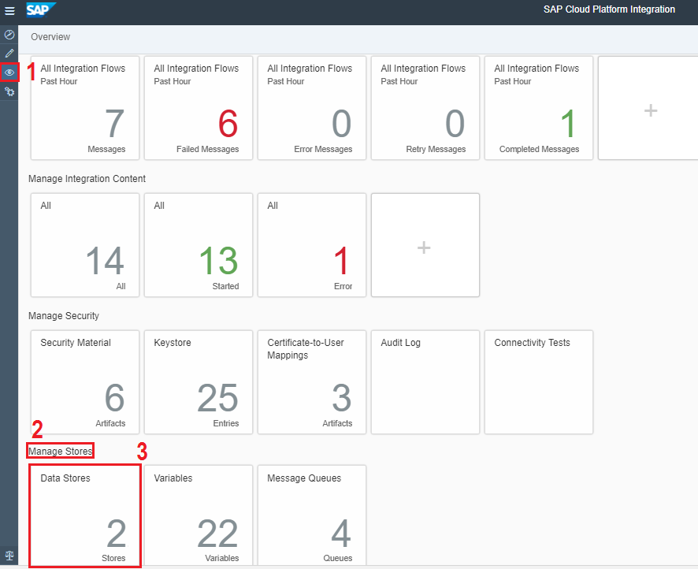

As you can see, 2 data stores are created and each has one entry.
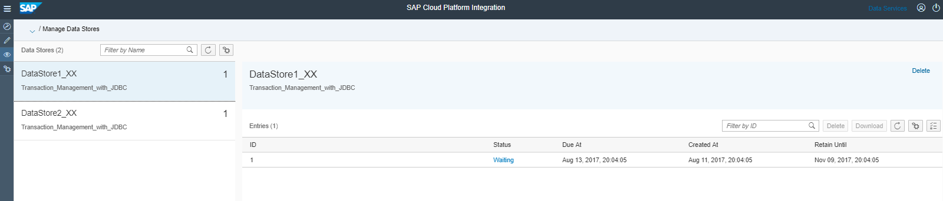

Now delete both the data stores from the system.
In order to do so, delete all the entries from it. Click Delete on the top right corner.
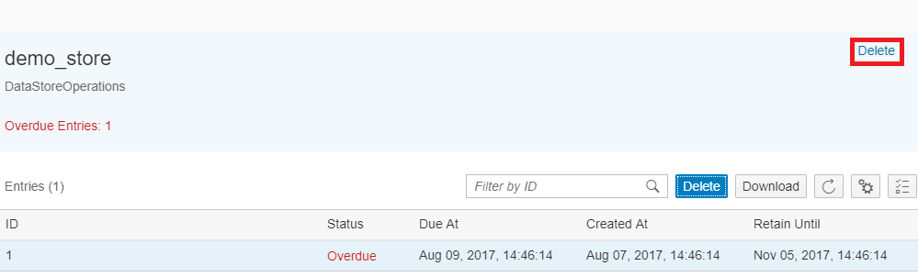

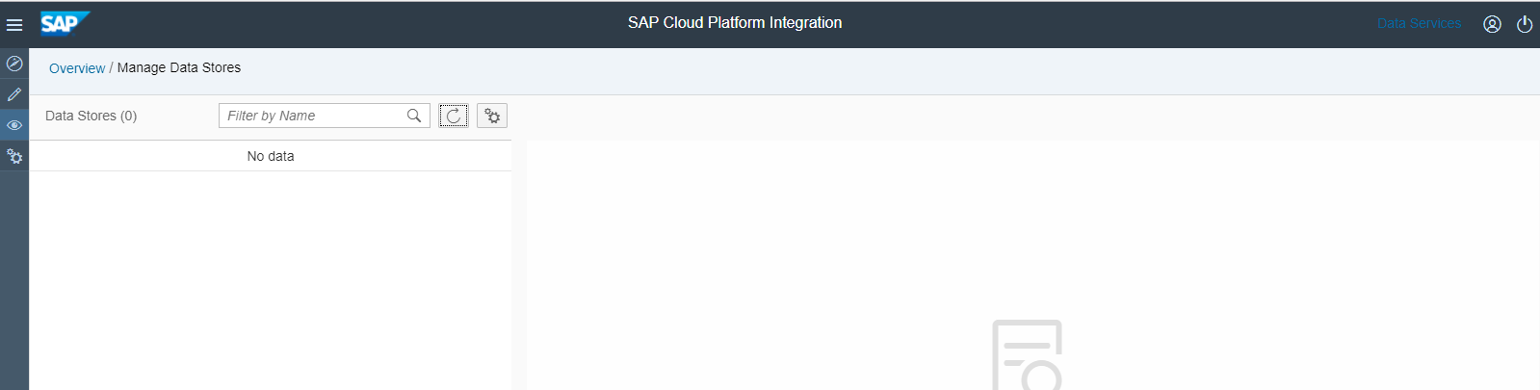

Now Go back to the integration flow and uncomment the statement that throws an exception in the script process step

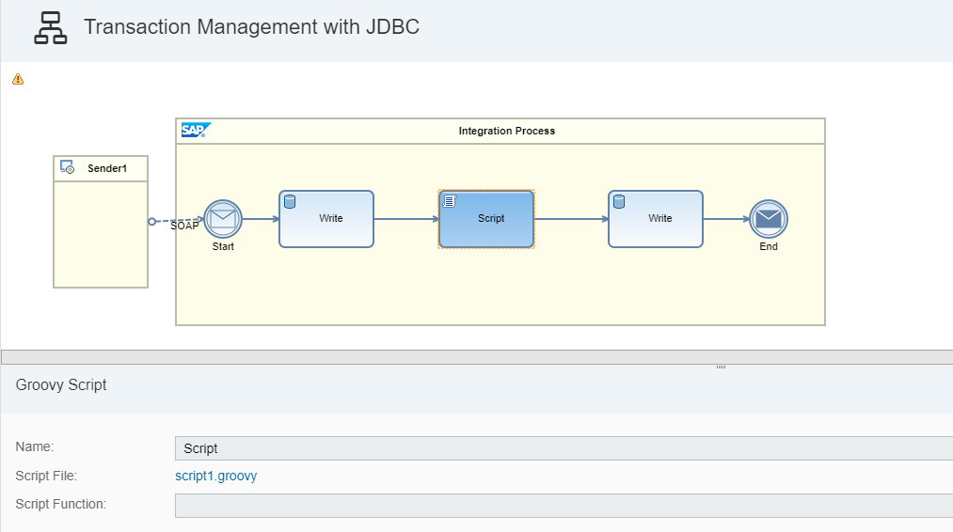
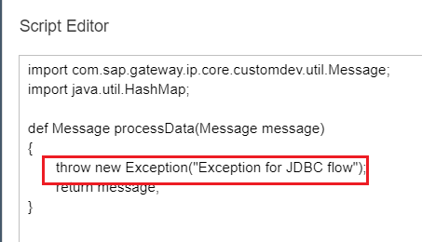

Save, deploy and retrigger the flow from Postman.
Go to the Data Store view. As you can see, there are no entries. Since transaction handling is enabled and the exception was triggered after the first write, it was rolled back. The control anyway did not reach the second write.

Now Go back to the integration flow. Click on the integration Process, go to the Processing tab in the Property Sheet.
Set the value for Transaction Handling to Not Required.

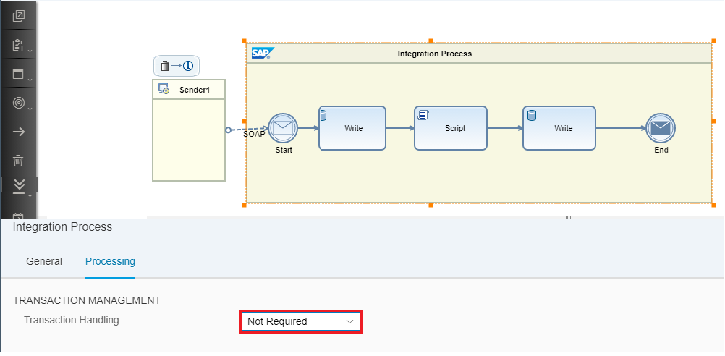

Go to the Data Store view. As you can see, only one data store gets populated.
Since Transaction Management was disabled, each data store operation was committed immediately. Since the exception occurred after the first write and transaction handling was disabled, the first write was not rolled back.
