SAP S/4HANA – Shopify
Stock from MRP Area

Action | Name / Owner | Date
Documentation v1 | Flexso | 01.11.2023

Table of contents
Table of contents 2
1. Interface overview 3
2. Pre-requisites 4
3. Integration flow configuration 5
3.1 SAP S4HANA Cloud to Shopify stock from MRPArea 5
3.1.1 Configuration parameters 5

Interface overview

This integration forges a seamless link between Shopify and SAP S/4HANA, enhancing the efficiency of the inventory management process. Leveraging a timer set up within SAP Cloud Integration, which can be configured to run as frequently as every minute, it ensures the timely transfer of updated stock information from SAP S/4HANA to Shopify. The integration updates the inventory levels in Shopify for products experiencing stock changes, maintaining accurate and real-time inventory tracking.
The below diagram clarifies the flow of the integration:
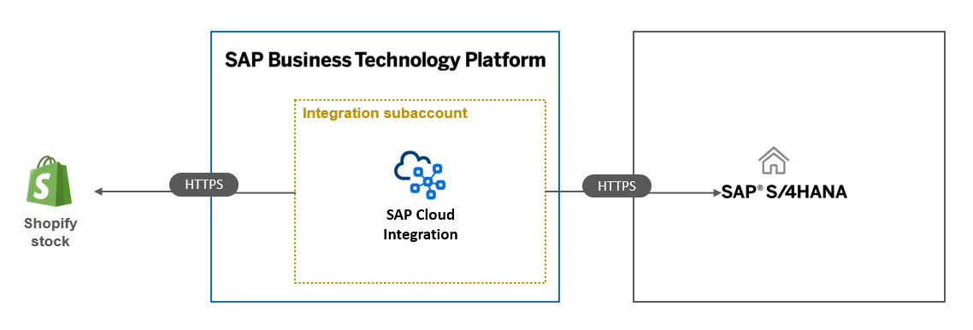
Both SAP S/4HANA & SAP S/4HANA Cloud are supported as source systems.
The current integration supports stock replication exclusively for MRP Area. To replicate based on StorageLocation and BOM usage, please reach out to Flexso.

Pre-requisites

On the SAP S/4HANA system the following OData services need to be activated:
- Product availability odata v4 (SAP_COM_0115, API_PRODUCT_AVAILY_INFO)
  - Allows the retrieval of stock information
- Product odata v2 (SAP_COM_0009, Product Master (A2X))
  - Allows the retrieval of product masterdata
Within Shopify a location id needs to be defined for which the inventory levels need to be synchronized.

Integration flow configuration

SAP S/4HANA Cloud to Shopify stock from MRPArea

Configuration parameters
The integration flow leverages the Shopify location ID to accurately transfer inventory levels for products, aligning with the Material Requirements Planning (MRP) Area specified in the SAP S/4HANA system.
Authentication with Shopify is managed using the Shopify access token. Additionally, the integration necessitates other essential parameters, including the URL and credentials for Shopify and SAP S/4HANA.
Externalized Parameter Name | Sample Value
Location_ID | 88888888888
MRP | 1000
Shopify_Accesstoken | token
Timer | Every x minutes
S4HANA_Client_Cert | sap_cloudintegrationcertificate
S4HANA_Product_Availability_ODatav4_URL | https://my12345-api.s4hana.ondemand.com/sap/opu/odata4/sap/api_product_availy_info/srvd_a2x/sap/apiproductavailyinfo/0001/
S4HANA_Product_OData_URL | https://my1234-api.s4hana.ondemand.com/sap/opu/odata/sap/API_PRODUCT_SRV
SHOPIFY_URL | https://myshop.myshopify.com/admin/api/2023-01/

