How to access a header or an exchange property in an XPATH expression.

Header AgeLimit is configured with a value 14

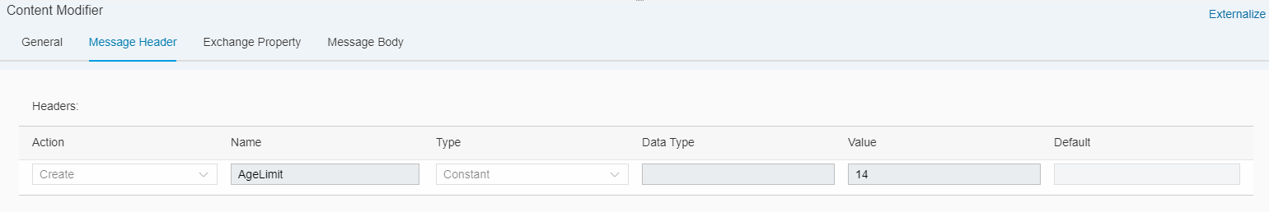

The payload is as follows:

<School>
<Grade>
<Student>
<Name>Amit</Name>
<Age>10</Age>
</Student>
<Student>
<Name>Varun</Name>
<Age>11</Age>
</Student>
<Student>
<Name>Vijay</Name>
<Age>9</Age>
</Student>
<Student>
<Name>Raj</Name>
<Age>13</Age>
</Student>
<Student>
<Name>Arjun</Name>
<Age>14</Age>
</Student>
<Student>
<Name>Aditya</Name>
<Age>15</Age>
</Student>
<Student>
<Name>Arun</Name>
<Age>11</Age>
</Student>
<Student>
<Name>Naveen</Name>
<Age>10</Age>
</Student>
<Student>
<Name>Akhil</Name>
<Age>8</Age>
</Student>
</Grade>
</School>

In order to choose all students who are 14 years or more, we can write the following XPATH:
/School/Grade/Student[Age >= $AgeLimit]

The same can be accomplished with a property. Use the same property name in the same way in an XPath.
If the integration flow has a header and property with the same name, then the header will take preference.

Working integration flow can be found at: Discover Cloud Integration – Exemplars Artifacts Access header and property in XPATH

