Building block Configuration Guide  Replicate Employee Data from Workday to SuccessFactors EC  June 2022  English | Customer
Replicate Employee Data from Workday to SuccessFactors EC

Document History
Revision | Date | Author
0 | June, 2022 | Yi Liang
Content
1 Prerequisites 5
2 Documentation 6
3 Configuration steps on SAP Cloud Integration 8
3.1 <Configure Sender Adapter> 8
3.2 <Configure Receiver Adapter> 8
3.3 <Configure Other Parameters> 9
3.4 <Configure Value Mapping> 9
3.5 <CSV File Template> 10

Prerequisites
- Access to SFTP (for configuration)
- SAP SuccessFactors Employee Central purchased license
- All employee master data CSV files should be provided in predefined templates, and compressed in one zip file.

Documentation
This iflow replicates employee master data including User, Personal info, Employment info, Job info, Compensation info, National ID, Email, Phone, Address, Emergency contacts, Global info, etc from Workday to SuccessFactors Employee Central.
Workday need to generate employee master data CSV files based on predefined templates, and compress all these files into one zip file then upload to SFTP.
The iflow is scheduled to load the zip file from SFTP, validate the data against existing data in EC, skip records if the same data already exist in EC, convert data to EC XML payload and upsert the data into EC. The iflow log all records which upsert fails or skipped with detailed error message, and send the processing summary log to EC Execution Manager.
The iflow can process full load as well as delta load. Therefor the files can be provided with changed data. But the entity key values should be provided for each changed record. If there’s no change for one CSV file template, it can be omitted.

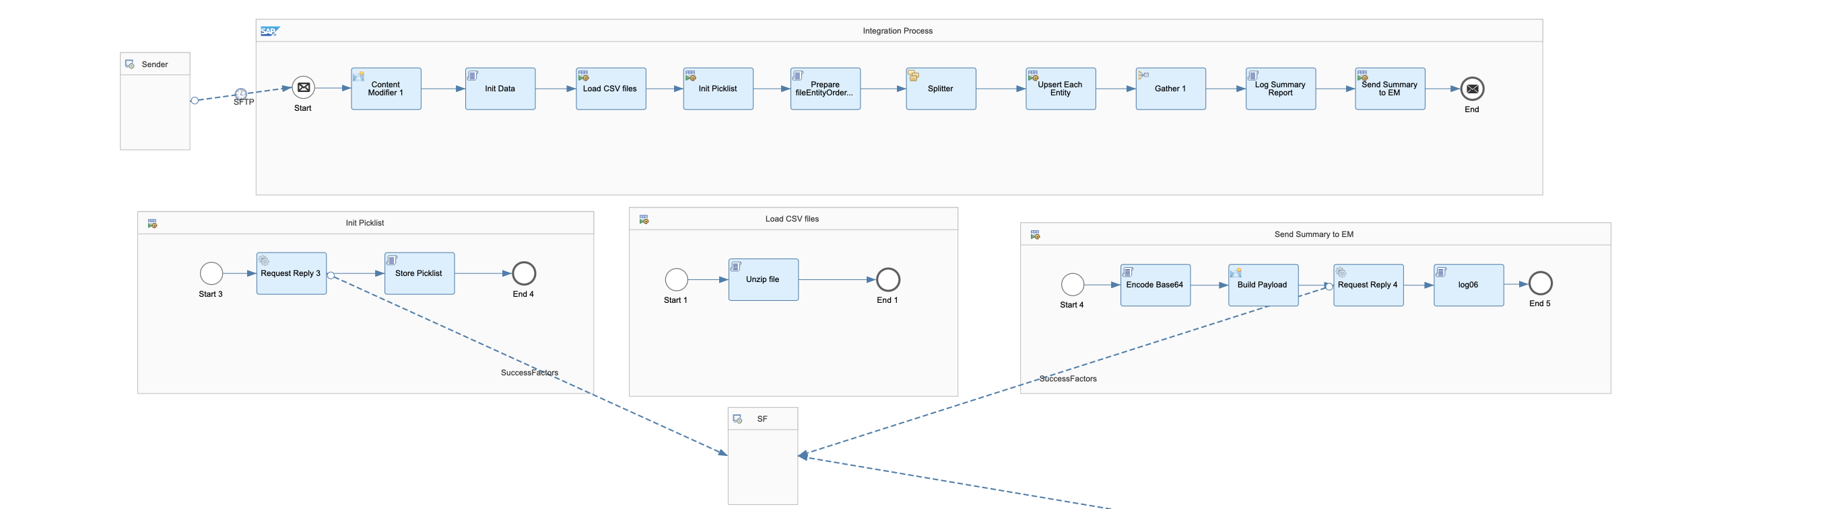
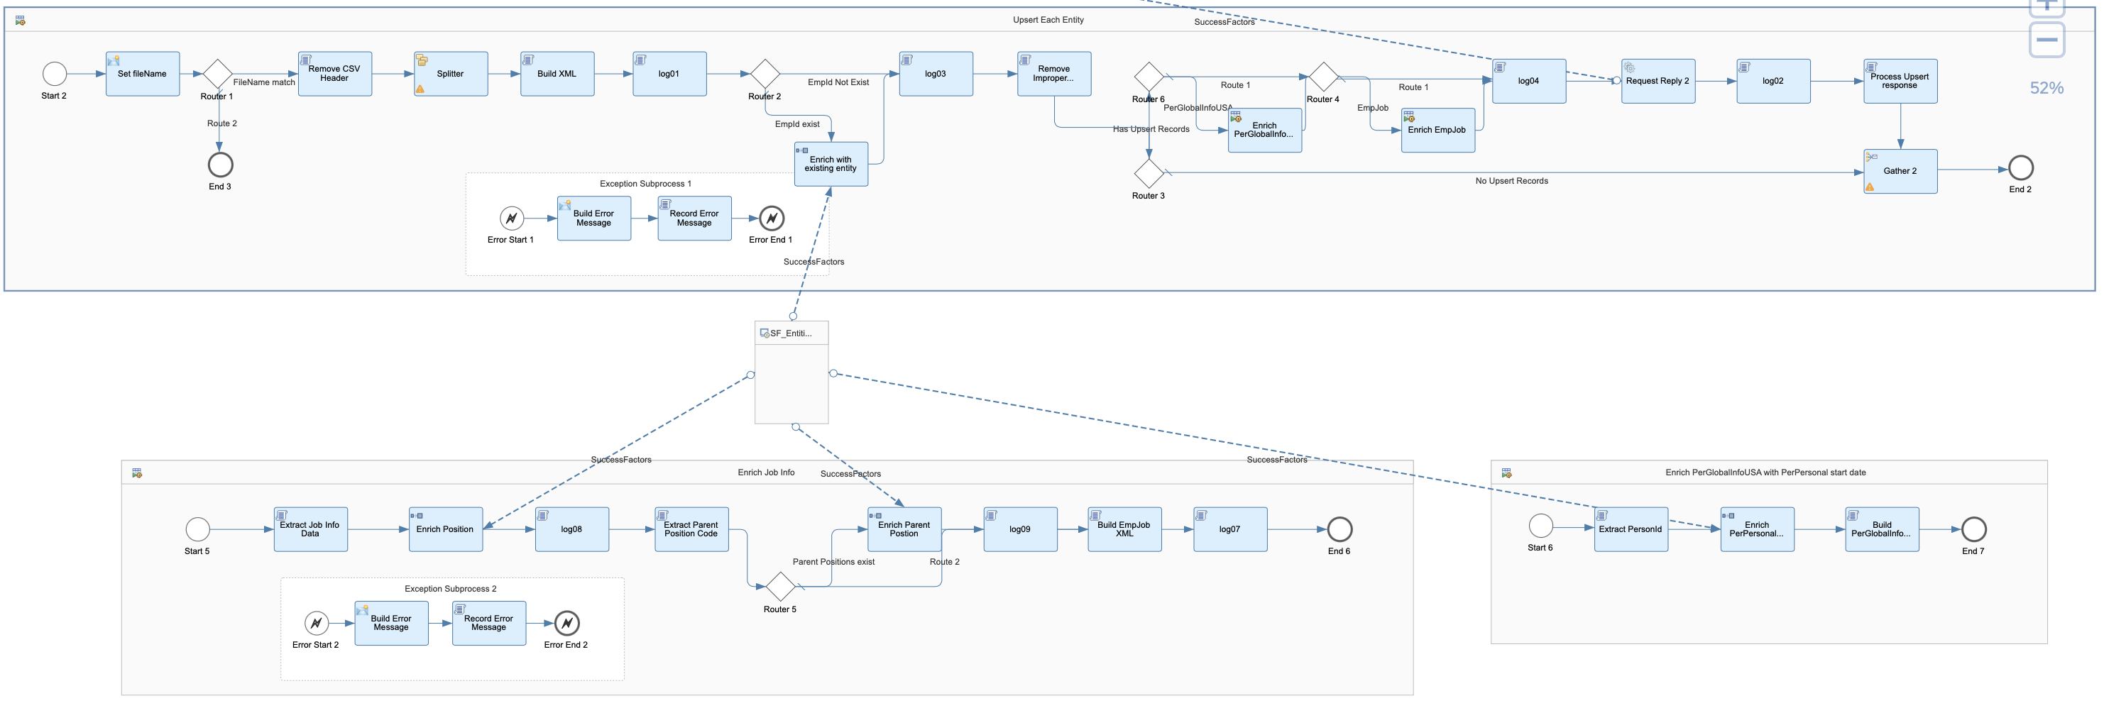

Detailed Processing Steps:
  - Initialize data including CSV file names and entity mapping, entity columns, picklist, event reasons, etc.
  - Uncompress zip file, store CSV contents in map.
  - Initialize Picklist, store optionId and external code mapping in two-level map.
  - Loop each CSV file to process corresponding entity upsert.
  - Validate if file name is correct
  - Remove CSV header for splitting massive records
  - Build XML based on CSV records, skip failed records, prepare OData upsert URL.
  - Enrich XML with existing data in EC.
  - Remove improper records which are same as existing data in EC, and start date is before the start date of existing data.
  - Enrich PerGlobalInfo entity with startDate.
  - Enrich EmpJob entity.
          - Extract Job info data to store positions and eventReasons in property.
          - Enrich Job info data with position data.
          - Extract and store parent position code in property.
          - Enrich parent position to retrieve manager id.
          - Build EmpJob xml payload.
  - Perform OData Upsert.
  - Process Upsert response to build summary report.
  - Send summary report to Execution Manager.

Configuration steps on SAP Cloud Integration

<Configure Sender Adapter>
Configure SFTP sender schedule, address, credential and file path and name. The file should be a zip file which compresses all CSV files.
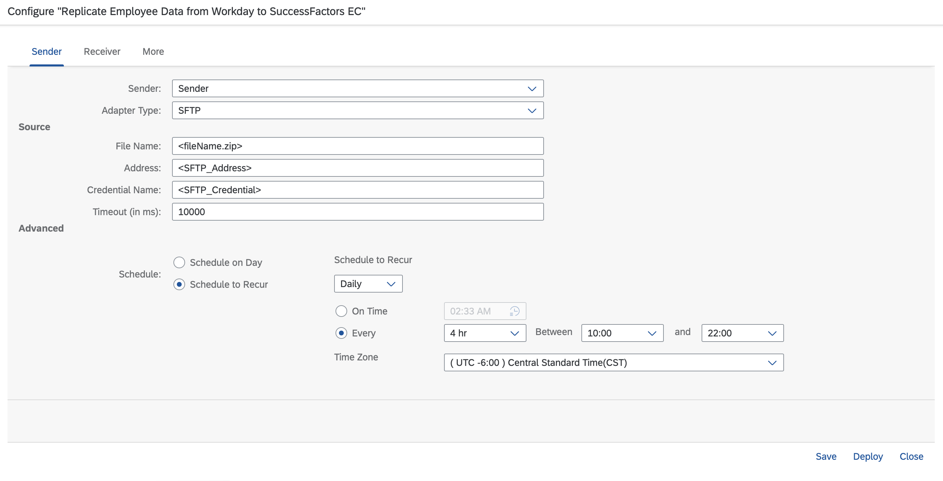

<Configure Receiver Adapter>
Configure SuccessFactors receiver address and credential.
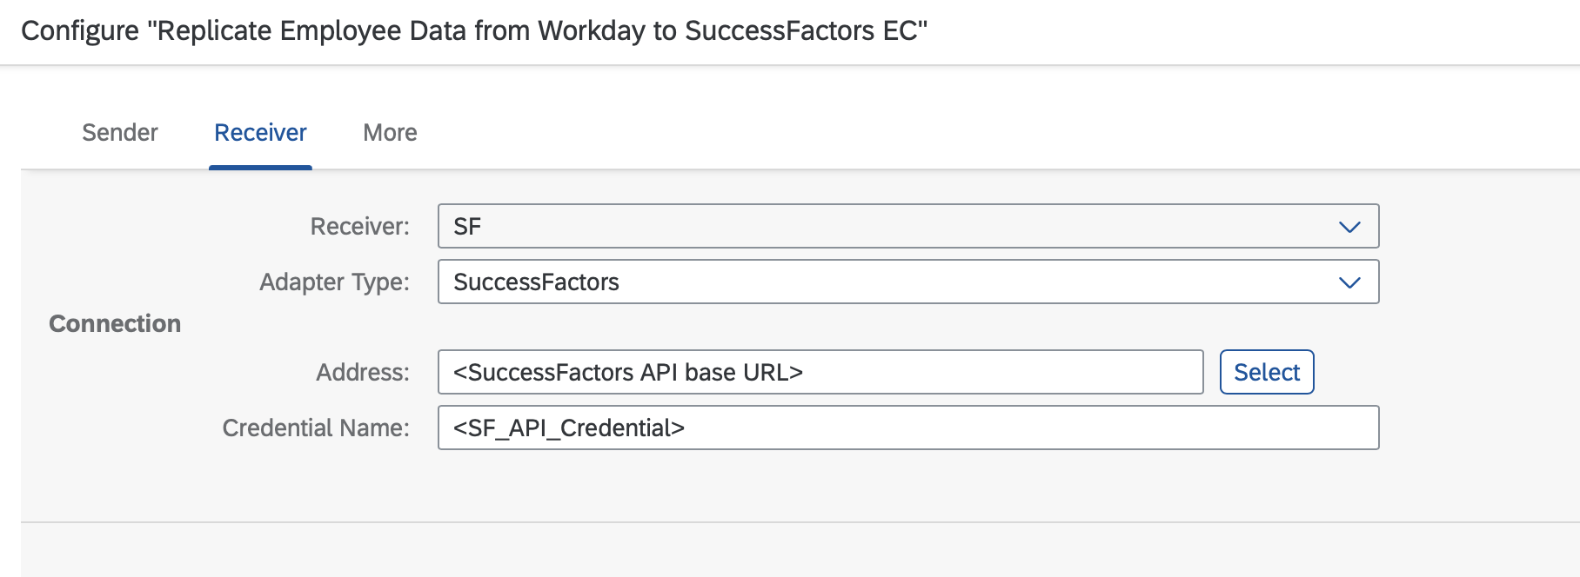

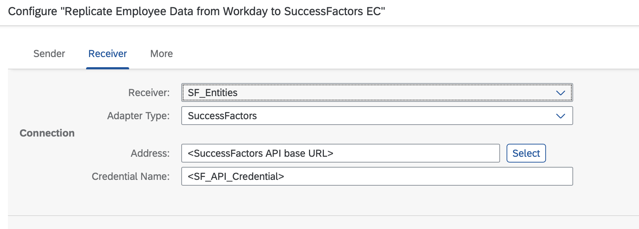

<Configure Other Parameters>
Configure batch process size for each entity upsert request and logging switch.

Configure Event Reason value mapping in the format ‘Workday event reason’:’EC event reason’, separate each mapping with comma.
E.g., 'Change_Job_Details':'DATACHG', 'Rehire':'REHREH', 'Promotion':'PROPWP'

Configure Picklist value mapping in the format ‘Entity.Field’:’picklistId’, separate each mapping with comma.
E.g., 'PerEmail.emailType':'ecEmailType', 'PerPersonal.suffix':'namesuffix', 'EmpJob.employmentType':'employmentType'

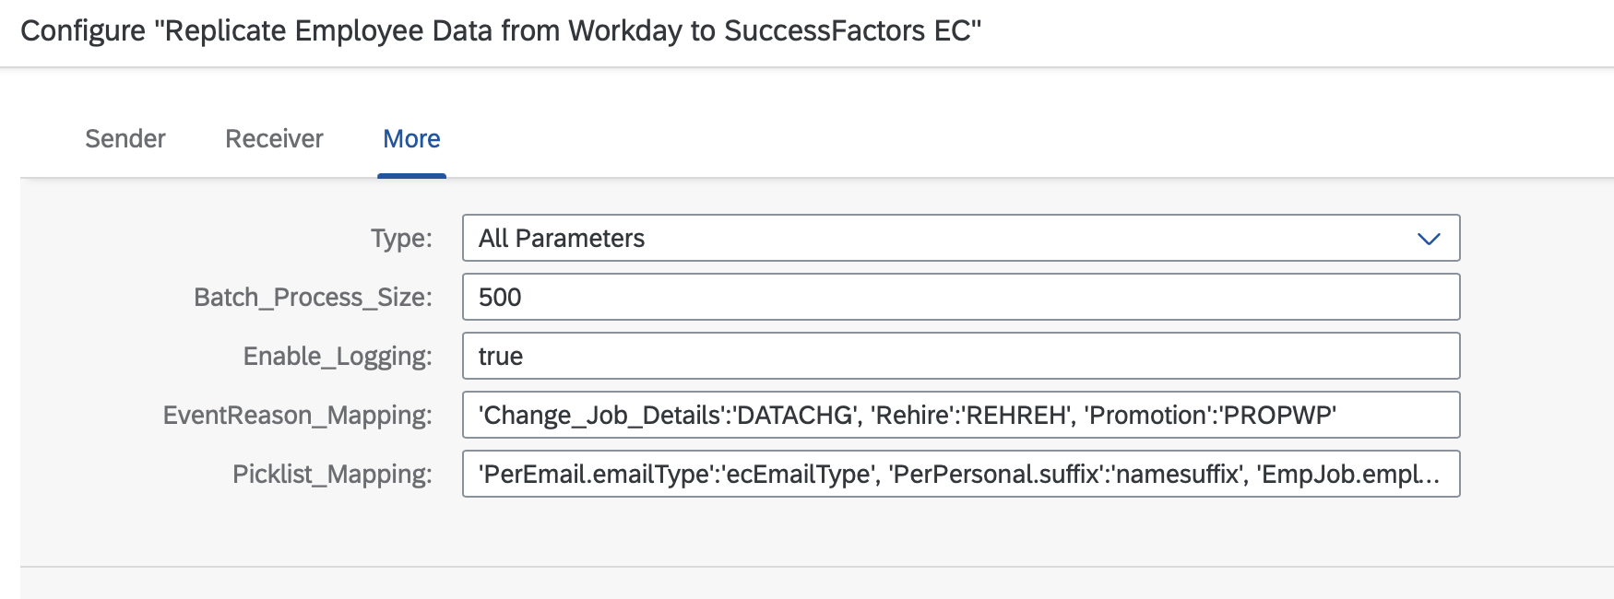

<Configure Value Mapping>
Configure each SuccessFactors entity in SF.Entity, and corresponding entity fields in SF.Fields.
The fields should be separated by comma.

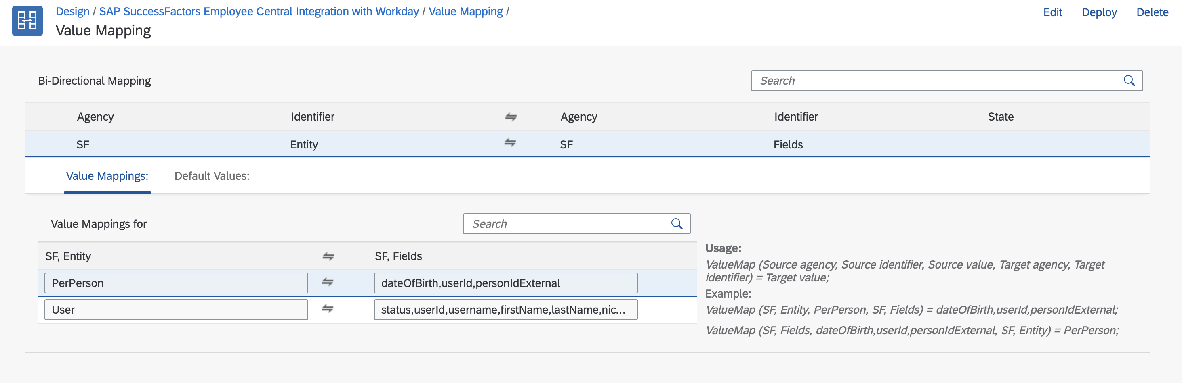

<CSV File Template>
Each CSV file should be provided in predefined template with below file name.
Compress all the files into one zip file, and upload to SFTP before the iflow runs.

PhoneInfoImportTemplate.csv
AddressImportTemplate.csv
BasicUserInfoImportTemplate.csv
CompInfoImport.csv
EmailInfoImportTemplate.csv
EmergencyContactImportTemplate.csv
EmploymentInfoImportTemplate.csv
GlobalInfoImportTemplate.csv
JobInfoImport.csv
NationalIdCardImportTemplate.csv
PayComponentNonRecurringImport.csv
PayComponentRecurringImport.csv
PersonalInformationTemplate.csv
PersonInfoImportTemplate.csv
EmpEmploymentTermination.csv

File templates and samples can be found in the CPI package documents.

