SAP SuccessFactors to SAP Concur Employees by delaware

General introduction
SAP SuccessFactors to SAP Concur Employees by delaware package is developed to transfer employee information from the SAP SuccessFactors to the SAP Concur.
Existing SAP package synchronizes employee data from SAP S/4 to SAP Concur. However in certain installations SAP S/4 is not a master system for the employee information. For example if there is a SAP SuccessFactors which handles all the employee information. In this case the employees need to be synchronized from SAP SuccessFactors to SAP Concur directly. The scope of this package handles this situation.

SFTP integration was chosen instead of API's since SAP Concur has different types of licenses and API's aren't available in all of them. SFTP integration on the other hand is available for all. SFTP was chosen in order to make sure our integration is supported by all customers licenses of SAP Concur.
This package transfers information about employees from SAP SuccessFactors to SAP Concur. It consists of the following objects:
- Replicate Employees from SAP SuccessFactors – main flow which requests a data, generates a file message and calls flow Encrypt and Send file to SAP Concur (timer triggered)
- Encrypt and Send file to SAP Concur– supplementary flow which encrypts file and puts it on the SAP Concur SFTP server
- VM SuccessFactors To Concur – value mapping (maps SF status to Active/Inactive in Concur)
- Get Certificates from SAP Concur– this flow is used for the initial certificate upload from Concur during initial configuration

The high level overall flow can be represented below:
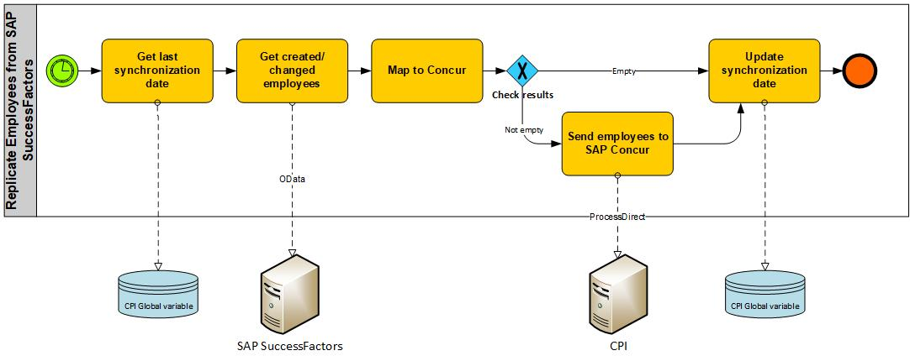
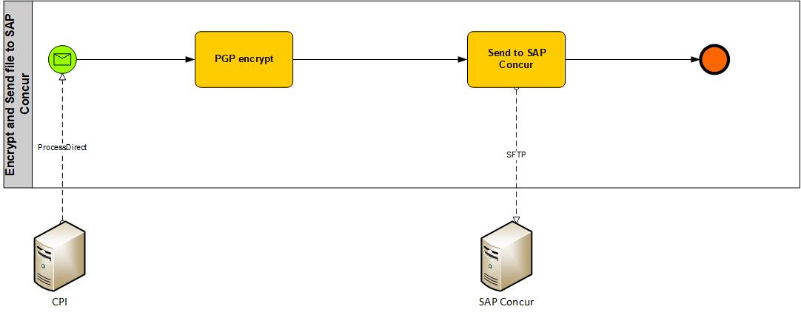

Flows are using the following logic:
- Flow Replicate Employees from SAP SuccessFactors picks up employees created or changed since last run. Using this data, it creates a CSV file and call Encrypt and Send file to SAP Concur
- Encrypt and Send file to SAP Concur encrypts a file and upload to the SAP Concur SFTP server.

After that file will be picked up by the regular job in Concur. This is a delta based integration and flow uses the variable “SF_Concur_Employee_LastRunDateTime” to store the last run date

Outgoing file contains information about employee status, which is mapped to the Active/Inactive status in Concur. As result terminated employees in SuccessFactors will be made inactive in Concur. On the Concur side employees are uploaded as Expense users with default password. For more details on this please refer to the SAP Concur employee upload manual.

Employees changes in SuccessFactors selected based on set of criteria’s:
- New hires are selected on the day equal to the startDate of the employee’s job information (EmpJob object)
- Changes in PerPerson are selected based on lastModifiedDateTime greater or equal to the last run date
- Changes in UserAccount are selected based on lastModifiedDateTime greater or equal to the last run date

To complete import into the Concur, import job needs to be configured and started in SAP Concur. Changes for users will happen only after file processing by SAP Concur. For more information on the configuration of the import job please refer to the SAP Concur manual.

CPI Tenant configuration

Send IP range of CPI
According to the Concur documentation all connections must originate from public IP addresses which reside on their access control list (ACL). Hence the IP range of the CPI tenant should be determined and sent to Concur to have it whitelisted.
The IP ranges for several datacenters can be found on this SAP Help page:
https://help.sap.com/viewer/65de2977205c403bbc107264b8eccf4b/Cloud/en-US/350356d1dc314d3199dca15bd2ab9b0e.html#loiof344a57233d34199b2123b9620d0bb41__CF-Enterprise

Send Public SSH Key to Concur
The SFTP server of Concur only allows authentication via a public SSH key. The following SAP Blog elaborates on the secure connection between CPI and a SFTP server and has instructions on how to create a SSH key pair in CPI.
https://blogs.sap.com/2017/08/03/cloud-integration-how-to-setup-secure-connection-to-sftp-server/

Important notes from this blog are:
- Don’t share the private key, each CPI tenant should have their own SSH keys.

Maintain SSH key in CPI
First check whether a SSH key pair is already available on the CPI tenant. Check for id_rsa/id_dsa/id_ecdsa or any other key pair in the keystore monitor.
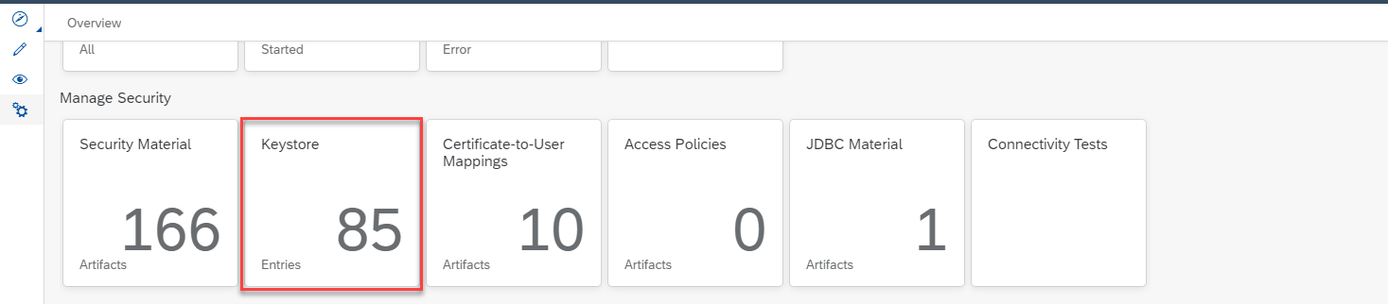

If there are no SSH keys available, create one directly in CPI.
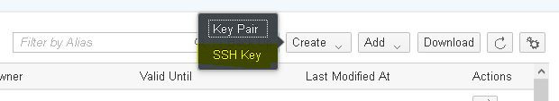
It’s also possible to upload SSH keys to the CPI tenant and use these for the communication with Concur.

Extract SSH public from CPI
The public SSH key can easily be exported from CPI in the keystore monitor.
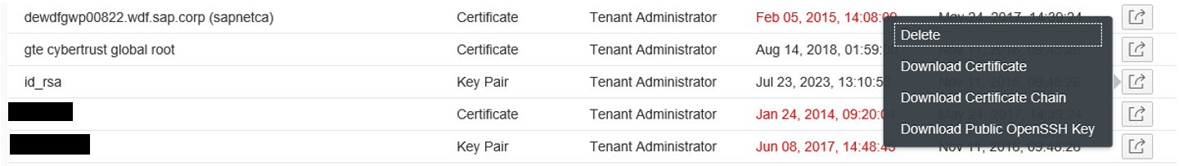

Add SFTP server to known hosts
SAP Note 2700759 elaborates on why this is required and how to do this.

Install PGP certificate from Concur

Fetch PGP certificate from the SFTP server
The SAP Concur public PGP key must be used for encrypting files sent to SAP Concur
and can be permanently found in the root file transfer directory. The scope of this package doesn’t include signing of the message, if this is required, the PGP key used for signing needs to be uploaded to the root directory of the SFTP server.

The SAP Concur public PGP key can be found as concursolutions.asc in the root directory on the SFTP server. The package contains a flow to fetch this key and send them as attachment via mail.

Deploy PGP certificate on CPI
To use this PGP key, it should be added to the pubring of CPI. First verify if there’s already a pubring available on CPI.

When the pubring doesn’t exist, follow 2.4.2.1 to create the pubring from the Concur public key.
When the pubring does exist, follow 2.4.2.2 to update the existing pubring with the Concur public key.

Note that for this setup the 3rd party tool Kleopatra is used which can be downloaded from https://www.gpg4win.org/index.html.
The installation of the tool isn’t documented in this manual.

Create the pubring from the Concur public key
In Kleopatra, inport the Concur public key.
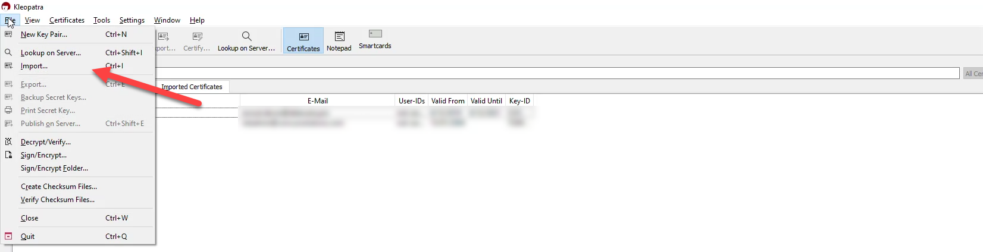
After the import, select the Concur key and click export.
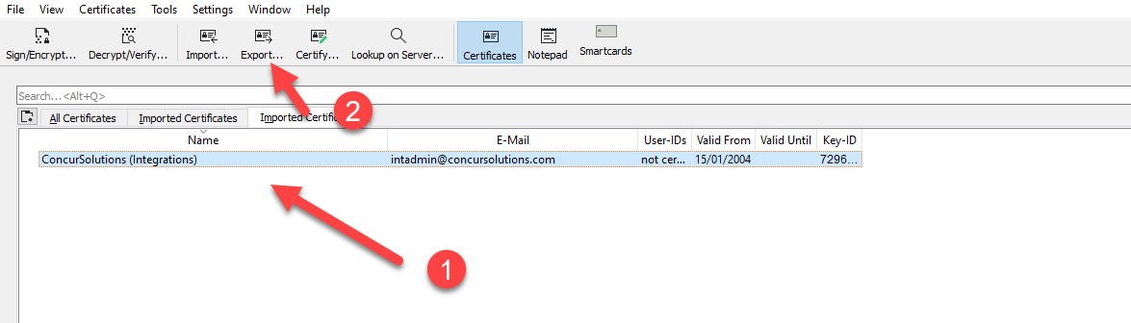
Call the file pubring.pgp.

Then upload the public keyring to the security material of the CPI tenant.
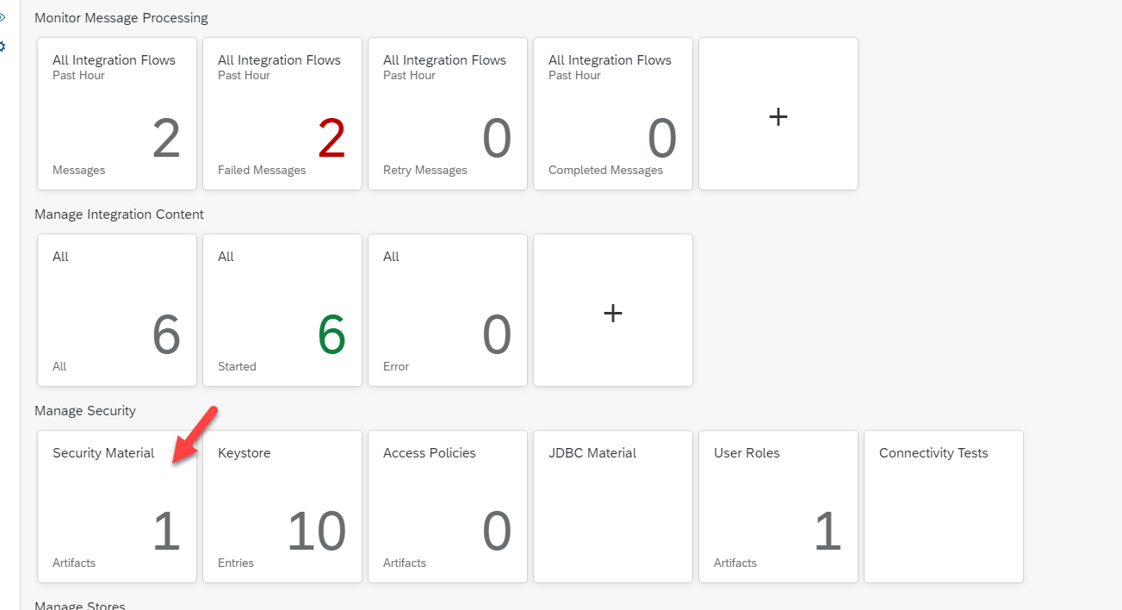
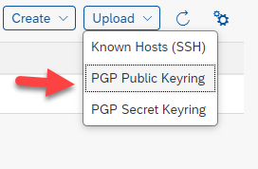

The keyring is now deployed.

Update the existing pubring with the Concur public key
The setup is similar to the setup of 2.4.2.2. The only difference is that the public keyring should be downloaded first from the CPI tenant. Then both the Concur public key and the keyring should be imported in Kleopatra. When exporting the certificates to the public keyring, include all the relevant certificates in the selection.

Download the public keyring from the CPI tenant.

Import the public keyring and the Concur public key to Kleopatra.

Select all the relevant certificates when exporting to the public keyring.
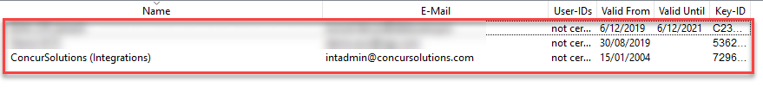
Call the file pubring.pgp.
Then upload the public keyring to the security material of the CPI tenant.

The keyring is now deployed.

Flow configuration
For the proper usage of the flow, it is required to make correct configuration matching your system. Both flows Replicate Employees from SAP SuccessFactors and Encrypt and Send file to SAP Concur needs to be configured before using the package.
The logic to send data to Concur is the same for all documents. Hence this logic was put into a separate integration flow which is then called from the functional integration flows. The integration flow encrypts the incoming data using the public keyring. Then the data is sent to the Concur SFTP server.
A prerequisite is that the fileType is given as a header from the main flow.

Please refer to the list of configuration parameters in Appendix.

Configuration of Replicate Employees from SAP SuccessFactors allows to turn on and off logging for the flow:
- Log the data received from SuccessFactors – parameter Data_log = YES
- Log the data after the mapping – parameter Mapping_log = YES
Logging data is saved via Persistence steps.

Value Mapping configuration
Value mapping “Value mapping for SAP SuccessFactors Integration with SAP Concur” contains two mapping fields:
- Employee Status mapping to the Active field in Concur
- CountryCode mapping to from ISO3 to ISO2 format
Employee Status mapping defines which statuses in SuccessFactors needs to be considered as Active. All non-mapped statuses are considered as Inactive. A list of standard Employee Statuses in SuccessFactors is pre delivered by SAP during the setup of the system and it is normally not changed. In case you need to add new statuses to the mapping please use one of the following approaches:

- Manually add the required statuses in the mapping table
- Adapt CSV file and make a massive update

For the massive update, please use attached CSV file:

Exception handling
Flows Replicate Employees from SAP SuccessFactors and Encrypt and Send file to SAP Concur support several ways of exception handling:
- Skip any handling
- Send mail alerts (triggered by parameter Mail_Alert = ‘YES’)
- Call custom flow via ProcessDirect (Mail_Alert = 'CUSTOM')

If you would like to use custom flow call in error handling, you should define ProcessDirect code for the flow using parameter customErrorHandler.
For the mail alerts, proper configuration of the mail adapter is required (via externalised parameters).

Usage of custom logic
Flow allows to call custom flow without major changes of the flow. There two points for custom calls available:
- After mapping, before converting file to CSV. This call is managed by two parameters - parameterCustomLogic = 'YES' and customCall which contains ProcessDirect code for the custom flow
- Use custom error handler (see chapter Exception handling)
For the custom call there is a possibility to use specific error handler different from the main flow. It is configured by the following parameters:
- parameterCustomHandling = YES – switch on custom error handler
- customLogicErrorHandler – parameter should contain ProcessDirect call for the error handler flow.

Appendix. Full list of externalized parameters.
Name | Description | Default value
Replicate Employees from SAP SuccessFactors Flow
Timer | Timer settings for the flow | Run Once
tenantID | Concur tenant ID. This setting is important for the proper creation of the users in Concur
SuccessFactors OData adapter settings
SF_Host | Host of the SuccessFactors tenant | apisalesdemo2.successfactors.eu
SF_Authentication | Authentication for the OData adapter for SuccessFactors | Basic
SF_Credential | Credentials for the OData adapter for SuccessFactors
SF_Timeout | Timeout for the SuccessFactors OData adapter | 1 min
Custom logic parameters (See chapter Usage of custom logic)
customCall | ProcessDirect code for the custom logic flow to be used | CustomLogicFlow
customLogicErrorHandler | ProcessDirect code for the custom error handler in the custom logic subflow | customLogicExceptionFlow
customErrorHandler | ProcessDirect code for custom call in standard exception handler. | normalFlowCustomException
Logging settings
Data_log | Log data received from SuccessFactors in persistence | YES
Mapping_log | Log data after mapping in persistence | YES
Exception Handling settings
Mail_Alert | Defines type of error handling for the main flow. Possible values are:  - YES – send mail alerts  - CUSTOM – use custom error handler  - For all other values no handler will be used | YES
Mail_Text | Text of the alert mail | The error has been occurred during processing.
Mail Adapter settings
SMTP_To | Standard SMTP Adapter setting. Mail recipients
SMTP_Subject | Standard SMTP Adapter setting. Mail subject
SMTP_Attachments | Standard SMTP Adapter setting. SMTP Adapter Add Message Attachments
SMTP_Auth | Standard SMTP Adapter setting. SMTP Server Authentication
SMTP_BCC | Standard SMTP Adapter setting. Mail BCC recipients
SMTP_CC | Standard SMTP Adapter setting. Mail CC recipients
SMTP_Credential | Standard SMTP Adapter setting. SMTP Server credential
SMTP_Encoding | Standard SMTP Adapter setting. Body encoding | UTF-8
SMTP_From | Standard SMTP Adapter setting. Mail Sender Address
SMTP_Host | Standard SMTP Adapter setting. SMTP Server Host
SMTP_Mimetype | Standard SMTP Adapter setting. Body Mime-Type | Text/Plain
SMTP_Protection | Standard SMTP Adapter setting. Protection setting | STARTTLS Mandatory
SMTP_Proxy | Standard SMTP Adapter setting. Proxy type | Internet
SMTP_Transfer_Encoding | Standard SMTP Adapter setting. Content transfer encoding | Automatic
SMTP_Timeout | Standard SMTP Adapter setting. Adapter Timeout | 3000
Mapping settings
defaultCountry | Default country | BE
defaultCurrency | Default currency | EUR
defaultEmplStatus | Default employee status | A
defaultLedgerCode | Default Concur ledger code | BE
defaultLocale | Default locale | en_US
defaultCustom21 | Expense group hierarchy in Concur | BE
defaultUserPassword | Default password to be used | p@ssword
Encrypt and Send file to SAP Concur Flow
SFTP Adapter settings
directory | SFTP target directory | /in
entityId | Concur tenant ID
fileType | File type to be uploaded. | employee
sftpAuth | SFTP adapter authentication | public_key
sftpDelay | SFTP adapter standard setting. | 1000
sftpDisconnect | SFTP adapter standard setting. | Checked
sftpHost | SFTP adapter standard setting. Target host
sftpReconnect | SFTP adapter standard setting. Reconnect attempts | 3
sftProxyType | SFTP adapter standard setting. Proxy type | none
sftpTimeOut | SFTP adapter standard setting. Timeout | 10000
sftpUser | SFTP adapter standard setting. User to be used for authentication
PGP Encryption settings
keyID | PGP key id to be used for encryption
pgpAlgorithm | Standard PGP settings. Encryption algorithm | AES
pgpArmored | Standard PGP settings | Checked
pgpCompression | Standard PGP settings. Compression algorithm | ZLIB
pgpKeyLength | Standard PGP settings. Key length | 256
pgpProtectedData | Standard PGP settings. | Checked
pgpSignatures | Standard PGP settings. | NoSignature
Exception Handling settings
customErrorHandler | ProcessDirect | normalFlowCustomException
Mail_Alert | If flow sends mail alerts in case of exception | YES
Mail_Text | Text of the alert mail | The error has been occurred during processing.
Mail Adapter settings
SMTP_To | Standard SMTP Adapter setting. Mail recipients
SMTP_Subject | Standard SMTP Adapter setting. Mail subject
SMTP_Attachments | Standard SMTP Adapter setting. SMTP Adapter Add Message Attachments
SMTP_Auth | Standard SMTP Adapter setting. SMTP Server Authentication
SMTP_BCC | Standard SMTP Adapter setting. Mail BCC recipients
SMTP_CC | Standard SMTP Adapter setting. Mail CC recipients
SMTP_Credential | Standard SMTP Adapter setting. SMTP Server credential
SMTP_Encoding | Standard SMTP Adapter setting. Body encoding | UTF-8
SMTP_From | Standard SMTP Adapter setting. Mail Sender Address
SMTP_Host | Standard SMTP Adapter setting. SMTP Server Host
SMTP_Mimetype | Standard SMTP Adapter setting. Body Mime-Type | Text/Plain
SMTP_Protection | Standard SMTP Adapter setting. Protection setting | STARTTLS Mandatory
SMTP_Proxy | Standard SMTP Adapter setting. Proxy type | Internet
SMTP_Transfer_Encoding | Standard SMTP Adapter setting. Content transfer encoding | Automatic
SMTP_Timeout | Standard SMTP Adapter setting. Adapter Timeout | 3000

